Mother Daughter Pageant  Inspired by a Captioned Image  Suggested by Annabelle Raven  By Maryanne Peters  I will not be the first person to say this and I doubt that I will be the last: My sister married an idiot.  My sister Julie married Don because she thought that living with him would be fun. It is true that if there is anything going, Don is up for it. The crazier the better. Their son Kevin in a bit a chip off the old block, except that generally he knows when to stop.  I told Julie about the Mother/Daughter Beauty Pageant by way of saying that it was a pity that she did not have a girl instead of a son in Kevin. Julie is 38 but she looks great. Then I put into her head the possibility that I might be able to give Kevin a makeover and have him pass himself off as female. I suggested that they would make an unbeatable pair. | 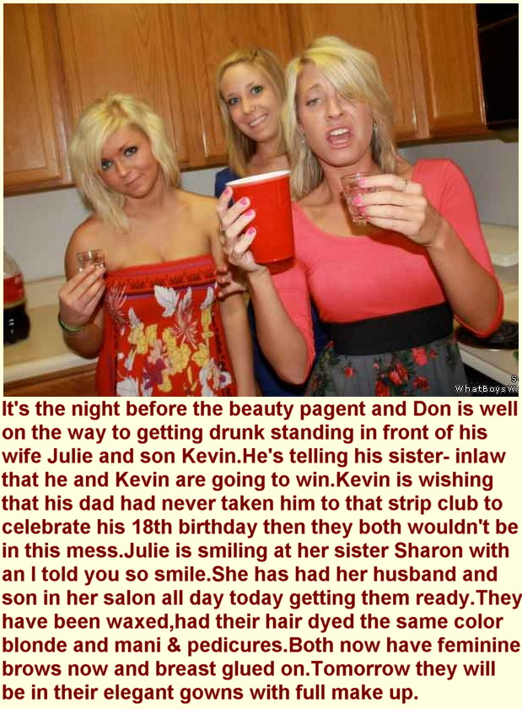

Of course, Don loved the idea, but he said that if I was so clever, he could be the mother in the lineup.

Then on Kevin’s birthday, he made it official. As a treat for his son, he took him and Julie and me, to lunch at the “Sassy Chicken” Roadhouse which ran and lunchtime stripper. Both he and Kevin started drinking, and out came his phone and the late entry went in with the hefty deposit. The details included the measurements for Doria, a statuesque blonde, and her daughter Keira.

“It’s over to you now, Sharon,” he said to me, slurring with way too much liquor on board. “Make us beautiful.”

We had only the afternoon and the evening to get ready, as the competition was the following day. I told Don that they should surrender themselves to me totally, to have any chance of getting a place.

“The Hell with that,” blubbered Don over his glass of neat bourbon and plastic cup of Coke. “We’re going to win.”

I never believed they would, given that I had such little time, but I had already straightened their longish hair and dyed it blonde, and had them in women’s clothes. And “Keira’s” eyelashes had been tinted. In their drunken state, both had been through full body waxing plus pedicures and manicures, including painted stick-on nails. But the day after was to be another full morning at the salon for hairstyling and full makeup for both of them. They could hardly turn up to the pageant drunk so I needed to keep the changes coming thick and fast so they had no time to think.

Fortunately, neither of them are great thinkers.

Julie and I spent all morning rehearsing the catwalk moves and the all-important answers to the judges questions, delivered with a ditzy sincerity that needs plenty of practice. We even rehearsed the winners breathless acceptance speech, although it seemed outrageous that it would ever be needed.

But just as our time was up and we were about to get in the car to go to the pageant, we had a chance to look upon our work and we were both amazed. Not only were Doria and Keira convincing, they were real. They even chatted with one another in feminine voices, primping themselves and one another. I have to say that I looked at Julie quizzically – what was happening in front of our eyes?

Strangely when Doria picked up the prize for the most beautiful mother (Keira did not place as the competition was stiff) we were only moderately surprised.

“I don’t know how you did it,” I said.  “Well, I’m not proud of it, but I needed to suck the Chief Judge’s cock to get the crown,” said Doria off-handedly.  “Oh my God,” I exclaimed.  “That’s not the worst of it,” Doria said. “He wants to take me away to his beach house next weekend, and worse still…”, she gulped.  “What?” I said.  “Worse still, I want to go.”  She did. And Keira found a new life too, with a guy she met at the after party.  The End  © Maryanne Peters 2019 | 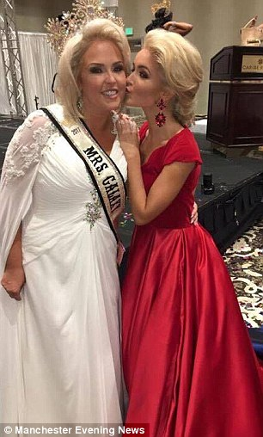

Working with Woody
A Short Story
By Maryanne Peters

It turns out that Westcliffe Colorado, is not so much a one-horse town, as a one burger joint town.

We were first to open, on the north edge of town, on State Highway 69. It was a family business. My wife Jill was still around in those early days, but I called the business “Dave and Son’s”. Not much of a name maybe, but I was building an empire that I could pass down to my boys Shane and Jackson. Shane was still at school in those days, but he went on to train as a cook and we worked side by side. Jack went to college out of state soon after his Mom left us.

I paid her out some money – the boys’ mother. It sure didn’t help, but that was not the reason why our business started to fail. No, it was Woody Farrell and his business on the South side.

Woody was aggressive in taking trade. I could spit and curse him for it, but the fact is that we did the same thing starting out, and that closed two Diners in town. At the time I just shrugged my shoulders and said: “That’s competition, Buddy”. I can hardly moan when I am on the receiving end. But I suppose I did.

Anyway, things got vicious for a while. I pumped all that I had and then some, into the business. Woody offered to buy me out, but I told him where he could stick his offer – right up his sweet ass. I just tried harder – worked longer hours and put more money in.

People in Westcliffe liked me, and Woody told me that nobody wanted to see me fail, they just didn’t like our burgers as much as his. Our slogan was “What we got you really hunger for”. Woody said that you would only eat them if you were hungry to the point of craziness. His slogan was “Tastes as good as it looks”. The truth is, they did.

The slogan wasn’t only talking about the food. Woody’s joint hired only women – good looking women. Tasty looking women. Even in the kitchen, which was visible to the public, only women. He said that men like to watch girls glistening with sweat getting their dinner together. And waiting staff, well, he had them in his little uniforms – “The Lumberjills” he liked to call them – plaid shirts and cut-off jeans. I called it “sex exploitation” in those days. I was just bitter, I figure.

Even though his food was way better, Woody said that because I was popular the folks of Westcliffe, they might not support him if he did not pay a fair price, so when the time came, I would have to pay him back in other ways for paying more than it was worth. I told him that time would never come, and that I would see him in hell before I sold to him. I meant it at the time.

But the burden of debt can bear down upon a man. The worst of it was that there were local suppliers that had supported me. When (not if) I failed, I would not be able to face them, and to leave town would be worse still, as far as I was concerned. It ended up that Dave and Sons had no value, bank debt, and angry creditors. The way I saw it, Woody would be crazy to buy it. It was all over.

A stronger man might have put a gun I his mouth. Don’t think the thought never crossed my mind. It did. But that is about as low as a man can go, before he loses his pride and goes to see his business foe, Woody Farrell.

“Is your pride really gone,” he asked me. “Because I will pay out the bank as my purchase price and take over the debts to your creditors and pay them out over time, but only on the condition that you and your little fair haired kid come and work for me until the last cent is paid, on the same wages as everyone else, of course.”

I felt a huge loading lifting off of my shoulders. But I said: “That seems generous, but don’t you only hire womenfolk?”

He said: “It is generous because I only hire women. I am looking forward to you two joining Woody’s as female employees. You know the uniform. You know the selling plan. You have to fit in when you work here, or there is no deal.”

I thought that this was just spite. I mean, we had cost Woody a lot of money fighting him the way we had. So, I figured that now we were over a barrel, he wanted our pants down as well. Nasty, but maybe understandable. But I had it all wrong.

It turns out that Woody had always had a hankering to see us in skirts. He said that he felt that I had the eyes of a woman, and as it turns out, once you have pulled my beard out at the root, much of the face of a woman too. I guess that’s why I grew the beard in the first place. Shane too, had a good look when you pull away the ugly maleness. And once we both had the long blonde hair and the tits, courtesy of Woody, we were knockouts.

I had every ounce of pride knocked out me, until I went back to work as Dianna, and then it just flooded back. Now I think I have never had so much pride. I now work front of house at Woody’s – I am good at it and I am twice as popular in town. Everybody knows me a the one who swallowed foolish pride and made the ultimate sacrifice, to ensure that everyone in town got all their money back.

Christina (as my oldest now calls herself) has her own pride too. She is popular for another reason. I don’t know too much about it, but I hear tell that a girl with a dick like Christina has the sex drive of a man while knowing more tricks about pleasing men than any woman. Pleasing men seems to be her thing these days – she says it’s a calling.

As for me, I have only one man, and that man is Woody. As I said, when I discovered that putting me in a bra and dresses was not a punishment but a gift, I gave myself to him in return. He does not care for a woman with a penis, but when we rectify that, he has promised to marry me.

Until the he is putting it where I told him he could put his first proposal to me, a year or so ago now, - up my sweet ass this time. And I am just loving it.

It turns out that Dave and sons are inclined towards the feminine. Who knows, maybe we were always that way, or if it weren’t for Woody we never would have been the women we are today.

And I mean sons, not just one. Because when Jackson came back home after dropping out of college and went looking for us; and being told we were now working for Woody, he walked in a saw his father and brother tossing our extended hair about and jiggling our plastic titties at the customers. You might expect him to howl blue murder at us, but instead he just burst out in tears. She (Julia as we now call her) now says that she always wanted to be girl, and was never going to college but trying to make it as a girl over there. Pulls off his baseball cap and the blonde hair just tumbles out, and now here we are:

I lost my business, but what with the laws in this state on sharing of property after marriage, I plan to have a stake in a burger joint all over again, and a successful one too. “Woodys” on State Highway 69 outside of Westcliffe Colorado.

That’s me, the busty blonde, front of house. Soon to be Mrs. Dianna Farrell. Hope to see you all soon.

The End

© Maryanne Peters 2019

Dad Wants to Party
Inspired by a Captioned Image
By Maryanne Peters

Part 1

I guess that you could say that I am exploring all gender options. People my age feel that we can do this. I am not alone. My friend Tom and some others decided that we would have a party for a bunch of us to experiment a bit.

I don’t mean one of the kitschy vice-versa parties, I mean the chance for us to genuinely present as an alternative gender.

Some might say that deciding to go to the party as a girly girl is to surrender to gender stereotypes, but I figured, if you are going to see what it is really like on the other side, go all the way over. I bought a blonde wig and heels, and two evening dresses – one in gold and one red. I hung them on the wall in my room. Then Tom and I went down to the salon to have our makeovers done.

But when I got home, I got the shock of my life. Sitting at the dressing table that I had set up in my room was my dad, in my heels, with my wig on and wearing a lime-green peignoir which was not mine and fitted him perfectly.

But the craziest thing was, that the face that was smiling at me in reflection was made up perfectly, with plucked eyebrows and mascara, and it was my Dad applying the red lipstick. I was gob smacked and could only mutter: “Dad, what the …?”

“I wondered if I might be able to go to that party of your tonight?” this person said. “Tom’s father is going to be there.” The voice was Dad but did not sound at all male.

“But Dad, this Party is only meant for our friends, not our parents.”

“Why should you kids have all the fun,” Dad said. “And besides, I have had a facial and a full body wax. And you can’t wear both of those gorgeous dresses, can you, young lady?”

I kind of liked being called “young lady”, and it had been years since Mom left, so I had somebody to help me choose my dress and my overall look.

“But that’s my wig,” I complained.

“it’s not a wig, you silly girl. Your wig is over there. They’re extensions. And I am not planning on having them taken out after the party either.”

“Is Tom’s Dad going to be dressing up too?” I asked. If I could not stop my dad from going, how bad was this going to be.

“Goodness no,” Dad said. “He’s going to be my date. So while we are at this party, you had better call me Mom.”

Part 2

Everything changed so drastically that night.

For a start Tom was supposed to be exploring his feminine side the way I was. We had both been to the salon together and he was made to look like quite an attractive girl, although maybe a bit too big. But he barely lasted an hour in costume. He said that seeing me in my dress made him realize that he could never be anything like a girl.

I thought that what he was trying to say was that I just looked so much more like a girl than he did, but he later told me that it was not that at all. He said that I made him want to be a man, so long as he could be my man. He wanted me to be his girlfriend.

He kissed me to show me how he felt. He took me outside onto the deck, and there, alone, under the moon, he kissed me. He told me that only one of us would wear dresses from that day on, and it would be me.

But even that was not the strangest thing about that night. It was my dad. I mean my mom. She was not exploring gender like we were doing; she was affirming hers. It is clear to everybody now, that my Dad has always been a woman, she just hid it away all those years. That party was her chance to come out, and boy, did she do that?

She told me that Tom’s father was her date, and I guess he thought that she was just going to be in drag like the others (except me, that is). But, well, just look at her. She wore the red dress; I wore the gold. Tom’s dad could not take his eyes off her. And when they started dancing, he could not keep his hands off her either.

They had been two solo fathers raising sons after nasty divorces, now everything had changed. There was only one solo father, and one son. We were something else.

After the party I got hair extensions too. I did not want to take my hair off. I wanted to be Tom’s girlfriend. The feelings that he brought out in me that night just seem to be growing more and more intense. I want to give myself to him. I want to be what he wants me to be.

Mom and I turned a corner at the party. I went to school the Monday following as a female, and Mom turned up to her job that day just the same. Nobody at school who had been at Tom’s party was surprised to see that I was now to be a girl, but Mom told me that at her work her appearance had caused quite a stir. Tom’s father said that if she likes Mom can go and work for him.

So, on the Tuesday Mom got us on hormones and we had a bonfire for our male clothes. We will not be needing them again.

Now with the weekend coming up Mom tells me that it will be a father/son – mother/daughter double date. That sounds kind of weird, right? But I know it will be fun. If my new mom is anything like my old dad, she will want to party.

The End.

© Maryanne Peters 2019

Family Hobby
Inspired by a Caption Image by Annabelle Raven
By Maryanne Peters

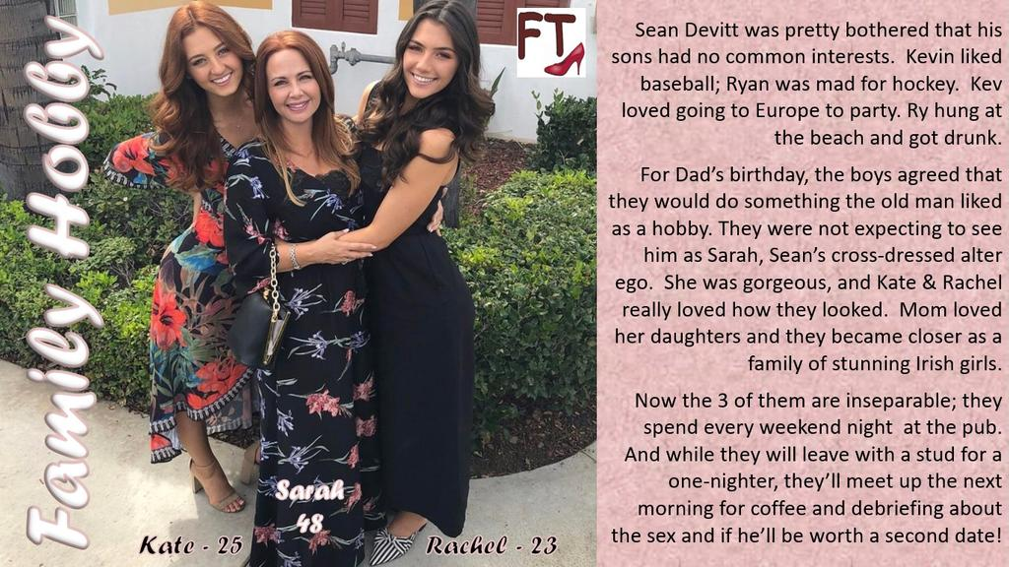

Of course, sons love their father, but that was not the reason why it all started. Our father just wanted us to do something together. His father, our grandfather, had been into motorsport, so Dad’s whole family got involved in that. That is why Grandad ended up setting up the auto parts business that turned into one of the biggest in the county. When he sold it Dad could afford to give us what we wanted, and all he wanted in return was a cast-iron promise that we would share in his hobby when we got back.

The deal was that he would pay for Kevin’s trip to Europe and my beach tour following the pro-surfing competition. We could take close to a year just so long as we got back by Dad’s birthday, and then we would spend a year with him, pursuing his hobby together.

I suppose we thought that hobby might have something to do with cars – maybe racing of some kind, or customized auto exhibitions. But Dad despite the business, Dad was not into cars or motorsport. He said that he never liked that stuff, ever. He did not like the noise, of the smell of rubber, or hot lube oil, or gasoline. He ran the business very well – better than his father – but he ran it by the numbers, not out of any interest in automobiles.

“You promised that you would follow my hobby, and I am going to hold you to that,” he said to us. So, he introduced us to Sarah.

Since he sold the business, he had been growing his hair, so it was as long as Kev and mine. He said that he has always wanted to have the full transformation done, and now the three of us were going to do it together. It was to be the ultimate experience for a lifetime involvement in cross-dressing, something we never knew Dad was involved in. We would share it together, just as we had promised him.

Maybe Dad did not feel that he could take this step alone, because this was going to be more than just an afternoon makeover and a night of the town in drag. Dad wanted to see whether he could live like this. And as we had promised we would be right there alongside him.

I have to say that I spat the dummy. I felt like I had been tricked, and that I was going to end up making a fool of myself. But as Kev said, nobody outside the family need know. We had both been out of town for almost a year and only got back on the night before Dad’s birthday. The three of us could do this as long as Dad wanted, but not more than a year.

Kev talked about some models he had seen in Paris who looked like girls but were really guys. That is not something you can get away with on a beach.

So, in the early hours of the morning the three of us left town and drove 4 hours to the city for our “feminization”. Dad talked the whole way about how much he loved us but as a man he had never felt able to express it. He said that we all had the chance to be women for a while and truly express our feelings – no holding back.

Kev seemed to accept that. I even saw a tear in his eye. He urged me to be a part of it. We stopped on the side of the road and we had a big triple hug. I have to say that it felt good. Dad was right. We had been too long in the shadow of Grandad and the auto parts business. It was a macho shadow, now somehow, we were free of that and standing in the sunlight, hugging one another.

I never eve new that these feminization places were a thing, but it was there, and busy. It seems like there are just as many people who share Dad’s hobby as there are stock car fans or surfer groupies – maybe not as many as there are baseball or hockey fans.

“The Full Transformation” seemed way too much, but given Dad’s obvious excitement, and Kev saying: “we agreed to this”, what was I to do? I had grit my teeth through the body waxing, and sit patiently while the hair extensions went in, and my face was “peeled”.

Dad started trilling like a little girl. He said: “We’re going to have to work on our voices,” he said. “nothing could be worse than looking like a girl and then opening your mouth and revealing that you are really a guy.”

“He’s right,” said Kev. Then he was trilling too. And so was I.

We had to stay over in the city. We had to go back for treatments over a few days. We had to learn how to live with our new hair and how to style it. We needed to trash our clothes and buy a whole new wardrobe. Dad was paying. It was only his hobby when we started. But I guess these things catch on.

The best hobbies are the ones that draw you in and give your life meaning. I seemed to me that Kev was right – it was like art. He really got interested in art in Europe, and particularly the portrayal of the female form in art.

“I can’t paint, I can’t sculpt,” he said. “But maybe this is a little bit of both.” He checked his lipstick, and then the lines of his dress with the padded underwear beneath. I had to agree – this was something truly beautiful.

I had my mother’s darker coloring. Both Dad and Kev said that I could be the prettiest of the three of us.

“That is what this hobby of ours is all about,” said Dad. “It is not just about appearing to be female, it is about putting real women to shame. We need to be better.” He was brushing his new extended red hair, wearing a pretty floral dress. He was doing it hard out.

I know about that. I was a damn good hockey player, when I played. To be good at hockey you need to go all in. Speed means big hits. No room for pussies. I guess being like a woman is the same. Give it everything.

When we went back to our small town we went back as Sarah, Kate and Rachel. The new ladies moved into Sean Kevin and Ryan’s house. Everybody knew Kevin and Ryan were miles away, spending their father’s recently acquired wealth. It seemed like their father was off to join them. Maybe for some time, if he had let the house out.

“That Sean came into a lot of money recently,” said Herb Hanley, our resident nosy neighbor. “I am not surprised he did not want to stay in this town.”

“He’s a distant relative,” said Sarah. “I recently divorced so he said we could stay here at a nominal rent”. Was our Dad flirting? The way she was standing and playing with her hair it sure looked that way.

“You should let me show you around,” he said. He had no idea. He was nosy when it came to strangers, but we hardly ever saw him when we were men.

“That would be nice.” Definitely flirting.

“In fact, my son Mark is coming to visit me next week, and bringing a friend. Perhaps we could all go out together?”

And that was how I met Paul. That was how we all met the men who would ensure that what had begun as a shared hobby would end up as a way of life. Three ways of life in fact.

But you know what they say: The best hobbies are the ones give your life meaning.

The End

© Maryanne Peters 2020

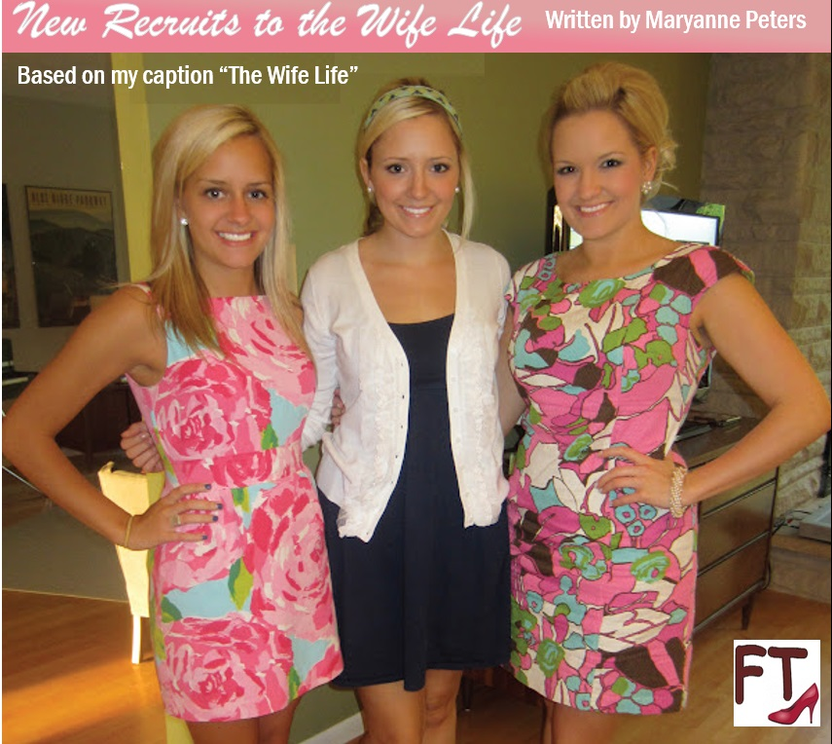

I never thought of my son William as gay, he was just inadequate. I knew it because we talked. I was always close to my boys – closer than most fathers, I think. We all shared the same problem – congenital microphallus, so I guess it comes from me. We all had hopelessly small penises.

I was able to cope with it when my wife was sympathetic, which she was when William was conceived. But after he was born sex became even harder. Brent was conceived from my sperm in a turkey baster. Because it was clear even at only three, that William had my problem, we hoped for a girl.

My wife left me for somebody with a real penis. The boys went with her initially, but her new man never came to grips with how my sons were, and even their own mother despaired of them. They cam back to live with me. Even with them back she was still claiming personal alimony.

William and Brent dealt with our collective problem in very different ways. Will concentrated on his studies and simply rejected sex. He made it to college, which was something I was not smart enough for, and worked towards his degree.

Brent chased girls. He flirted with them, chatted them up, dated them, and dumped them before they could discover his secret. He said that maybe the right one would come along, the way it had for me. But he knew that his own mother had eventually cast me aside, and to some extent she had done the same to him.

Penis size does matter.

When William came back from college six years ago, Brent and I were about as low as you can get. My employer had just gone out of business and one of Brent’s girls had gone too far and discovered his secret. The whole school now knew and all the girls he was going with dropped him like a hot brick. The shame was so crippling for him that he had no choice but to drop out. Brent and I were sitting at home, sorry for ourselves.

Then into our house strolls Whitney. That is the name William was going by then, and she still does. She just glided in as if she was the happiest person in the whole world. We could see who she was, or rather who she had once been.

“This is me now,” she chirped. “I have found the perfect partner. Somebody who not only doesn’t care that I have a tiny dick, but who positively adores it being so little. It is just that he happens to be a guy. A guy who likes girls with little dicks. Girls just like me.”

Of course it was a shock. No man is ready for his son to walk back into his house as a daughter. Maybe I would have been disgusted or angry, but I was so depressed and Whitney was just so happy.

“My guy Paul says that there are plenty of guys who like people just like me … just like us. Maybe you should follow my example.” Whitney was doing her best to cheer up her family.

“You take a guy up your ass?!” Brent was blunt as usual.

“You should try it, little brother,” said Whitney. “Rather than tugging on that little crotch nipple, you will find that a handless orgasm it a wonderful thing, probably because you are not getting it on your own.”

On my own. That was what I was, and Brent now too. I missed physical intimacy. I am not taking about hiring a whore and having her snigger at my tiny erection and set about making me cum, I am talking about a lasting relation between two people who are physically attracted to one another. Whitney had found a way to get that. It just required that he become a she.

And she was definitely a she. That was six years ago, so her fair hair was not as long or as blond, and her breasts nourished by the early effects of hormones, were not as big as the are now. But she was very attractive. We were all three of us slight of build, fine features and, of course, poorly endowed.

“Paul looks after me,” said Whitney. “He wants me to be his wife. Will you be mother of the bride, Dad? Will you be my bridesmaid, Bro?”

It sounded crazy, but I figured: What do I have to lose?

Now here we are. Look at us. We are all married now. Whitney and Paul have two adopted children. Boys without the curse of our family’s genetics. Bella, as she now is, has been married to Hal for a year, and they are talking about kids too. And I married Paul’s uncle Mark, and I have found my true vocation – wife.

And at last, I have somebody who loves my body. It is a different body now after six years of hormones. I have curves and breasts, and soft skin and hair, but I still have a small penis. It is nutless now, but Mark delights in twiddling it, and I love having it twiddled.

Even people like us can find intimacy, if we are prepared to change.

The End

© Maryanne Peters 2020

