What did the Twins say?
By Maryanne Peters
Inspired by a Captioned Image

Is it not every guy’s fantasy? To have a threesome with a pair of gorgeous twins? My only problem was that there was only one difference between Meghan and Moira Spillane, and it was not an obvious one – Moira is a lesbian.

They do everything together. And I mean everything. Moira told me that the only thing that they could not do was share a sexual partner. Meghan had the hots for me, but she said that without Moira agreeing to participate, it was not going to happen.

I needed it to happen. I wanted both of these girls.

It was my mother who came up with the idea. It would be crazy coming from anybody else, but my mother had always wanted a daughter, and we all know that she was disappointed that her third child (me) was another boy. She always told me that I was too pretty to be a boy and had always nagged me to parade before her in one of her dresses, or wear a girl costume for Halloween.

She knew Doris Spillane very well and she knew that I was besotted with the twins. So when she learned that Helen Beadle had broken a leg and would not be able to join Meghan and Moira as the third of “The Three Witches” tableau on the Halloween parade, she suggested that I fill in.

“Don’t be crazy Mom,” I said. “These girls have been planning this for weeks. It is not three ugly old witches, but three beautiful witches in long black dresses with glamorous hairstyles.”

“You could do glamorous Bobby,” she insisted. “Your hair is long enough, and you are small enough to get into Helen’s dress. We would just need some padding, and we will need to give that face a makeover.”

I never would have done it, but my mother blabbed to Doris about the idea and she loved it. And then I had a call from Moira. “I think that you would make a really pretty girl,” she said. “The kind of girl I could really go for.”

“But Meghan would never go for me in a dress?” It was supposed to be a statement, but it ended up a question.

“Oh, I think you are wrong there,” she said. “She might be more interested in what’s under the dress. And I might even be able to pretend it’s a strap-on if you act girly enough for me.”

She sounded so sexy I almost came in my pants on the other end of the phone.

“What do you want to do with my face and hair?” I asked my mother. She was thrilled for the opportunity to dress me up at last.

Mom and I went round to the Spillane’s place on the day. Mom and Doris were both skilled amateur beauticians and hairdressers, although Meghan and Moira had already had their hair done at the local salon.

The mother’s sat me down and went to work plucking my eyebrows. It was only when I saw what they had done that I realized I was in real trouble. How would I be able to hid this tomorrow?

And then my hair. Once they had straightened out my natural curl it seemed as if my hair was really long. They used curlers and setting solution to style it to curl under. That was supposed to hide my wide neck and Adam’s apple.

“She looks gorgeous,” said Mom. “We need to get a photo”.

And with that the twins stood either side puckered up and whispered to me together, in perfect unison as they often did: “Its going to happen tonight, after the Halloween party, a threesome.”

The End

© Maryanne Peters 2018

And then John Turned Up  Inspired by a Captioned Image  By Maryanne Peters  And then John turned up. I was sitting on the veranda in the dress my mother had laid out for me, with my hair pulled back in a small ponytail, and with bangs brushed down over my eyebrows. She had even put a little mascara on.  She had said that as long as I had these awful growths on my chest, she would like to take a photograph of me as a girl – as the daughter she might have had, before I went to the specialist as to how to remove them. Of course, I should have refused, but she was acting weepy and sentimental and I am sucker when it comes to my Mom. | 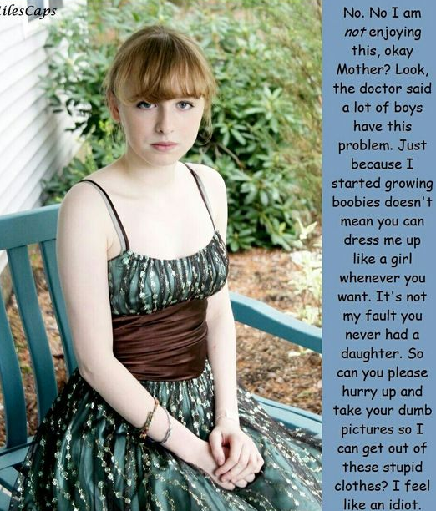

And then John turned up.

John was there to see my older brother Ned. They are close friends. He saw me sitting there, waiting for Mom to come back outside, in the dress, with my boobs on full display. He just stops and stares.

“Well this is a surprise,” he says. “A pleasant surprise too.”

“Please don’t tell anyone,” I beg him. “It just for Mom. I don’t dress like this otherwise.”

“Why not,” he says. “You look beautiful.” And he comes up onto the veranda, looking like he’s thinking just that. Almost undressing me with that stare. And he walks around behind me, and I am looking at the door for Mom. And I can feel his breath on the back of my neck like he has bent over to kiss it.

Mom steps out and saw John, and she says, nodding at me: “Oh, doesn’t he look adorable. He is pretending to be Nora, the daughter I never had.”

“Nora,” says John. And to me: “Hello Nora.” He knew who I was, but he called me Nora.

“Hello,” I say shyly.

“Ned is not back yet, John,” says my mother. “He’s about 15 minutes out, but I am sure Nora can keep you company.”

“That would be nice,” says John. “Perhaps we could go for a walk, Nora?”

“These shoes are not for walking,” I said, pointing at the heels.

“We’ll stay on the path,” he says. He holds out a hand to me.

“That’s a good idea,” says Mom. “Take John’s hand, Darling.”

I take it and rise, and he places my hand in the crook of his arm so that we walk together closely. He says: “For support when walking on those heels”.

He did not let go of my hand as we went down the steps. With still a little unsteady I was thankful for that. But then he kept hold of it as we walked down the path.

“You sure make a very pretty girl, Nora,” John said.

“It’s just for today,” I said. “Just for Mom, I’m to be a girl today.”

“Then you have just one day to experience everything that a girl should experience.”

“Like wearing a dress and heels?” I swung the hem of my pleated dress around, and turned my leg out to show him my shapely calf. The dress felt good in the warm early evening air. In that moment somehow the idea or wearing pants seemed constricting. In a light full dress like this I could feel free. My little penis seemed to flicker into a life.

“Like kissing a boy, under this tree here.” He stopped.

“No, John, please,” I said, as his body pressed me up against the trunk. I could smell him. It was dry sweat. The smell of a man. It smelt good.

“Please what?” she said. He stroked my bare shoulders and chest with the back of his hand, while looking down at my pale and undeveloped cleavage. Perhaps I might have trembled a little. Could he feel it? His eyes lifted to look into mine. “What do you want me to do?”

He must have read it in my eyes. I don’t know why, but I was willing him to do it.

He kissed me. He cupped my smooth pale face in his strong hands, and he kissed me.

I lifted my arms to push him away. Not because I wanted to, but because I knew that I ought to. I was a boy being kissed by another … by a man. It was not right. I was not gay. So why were my arms not pushing, but pulling? My arms were around his neck and I was pulling him towards me.

Our saliva and the hot breath from our noses mingled. We hungered for one another. It was the stuff of movies, of dreams, dreams that end with sticky bed sheets.

Reluctantly our lips parted. He licked my chin and up to my nose.

“What else would you like to experience on your day as a girl?” he asked.

“Be gentle with me,” I said. “I have never done this before.”

What was I suggesting? I had never done it before, and I would never do it in my life. And yet I was lying on the grass while he slid a spaghetti strap off one shoulder so that he could lick the big pink nipple of my left breast. So much feeling where there should be none. My body was limp. I was his, and he knew it.

“I promise I will be gentle,” he said. “Although you are driving me crazy with desire.”

Instead of saying: “That makes two of us”, I just let out a little girlish moan. A moan or submission or invitation or both.

I never noticed the pain of my first impalement. I felt only him. His presence, his flesh, his seed.

When we got back to the house Ned had just pulled up. He saw me in the dress, with his best friend’s arm around me. John was not ashamed to show it. Ned looked at John strangely, but did not have time to say anything.

“Where have you been, Dude,” said John. “Lucky I had your new sister to keep me company.”

Ned motioned for him to head inside, but before he did, right in front of my mother and my brother, he gave me a kiss. He lovingly pushed aside my bangs and kissed me on my forehead.

“I confess that I called John and asked him to come over,” said Mom when they were inside. “Ned told me that John has said to him in the past that you would make a great looking girl. I hoped that John would be the man who you needed to help you make the decision to stay as Nora, once those breasts started to swell up. I really do want you to stay as my daughter. Would you consider doing that?”

She had a look of longing on her face that would melt the heart of any mother’s child. It would be hard to refuse. But even harder to refuse John.

My mother’s daughter and John’s girlfriend?

Of course I agreed.

The End

© Maryanne Peters 2109

Pageant Mom
Inspired by a Captioned Image
By Maryanne Peters

I was pretty, but not as pretty as him.

So tall, with legs longer than mine, and slim hips as only a boy dressed as a girl can have.

He has thick hair like me. Beautiful hair that should grow as long as mine was when I was his age. Until then those extensions will have to do. He will need to live with them after the contest and learn to care for and style long hair. Good hair is a must for competitions.

Good skin too, and he is blessed with that. All his friends seem to be erupting with greasy pimples. Some of the girls too. Not my Josh. Perfect skin.

All of that is wasted on a boy. It seems sometimes life is playing a cruel trick on us, besmirching something as beautiful as this with the addition of ugly male genitals – like shit on a rose petal.

He did not want to do the pageant. I pushed him into it. I made him all sorts of promises. I was so keen to see him as a girl. I hoped that he would be passable. He ended up being truly beautiful. It was not surprising considering the money I spent on the hair, the manicure, the pedicure, the breast forms, the girdle.

I told him that I would not have him hamming it up. I did not spend all of this money to have him go on stage as a drag artist. He looked like a girl and so he needed to behave like one. In the lead up to the contest I had him modify his behavior even at home, the idea being that it would become second nature.

I suppose it did. I think that he found himself slipping into his feminine self even at school. He was fortunate to have Brad to cover for him. Big and gentle is Brad, the boy from across the road. Brad was somebody who ensure that nobody teased him for these new traits.

Brad was there watching at the pageant, right near the front, strangely entranced by the whole thing, or at least the appearance of my precious rose. He had to win. I would have burned the place to the ground if he had not.

But where do you go from here? The world deserves to have such a blossom on constant display. There are plenty of pageants around, but now I am talking the real thing. There is no room for boys in those contests. My son needs to bloom, to become the true Rose.

I am sure Brad will help. Somehow, he has already been able to change her attitude. Somehow on his regulars visits to her room in the evenings, he seems to have convinced her that she can live as a pretty girl 24/7.

The End

© Maryanne Peters 2020

Try a Few Things
Inspired by a Captioned Image
By Maryanne Peters

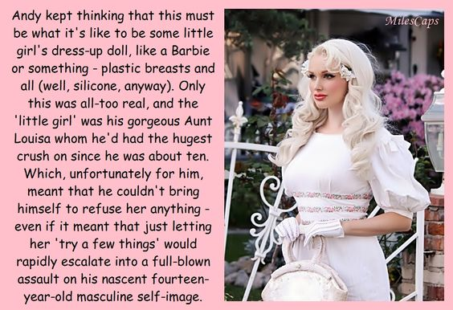

He could still see himself in the face. He was there somewhere behind the painted cheeks, the false eyelashes and the glossed lips. Andy was still there, but only a trace. Nobody else saw Andy. They saw Angela, the model of feminine perfection.

Louisa and her husband Henry could not have kids, and Andy’s mom. Louisa’s sister, a solo mother, living miles away and on hard times, had asked her whether she would take one of her three children. But they were all boys. Only Andy, which his clear adoration for his aunt, seemed worthy of consideration. Could Louisa give him a better future? Andy’s mom was not one to ask for charity, but in letting one of her precious sons go to the home of another, she was not taking but giving. Giving to both: To Andy a chance at a better life; to Louisa and Henry somebody they could treat as their own.

From the moment he arrived Aunt Louisa asked him whether he would “try a few things” to improve his appearance. There was nothing that she would suggest that he would not do for her. They were just little things to start with – she wanted cleanliness, and she regarded body hair as being filthy. She preferred longer hair on children, she said, properly care for. Skin the same – sometimes treatments were needed to maintain skin condition.

And then there was the constant requirement that he always dress in white. That is something that limits what a boy can do. White shows the slightest stain. And when the requirement extends to wearing white gloves when leaving the house, those limits are oppressive.

It always seemed to him that he was being smothered with attention. Of the three boys at home, he had been the one who felt left out. Now he was an only child being pampered by an adoring mother figure who was not just concerned for his wellbeing but obsessed by it.

The feminine aspects just crept up on him, or more accurately slowly accrued in his body by whatever means she was able to employ. And now here he was. Now he had no testicles and a pair of breasts that would not belong on a fourteen-year-old girl let alone a fourteen-year-old boy.

Like the frog slowly brought to the boil, Andy had no idea that he was in hot water. He had just felt warm, wonderfully warm and comfortable, until he was cooked.

Had it truly been a rapid escalation? Exactly how long did it take? He could hardly remember.

Now he was aware enough to know that he was nothing but a plaything in the hands of his aunt. A life-size living and breathing Barbie doll, whom she could dress in clothes too feminine for most women. Lots of pink and white, to match his bleached hair that now tumbled down well past his shoulders.

His mother had seen him at Christmas. She had been horrified. But Aunt Louisa gushed so much about how perfect he was and how grateful she was to her sister. Instead of a present she and Henry both gave Andy’s mother a substantial check as a present.

Over Christmas dinner Andy’s brothers had watched in disbelief as he checked himself in the mirror before mincing to the table and pushing his skirt and petticoats under his rounded bottom in taking his seat. While they shouted and scoffed their food, Angela delicately nibbled at her and drank her tea (instead of sod) with her pinky extended.

Angela had nothing in common with her brothers anymore. They were rather dirty and common.

One thing was very clear to Angela: She would endure Christmas is this slum, but she would avoid coming back. She could not wait to slip her gloves back, snatch up her handbag and trot out of that place in white Louboutins. She looked despairingly at Aunt Louisa, who smiled at her knowingly.

It was not said - that would be unkind - but: “They are not really our kind of people”.

The End

© Maryanne Peters 2020

Primping
Inspired by a Captioned Image
By Maryanne Peters

I don’t think Lisa was a lesbian. If she was, we would probably still be together. She has another guy now. Maybe she will want to turn him into a girl as well.

The crazy thing is that my mother was with Lisa all the way. They both hounded me to try on women’s clothes and to have my hair cut and styled in a feminine way.

Okay, I am not the manliest of men, but I was not about to give in – not at first anyway. But I now understand that a man would put his foot down. He would simply say no.

But I didn’t do that. I just whined about it, and said that I did not want to do it. It was almost like they enjoyed that reaction and it made them push on and have me lift the volume. But looking back there was never a refusal.

Lisa had to take the photo after I stepped out of the salon. I am wearing my button up lace blouse with the eidelweiss clip. But there I am with my hair cut colored and styled, and my shaped eyebrows and false eyelashes, and my hands softened and manicured. I just had to reach up to check the bounce in the curls. She caught the moment forever. The look of fascination and self-admiration.

She calls it my primping image. It is the moment that I fell in love with myself, or rather the new me. There is no going back now. Somebody as pretty as I am should never be consigned to just the memory of this moment.

Form that day on I swallowed up the hormones and immersed myself in beauty magazines.

I am kind of glad that Lisa is not a lesbian and is looking elsewhere. Somebody as pretty as I am is a real magnet for the boys. So excuse me while I primp for the date who is picking me up in an hour.

The End

© Maryanne Peters 2021

