New Wardrobe  Inspired by a Tiffany Captioned Image  By Maryanne Peters  We did fight. It was bad enough that she had her bag, but she had not put the name tag on mine. Then on the flight she had spilled the airline meal all over my pants, so they were unwearable. And on top of that she made this crazy suggestion, as if trying to make some point about the way I lost my shit in the arrival hall.  “You’re the same size as me. You can wear something of mine, and we can stroll down the Boulevard Saint Germain together and find you something else.”  She knew that would set me off all over again. She had found out about my cross-dressing thing, and instead of walking away, she used it to needle me.  “You sound just like a girl when you are mad,” she said. “Your voice becomes a high-pitched squeal. You could use that.” | 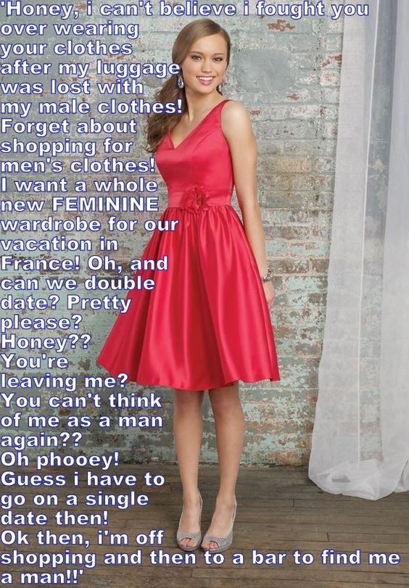

I only dressed for the mirror – the mirror and me. I never would have dreamed of stepping outside. It was just a private fantasy, but it was one that I lived for. I had even kept my hair long. I wore it in a braided queue down my back at work. I have a bit of Asian blood in me so the look was manly enough, and I made sure to act as manly as possible when dressed normally, including lowering my voice. But my girlfriend was right, when I was angry or upset, my voice seemed to shoot up to a soprano.

But I guess even the most repressed cross-dresser wonders what it might be like. It is just that it is hard to imagine a circumstance that would force you to do it. Now it seemed that this was one of those situations. We could take a cab to the hotel in my soiled pants, but then what? Send out for clothes?

I think she knew how thrilled I would be to wear something of hers. She had nice clothes, and she was right, we were the same size. I just needed to stuff one of her bras to get into one of her dresses. The crazy thing was that she had pants I could have worn, but I just pushed those aside. I guess I felt that if I was going to do this, I was going to go all the way.

I suppose my only fear was that I would get excited and it would show. I needed wear two pairs of shaping panties to get myself fully restrained.

Shaved my legs and washed my hair. It was really all that was needed. I applied my own makeup while she watched with a strange look on her face. She had caught me dressed, but I was a man in a dress stammering out what I thought could serve as an explanation. What she was watching was me slowly and deliberately removing any masculinity from my face and body.

I think that she started to realize from that moment, but she was keen to step out of the hotel and into the streets of Paris, and so was I.

Paris really is a city made for women. It has beauty and romance, and so many clothes shops. Shops that don’t sell clothes seem to sell accessories or cosmetics, or little sweet things that girls like to eat. The bars sell colorful drinks in small glasses and the seats outside seem made for women to sit on and show off their legs while mean walk by.

If inclinations were feminine, and losing my luggage started it, then Paris finished the job. But she played a part too. It seems hard to imagine how we could have spent that day as a couple – a man and a woman. Two women can have so much fun together, shopping and just strutting our stuff on the leafy boulevards.

The men would turn their heads and it was her idea to accept the proposal of a pair of businessmen who approached us at a café. They were not the first either. The first time it happened I told them that we were a couple, and lesbians are not interested. But with these two she grabbed my hand to stop me from saying anything. One of them gave her his card, but he was looking at me.

“Can we double date? Pretty Please?” It was her idea. I was against it, right up until I relented.

But then it seemed like the perfect end to a day in Paris. New outfits and two Frenchmen in a wonderful little restaurant – an intimate dinner for four, listening to a man purr into our ears in that wonder French accent.

She was the first to accept a kiss. I just thought that I should follow. There could have been more … much more, but we were tired. It had been a long day. We had their numbers. They understood.

It was when we got back to the hotel that she told me that it was over between us. She would spend the holiday with me, but we would be roomies and not a couple. She told me that after that night, she could never think of me as a man again.

I could not blame her. After that day, and that night, neither could I.

The End

Suggestable
Inspired by a Captioned Image by Tiffany
By Maryanne Peters

Men are just so dumb. Not me of course, but then I was never a man, not even before the changes.

For me it was love at first sight when I met Dan. We had met one another in a bar, and we ended up talking about women. He was complaining about his wife being a modern woman and saying that he always wanted a more traditional wife – somebody who only wanted to please their man.

Of course, I agreed with him. I did agree. That was the kind of woman I was, even though I was in a man’s body then.

We started talking about using hypnosis to change a woman’s personality.

“The problem is that some people are open to suggestion, and some aren’t,” I carefully explained to him. “Me, for instance. I am highly suggestable.”

“What does that mean?” he said. He was puzzled, but somehow that made him even more attractive to me.

“If your wife is not open to being hypnotized then you are wasting your time,” I said. “But for some reason I am the type of person who is easily hypnotized and the suggestions stick. If I was a woman you could mold me into whatever woman you liked, as if I was a Barbie doll.”

He was intrigued, and I could see him looking me up and down. I always was a pretty boy, and I was bisexual, but I did not really want sex as a man with Dan. I was happy to become a woman for him. That was what I really wanted. And that night I saw him look at me and see something of the real me.

All I needed was to give him a reason to change me. That was when I came up with the idea of having an affair with his wife.

He was right about her. She was the wrong woman for him. Not only did she want everything her way, but she saw no reason to be bound to keep her vows to Dan. I could not wait for him to find out. I engineered it so that he would.

He was furious as I hoped that he would be. His wife stopped him from taking physical action, and I suggested that we meet privately to discuss things. I suggested that I was doing him a favor because he and his wife were not suited, whereas I was a different kind of man, and might succeed where he had failed. It was designed to incite him.

He had studied hypnosis techniques. It was pathetic really, but I pretended to be under his spell.

“You will want to be a woman,” he said. “You will want to have your balls removed and replaced with a juicy vagina. You will want to grow a nice big pair of tits and have long blonde hair. You will want to wear pinks dresses and makeup and do whatever I tell you.”

“Yes,” I said, staring into oblivion. “I want to be a woman. I want to obey you.”

I was his, you see. I was under his spell so he had to get a new apartment and have me in it, and pay for everything. That means beauty treatments, clothing, and even surgery. Rick is a decent man, so once he believed that it was all his doing and he could not snap me out of it, I was his responsibility.

But he could only ever be mad with Bob, and as I said – “Who is Bob?” All I had to do was make sure that Barbie was the kind of woman that he wanted – the kind of woman he talked about in the bar - more traditional wife – somebody who only wanted to please her man. That’s me.

I loved him all along. I just needed to make him love me. I am getting there. He can mold me to his will. Smile like this. Arms like that. I am the real thing – a real life doll. Who could fail to love me?

The End

Author’s Note: I love Tiffany, and I fell for this image, but the caption is a bit confusing – who is Rick? Who is Dan? Never mind. It is just the two of them – Rick and Bob now Barbie.

Hatred Made Good
Inspired by a Captioned Image by Tiffany
By Maryanne Peters

He waited outside the house – no sign. He had thought of finding his son at the local high school – Timmy should have been in his final year – but the principal said that he had been taken out of school 3 years before to be home schooled by his mother.

It seemed that once again the woman who had once been his wife was determined to imprint on the boy the hatred for him that she felt. She would not be alone in using a child as an instrument of spite, but in her case, he felt that he had reason to fear.

He had tried to stay in touch with Timmy. He had sent letters and gifts, but they always bounced back “Return to Sender” in her demented scrawl.

It was just that his work took him overseas for extended periods and contract after contract had seen him denied the chance to be the father he would have liked to be.

But now he had the time to seek out his boy and try to make things up. He needed to re-establish contact with his son. Try to be a father. Take the boy hiking or fishing – help him to be a man – belatedly perhaps but be as good as example as he could be. But where was Timmy?

He had seen the gorgeous young woman step out of the house every morning and walk the short distance down the road to the realtor’s office on the corner. She was tall and blonde and looked a lot like his mother did when she was a young woman. Perhaps this girl was a boarder bringing in some extra income given that child maintenance payments were due to end in a month. But if his room was up for rent, where was Timmy?

He decided that rather than call upon his ex-wife it might be easier to stop her on the street and ask her – did she know where his son was to be found?

It was when she turned that he suddenly realized. She recognized him and she gasped. How did she know him, and there would be no images of him in that house? But also, how did he know her?

“Timmy?” It seemed a crazy thing to say, but he knew his own flesh and blood. It was his mother’s face and it was his face too – that square jaw and the hint of a cleft chin.

She told him the whole story. How his ex-wife had decided that all men were bad and how she would not let Timmy be a bad father, or even a father at all. Anything to do with men was destroyed, and with that came the demand that Timmy live as Tammy from that moment.

Timmy was not going to fight it. It was just the two of them, and he loved his mother. Perhaps he thought at the beginning that time would heal and that slowly his mother would get over it and drop the whole “no male in the house” routine. But, as they say, hell has no fury like it – it just goes on and on and on.

“So I love being Tammy now, Dad,” she said. “I can’t be your son, but I can be your daughter. I hope that I see more of you, but we will have to keep any meetings secret. Mom’s hatred lives on. But if we can keep it under wraps, I hope I will see you around.”

As he walked off and I stared at that feminine behind, I felt a pang of loss for my son. But I realized that now I had a chance to build a new relationship, albeit a secret one, with my beautiful daughter, Tammy.

The End

Tight End  Inspired by a Captioned Image by Tiffany  By Maryanne Peters  It is hard being a transgender football player. You might wonder why I even took up football. The truth is that I was fighting back. I did not want to be a freak of nature. I thought that I would rather be a guy. I wanted to prove that I could be a one, and a good example of one. It is weird motivation, but it worked on the field.  I problem was that some of my team mates made me feel like a girl inside all over again. I could imagine myself lying back and being made love to by three or four guys in my team. Of course I didn’t have these thoughts during a game when I was busy with the task in hand, but at other times … it was hard for me.  I suppose you just reach a point when you can’t fight anymore. There was a discussion about transgender issues in class and I spoke up. Some of the guys started making noises and it just seemed like something inside me snapped, and I said – “Hey, that applies to me – I am transgendered.” | 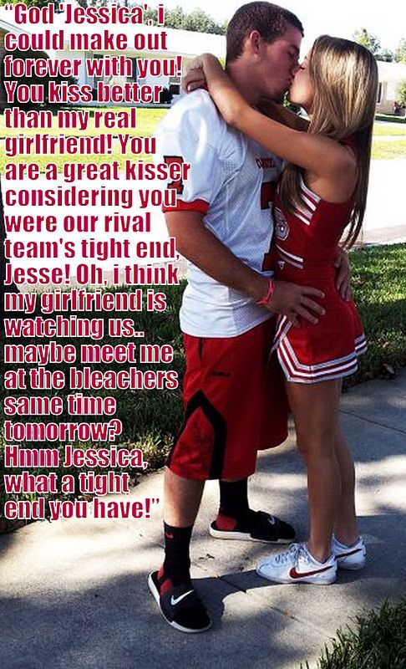

Once it was out it was like a huge weight had fallen from my shoulders. I told my family, I sought medical intervention and I went on hormones. I had to pull out of the team, and in many ways that was harder than you might think. I mean, I liked the guys, but part of the problems was that I liked some in a girly way.

I still like football guys. Now that I am Jessica full time, I am chasing a football guy to be my boyfriend. He is not one of my old team – that would be weird. He plays for a rival team and that seems a little weird too. And I have played against him and he used to mark me! I told him my whole story after our first time out together, and he still has the hots for me. He finds it kind of cool that I know so much about football, and I also know things about pleasing a guy that a born girl would never know.

He is marking me again now, and I just have to let him sack me. It is only a matter of time.

The End

Car Crash  Inspired by a Tiffany Cap  By Maryanne Peters  We never would have met in any other way. We sort of crashed into one another’s lives. I am not sure who was to blame, but it was going be hard for me to pay up.  “Don’t worry,” he said. “My family have plenty of money. The most important this is that you are not hurt.”  He had such a look of genuine concern in those brown eyes of his that I knew that I was in love. I just hoped that he was gay like me. I guessed he was. We just seem to know.  It was just that his family didn’t, or at least everybody but his mother. Her main concern was to keep Antony’s homosexuality a secret, by any and all means.” | 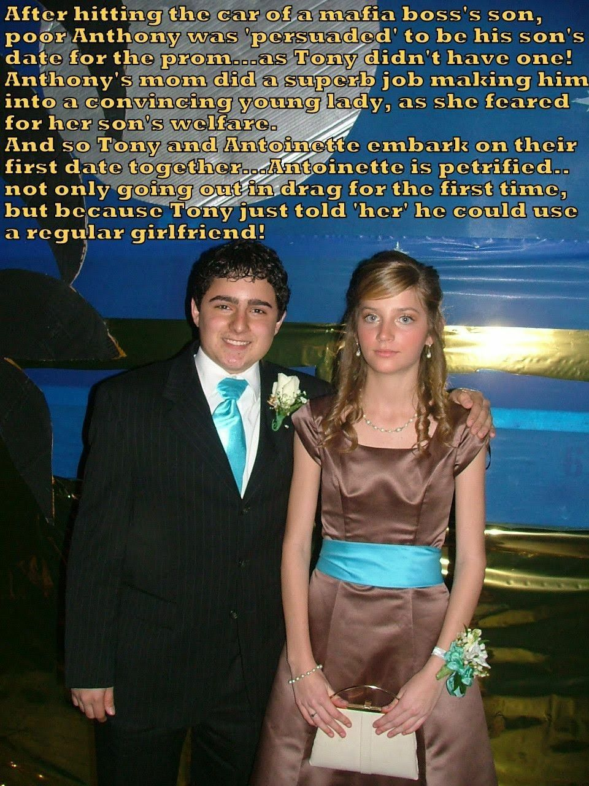

“The thing is that you would make such a pretty girl,” she said. “Not the kind of girl I want my son to marry. He needs a good Italian girl. But with that blonde hair and those blue eyes you could be his girlfriend or his mistress. That would be OK. I can tell you what not OK, and that is that my Antony would have a boyfriend. In our family that would be the end of his career in the family business, and maybe his life ”

I was polite. I talked about how the world has changed and that gay relationships were now fully accepted by society.

“Not by ours,” she said. “You don’t understand, my Dear. We are a special family – one of several. Our families are steeped in tradition. We have our own rules and our own way of doing things. These traditions cannot be broken. We have our own society, and the rules cannot be broken. If they are then death is certain.”

My blood suddenly ran cold. I knew exactly what I had crashed into the day before. Tony’s family were the mafia. She didn’t have to tell me.

“I need a date for the prom, Mama,” he said to her. “Any Tony here is going to be my date. He has already said yes. To hell with what others think. I need to be me.”

“You can be you, but just not gay,” his mother said. “If you want to take blonde Tony here to the prom as your date, there will need to be some changes made. But don’t worry, we have a few days and we have the skills and resources.”

At that stage I just wanted out. I wanted out of this house, I wanted out of being his date to the ball, I wanted out of any thoughts of love. I was not about to get involved with the mob.

But Tony had different ideas and so did his mother. I was trapped. What could I do?

Yes, that’s a photo of us about to head of to Tony’s prom dance. His mother spared no expense with the hair extensions and make over, and that is a designer dress. Plus I had an intensive deportment course to chip off any masculine behavioral traits.

Tony looks as happy as he is, and me … well, I was told to smile but if I look nervous, that would be because I was terrified. I am not talking about the fact that it was my first time in drag, but the fact that Tony is talking about making this a permanent arrangement. He wants me to work with him in the family business and be his regular girlfriend.

It is tempting. I mean he is adorable. And he is rich. I after that prom night I discovered that I quite like being a girl, provided I am a rich one. But then there is the slight issue of the threat hanging over us. I can never be caught. Tony can never be caught.

This relationship is a car crash.

The End

© Maryanne Peters 2023

