Afterparty  Inspired by a Captioned Image  By Maryanne Peters  If I had more money, I could have afforded a proper outfit, but instead I could only afford to buy that tiny little dress from the second-hand shop and a pair of panty hose. I could not even get a wig – I had to use my own hair! It was long enough to wear it up with some decorations from my sister’s dresser, plus some of her makeup applied with a bit of help from YouTube. I was quite pleased with what I had done, but things got weird when people did not recognize me. Even the friends who I went to the party with did a double take. One even accused me of being my own sister! | 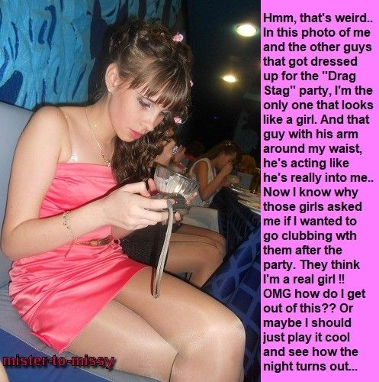

When I looked at the image on my phone, I guess I could see what the problem was. Like I said: I was the only one of the group who looked like a girl. And that guy Alan who is the one with his arm around me in that shot, looks like his is smelling my hair!

It seemed like every guy who was there was acting weird around me. Guys who knew me weren’t laughing like they were with the other guys in costume, they just looked uncomfortable. Guys who didn’t know me looked confused or worse still, desirous.

I didn’t know most of the girls at the party, but because things were getting awkward with the guys, I ended up chatting with them instead. They were talking about how pathetic the guys were and how badly they dressed and acted. It suddenly occurred to me that they were talking to me as if I was a girl!

It seemed crazy. I was not even trying. Well, maybe not, but when you are wearing a dress like that, and when your legs and shaved and looking long and lovely, and your hair has been washed with that floral shampoo and is worn up, well, you just behave differently.

“Let’s get out of here,” one of them said. “I know a place nearby. Girls get in for free. If those guys want to follow they can stand in the queue and pay the cash.”

Like I said: I could have walked off back to the guys, but somehow, I felt that I belonged with them – the girls I mean. I thought: “Free entry to a club - Let’s just see how the night turns out”. To be honest I felt a bit safer with the girls too. It was something about the way some of those guys looked at me that made me feel uncomfortable.

I managed to follow them down the street in the heels I had taken from my mother’s closet. They fit me well and they were a shade of darker pink that were perfect with the dress, but they were high.

We just breezed straight past guys and couples waiting to get in. Girls on their own make a club a destination, but that doesn’t mean that you have to hook up. We all seemed on the same page. “Hey Buddy, look but don’t touch. We are not that kind of girls”.

I like to dance, and I think I am pretty good, even in high heels. We danced together and some guys were dancing with us and buying us drinks. I was thinking that I could get used to this. I could do the same thing next week. I had proved that I could pass as a girl, and girls have fun. All the guys in the club seemed so serious. We girls (weird as that might sound), we were just out for excitement of it. I started to look at guys as if I was not really one of them.

Then before I knew it, the guy from the party appeared. You know, the one who put his arm around me and gave me that look.

He introduced himself as Blair. He confessed that he had followed me to the club and had been waiting to get inside for almost an hour. He said that he could not take his eyes off me at the party, and that he would follow me all night to get my phone number.

I went to the ladies’ room with some of the girls. That’s what we do. I sat down to pee and gossiped through the stall door. I told them about Blair, and they said that anybody who is that dedicated should be given my number. The ones who had seen him described him as “a hunk”. I guess he was.

All the girls said that meeting a girl at a party is not a date. He should not expect anything more than a parting kiss. I have to say the thought of that seemed disgusting.

So I went back out and gave him my number. But I told him: “I warn you that I am not the same person in the daytime. I am sure that you are not going to want to know me when you meet the real me.” But he seemed ready. Saturday in the park. This Saturday.

It was time to endure that parting kiss. I was ready. He held me close and tenderly and my face was softly drawn to his. I just melted. There is no other way to describe it. I just became like a rag doll in his arms – a soft feminine rag doll, with his tongue exploring me. A wave of pleasure came over me. Something terrible had happened. I had become gay.

And now there is barely two hours before I am to meet him. There is a dress, or there are my t-shirt and jeans. Should the dream continue until one of us wakes up, or should I confront him and invite him to be gay like me? Even if he was, there is something that makes me think that I don’t want to be a boy anymore.

What am I to do?

The End

The Recital  Inspired by a Captioned Image  By Maryanne Peters  I have never been more scared in my life, nor more excited. I knew that I could not live my life until I had taken this leap into my future. What we ballet dancers call a grand jeté.  My parents had no idea that I had been rehearsing for one of the lead roles in the ballet, and rather than being a male supporting dancer, their son would appear on stage as a ballerina. This had been my dream for most of my life – to dance as a girl. | 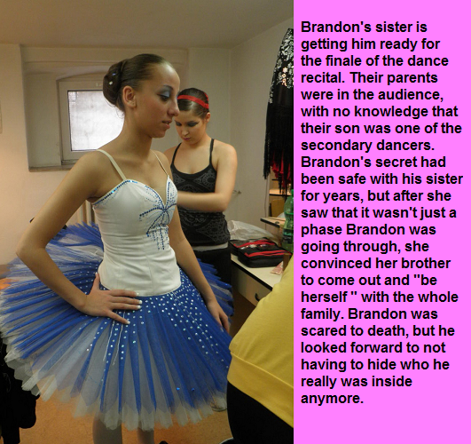

It was all thanks to my sister. She had helped me to conceal the changes from my parents, even though they seemed to obvious to me, and to the other girls that I danced with.

I needed to grow hair, just long enough in the front and at the sides, to pull it back and clip a braided bun hairpiece in. And I needed to take hormones to grow enough breast to make (with quality inserts) a convincing cleavage for the costume that I would be wearing. And I needed to work on my skin, keeping it smooth, hairless and (with the assistance of the hormones) soft for my delicate appearance.

After helping me behind the scenes, my sister took her seat beside my parents.

“Where’s Brandon?” my mother asked her after all the dances had appeared on stage.

“That’s him in the blue tutu,” she said to them. “Or rather that is your new daughter Brenda. Look how graceful she is; how feminine her movements are.”

She said that my parents were in shock, but they were transfixed. As I leapt my father must have noticed that my groin was smooth. How was he to know how well I had shrunk my bits and how skilled I had become at taping them into nothingness? He might well be horrified by not as much as I might have been had they worked loose in the middle of my performance.

At the curtain call, I saw them in the audience and blew them a kiss. Then my father stood and applauded, followed by my mother and sister. I could see the pride in his eyes, and I burst into tears of joy.

The End
Nerdy  Inspired by a Captioned Image  By Maryanne Peters  Don’t tell my sister that I said it, but I think that I turned out prettier than her. I have her to thank for my skin. I always had problems with my skin. It turns out that it was those male hormones. Now I have got rid of them I have perfect skin.  I think those hormones were making my hair greasy too. It does that for some guys my age. The blockers have been great for my hair, together with a proper hair care regime and quality shampoo and conditioner.  The prissy look with the cardigan and the patterned tights and bows on my shoes and bag was down to her, but that is no longer my style. | 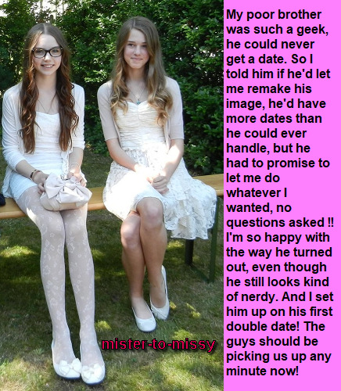

Sometimes I think that look was just to keep me a little less sexy than her, and I guess she was right. The ultra-feminine look helps to keep me from slipping into any male habits, and when you are guy pretending to be a girl, you don’t want that.

Of course, she didn’t tell me what she had planned until she had me well down the path, but I have held her to some pretty shitty bargains before, so I could hardly go back on the promise I made. The only condition was more dates than I could handle, and that didn’t seem likely.

It was not just the bad skin and the long greasy hair that had me at a disadvantage. The truth is that I was painfully shy. I could only talk by sending messages through my computer. Put me in front of people and all I can do is sit, and stare and maybe smile. It turns out that that is the very thing guys look for in a date. A girl who just sits and stares at them, and smiles when they tell a joke.

Guys want other things from a date to, and it turns out that was not such a big deal either.

Mom took the photo and she said: “Larry, are you sure you want to do this?”

My sister said: “Call him Laura, Mom”. I am smiling, but I guess my sister is thinking: ‘This is going to be an interesting evening’.

Cole and Andy picked us up in Cole’s brother’s car. I sat in the back with Andy.

“How come I haven’t seen you around before?” he asked me. I smiled at him and took his hand. He wasn’t offering it. I just reached over an took it.

“Laura is my cousin,” my sister said, building a story. “She might be coming to go to our school, if she can make some friends.”

Andy looked at me quizzically. I smiled. I have checked it in the mirror. It’s a good smile, especially with a bit of lip gloss.

“I sure hope you come to our school,” said Andy. I smiled.

Andy talked and I listened attentively. I can’t even remember what he talked about. Sports he played, I think. I don’t know anything about sports. Just like a girl I suppose.

We went to a movie and I snuggled up next to him. He liked that. He put his arm around me. I think it is the first time that anybody out my family got that close to me. It was better than any of them, except my Mom of course. Uncles and aunts are smelly, and Dad too. Andy smelt good.

We went to the diner after the movie. I had to speak my order. It was a squeaky whisper. Just like you would expect from a girl in white tights and bows. I turned to Andy when I finished and he was looking at me as if I was a goddess. Who can’t be effected by a look like that? I smiled at him.

“Tell me about you, Laura,” he asked.

“I am a nerdy girl,” I said shyly. “You are a rock-star athlete with a huge personality. I want to hear more about you.” Under the table I reached over and stroked the erection growing in his pants. I smiled. He had to hurry to the Men’s Room.

I like Andy, but some guys are so shallow. He came back to the table and started talking again. He was talking and my sister was talking. I could see Cole looking at me and thinking: “What is this bitch talking about - I wish I was with her.” Meaning me.

He must have said something at school the following day, or maybe it was Andy, or both, because all the guys were talking about Laura, the girl who is the cousin of what’s-his-name. Well, what’s-his-name was invisible again, with some oil in my hair and a cap on my head and few spots drawn on my face by my sister. Larry the nerd.

More dates than I could handle was what my sister promised. If two guys want to take you on the same night, and you don’t know which to choose, that is more than you can handle. Not surprisingly Larry dropped out and was never seen again. Laura came to our high school.

The End

Genius
Inspired by a Captioned Image
By Maryanne Peters

I am behaviorial scientist, and a good one. I may not look like one, but that is all part of my research strategy. I cannot get the information that I require if people know that I am studying them. The questions that I am asking would sound odd if they were coming from the mouth of anybody who did not look like I do. Now those questions might sound dumb, but I assure you, every question is calculated to build the data that I need, and every answered received is recorded by me for later.

My biggest problem was that I was a guy, but science has a solution to every problem, if you work hard enough on it. The fact is the human body develops in the womb without sex, and that sex develops only relatively late in the womb. Why do men have nipples? They have no purpose. They are the vestigial trace of our early form during gestation. To acquire the appearance of a woman only requires the application of biochemistry.

That looks after the physical side of things, but to truly develop the form of the scientific questioner requires knowledge of the behavior or women. But that is my field. I am behaviorial scientist, and a good one. I observe – I imitate.

The casual hair, the hoop earrings, the huge cleavage, the pouty lips, the come-to-bed eyes – they are all part of the look to enable me to interrogate in a relaxed atmosphere so as to achieve total candor from my subjects. Every now and again I am required to go a little further to achieve further easing of any inhibitions, and I have discovered that fellatio is a useful device.

As a scientist I know that such activity presents no significant health risk provided that sanitizer is used under the pretense of being lubricant. Because it is alcohol based there is a slight risk of modest intoxication by inhalation, if there are multiple incidences, but I find that subjects are more open to being frank with their answers if sexual gratification is assured.

Gurgitation is recommended to eliminate messiness. The taste is not unpleasant. It is an organic secretion and does have some nutritional value.

And of course, I get the information that I need.

The only complication is that some of the subjects tend to become attached and somewhat persistent. I have discovered that the easy way to deal with that is to return to a public place (for the purpose of safety) and to reveal that I am in fact, a man. If necessary, I can prove the fact by lifting my feminine garment and showing them my male genitalia, although that is becoming increasing hard to fully make out.

Most recently, one subject, whose name is Garfield Laramie Hudson (but I call him Gary) saw what I had and took hold of me and kissed, for a very extended period of time. He is an extremely strong individual with very attractive sandy hair. I found it very hard to resist him in public, and even harder when he took me back to his apartment.

Anal intercourse was not something that I had anticipated in taking part in when I started this study, and it is not to be recommended without proper preparation, but now that Gary has forced his way in, so to speak, the door is more or less off its hinges.

I seem to be spending more an more time inside Gary’s place, almost as much time as he spend inside mine, as it were.

I am behaviorial scientist, and a good one. But I have to admit, I appear to have completely forgotten what it is about human behavior, that I am actually studying.

The End

Jilted
Inspired by a Captioned Image
By Maryanne Peters

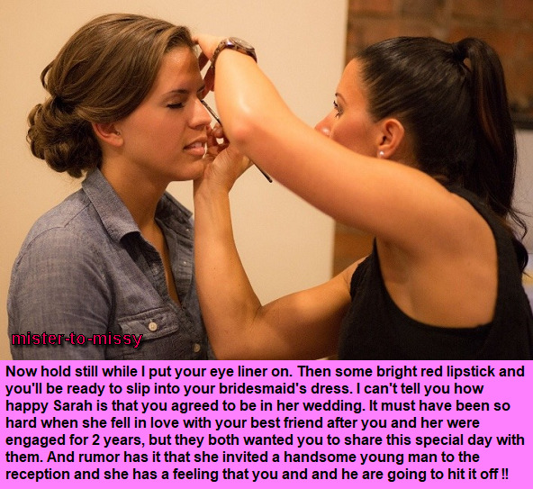

She abandoned me, but I would still do anything for her. It sounds so pathetic, but that is the way I felt. There was no chance of winning her back. It was her wedding day – the day she would marry Jason - the guy she dropped me for. And yet I still nursed some forlorn hope that she would see what I was prepared to sacrifice for her and love me for it. Even if she married him, she might still love me, in some lesser way. Maybe that would be enough. It does not just sound pathetic. It is pathetic.

My friend Jason was the opposite of me. He was the boisterous one – the more manly. There is no doubt of that. His view was that she only went out with me because she was sorry for me. Even taking my girls has not broken our bond. We talked about it. He explained that it was her choice, not his. He says that maybe if she had not already told him that it was over with me, never would have gone with her, and he never would have fallen in love with her. But that is what it is, he says. It certainly seems that way.

He said that she wants a guy who will look after her. He said that is not who I am. I need somebody to look after me. The way he says it, I was like a stray puppy that she picked up and cuddled for a bit. It is like I was never really her boyfriend, so why should I feel jilted? I know that he is just trying to comfort me. He said that if I did not want to come to the wedding, he was OK with that.

“But you’re not inviting me. She has asked me to be one of the official party on her side.”

He said back: “No buddy. Her official party are three bridesmaids.”

“That’s right Jason. I am one of them.”

“That is not right, Man. Let me talk to her.”

“No Jase. I want to do it. I want to be part of her team. I want her to know that even if she does not want me, I will be there for her, in any capacity she wants me,” I told him.

“I can’t believe that she is ready to humiliate you. I love her, but this is so not cool.”

“She is arranging everything so I can participate to the full,” I explained. “I have heard that she is even arranging an escort for me. Some guy called Kurt.”

“I know that guy,” said Jason. “He is on the football team. Rich and smart too. But there is a rumor that he might be gay, or at least bi.”

“Why would she put me with him?”

“He is actually a really nice guy. A bit like Sarah. Picks up strays and like looking after them. Maybe Sarah is just trying to soften the blow. Not that she has ever experienced, but I guess she understands that it sucks to be jilted.”

The End

© Maryanne Peters 2020

