Goaded on Purpose
Inspired by a Captioned Image (by who?)
By Maryanne Peters

It was all my fault, even though this thing must have been lurking inside him all along. But what irked me was that he was just like all the other guys: They have no idea what we have to endure and the price that we have to pay, to be beautiful. Except he wasn’t like all the other guys, was he?

He could have backed out. He should have backed out at the waxing. Just like a guy to be too stubborn to admit they were wrong. But Alice is not like a guy at all. Not now.

When they took his long dark hair and put in the red tinge, and then cut bangs that were so unmistakably feminine he should have screamed: “No! Enough! Give me a buzz cut!” Any normal guy would. So I guess somewhere along the line Alex faded away.

The pierced ears, the makeup and that flower in the hair pinned up into a loose bun seemed to push him over the edge. I suppose that means that it was going to happen one day.

“Alice” could not wait to get home and get out of those boy’s clothes. That even meant cutting his T-shirt off so as not to ruin his hairdo. Then running and going through all of my things as if they were his own.

“Oh Rachel they have made me so pretty!” he said, or is it she?

The worst thing was that Alice looked better in that dress than I do. And then she managed to squeeze into the tan heeled sandals that set it off perfectly, with legs so much nicer than mine.

It looks like Alice is here for the summer, and it is all my fault.

The End
Traded
Inspired by the following Captioned Image (if you know the author please leave a note)
By Maryanne Peters

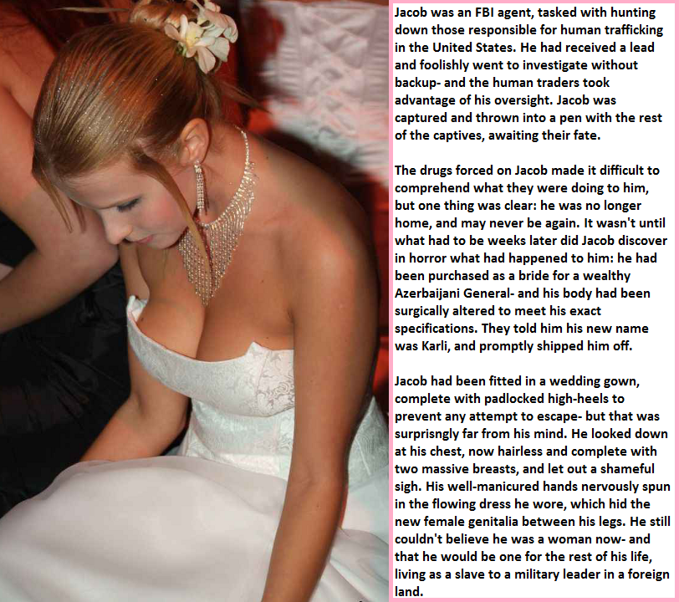

Abdul said that he had always wanted an American bride – one who was blonde and busty. I had naturally fair hair, and I really is that color now that it long. But the bust is not natural.

I travelled to Azerbaijan and to the Russia province of Chechnya to get information about a human trafficking ring operating on the West of the Caspian Sea. I had studied Russian, so I was there to support a senior Special Agent mainly as an interpreter, but I have to say it: But it soon became clear that he was not there to chase the criminals to ground. Instead it seemed to me that he was just taking an international trip on the bureau and killing time until retirement. I felt for the victims and I was keen to get to the bottom of this case.

So, I made some waves. But waves bounce back, and they came right back on our two man task force. It was made to look like an accident. Our car in the river, the body of my colleague found, dead before the car left the road. My body missing, presumably swept out into the Caspian Sea.

But I was not dead. I was classed as meat able to be sold, as I can crudely translate the phrase. And given I spoke Russian I was suitable for the domestic market. All that was necessary was for some modifications.

Everything is available in Baku. You can buy women; you can buy boys; you can buy women who were once boys, you can buy the surgery to do that. My captors were ready to make the investment, because they had a buyer in mind. When I woke up in pain, with breasts on my chest and my groin slashed and inverted, they told me that the deal was already done.

I was sent to recover to a place that was no so unpleasant. It faced out over the sea with cliffs as a natural barrier, and walls where there were no cliffs. I was told what I needed to do to ease the pain, present and future.

I believe that there are two types of people in this world: Victims, and those who choose not to be victims. I put myself in the latter category. That meant that if he wanted a wedding (I was to be his fourth wife) then I would go through with it. I would bide my time.

Looking back at the image you can see some inkling of my distress, but even then in all that finery with my face made up, I had no full appreciation of just how beautiful I was. I discovered that only when I looked in Abdul’s eyes for the first time, standing before the mullah. I had imagined him as some kind of drooling sex fiend with the wedding just a cruel and humiliating performance. But that was not what it was at all. It was a statement of commitment, and where mine was for expedience, his seemed genuine.

Sometime has passed since our wedding day, and I am not the slave to a military leader in a foreign land as might have my lot. I will not be a victim. I am intelligent, well-educated and I now speak three languages – English, Russian and Azerbaijani Turkish. And I am beautiful, and I have learned to carry myself in a manner that is the very opposite of a slave, with a haughty indifference that appears to everybody to be a sign of class.

Everybody but Abdul that is. He loved it to start with. He told me that my coldness was a mountain to climb, but that he was a mountain climber, and he had conquered every peak he attempted. I would not have thought it possible that he could conquer me, but he did.

You see, I like sex. I mean I have always liked sex, but I like sex as a woman better, and sex with Abdul in particular.

Because a military man should use his position in a country as corrupt as Azerbaijan but not soil himself in matters of business, my skills have seen me take over control of his commercial activities. He has wives for motherhood but my role is in money and sex. I have found myself enjoying both way too much to consider ever leaving my new home.

The End

Granddaughter
Inspired by a captioned image by TGgirlnextdoor (https://tgirlnextdoor.tumblr.com/)
By Maryanne Peters

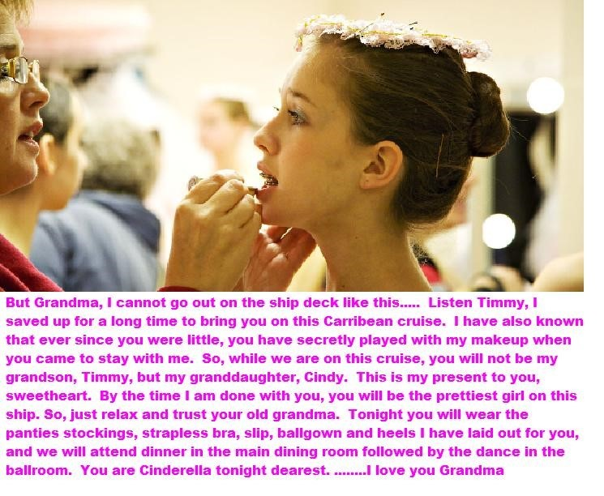

It was my last year in Middle School and because I was off to high school across town at the end of summer grandma offered to take me with her on her cruise around the Caribbean. I had been at camp in the first couple of weeks of July saying goodbye to some friends who would not be going to the same high school, so I had the time to be with her later in the vacation period. Plus, I liked my grandma and liked being with her. She was a stylish lady and a young 68 whereas my Mom was an old 41 and struggling. Both my older brothers were working over summer, so in any event there was no chance of a family holiday.

I went around to her place to wait for the cab and she insisted on repacking my suitcase while I watched TV. She is very organized and I just let her sort things out. I was just wearing jeans, but she insisted that I wear some new trainers and a sweat-top that she had bought me. That was nothing unusual, except maybe the big patch on the front of the top. My grandma buys me things all the time. Mom says it is all we ever get out of her, so take it.

It was not until the gangplank was up and land was just a green strip on the horizon that I learned that things were not going to be anything like I planned. I just figured that I would hang around the pool and catch some sun, and spend plenty of time gaming, and then stay with Grandma on any excursions.

Our cabin had twin beds, but a bathroom for privacy, so it would be no problem sharing. It had a desk with a computer screen and there was internet access, which is all I wanted. It was just that Grandma did not buy the data package. She had other plans for me.

My hair was long. Mom did not like it long, but Grandma always said she preferred it that way, and Mom said that as the favored grandchild I should go along with it. The first thing that Grandma required as it got closer to dinnertime, was that I wash my hair, and that I use her special shampoo and conditioner.

“We need to make a good impression for the ‘Welcome Aboard’ Dinner”, she said.

It was not until I got out of the shower and saw my suitcase open alongside hers, that I knew that I was in deep trouble. There were none of my clothes in there. My case was full of girl’s clothes. I checked her case, which was full of her stuff. My stuff was gone.

On the bed she had laid out panties, stockings, a strapless bra with gel inserts, a slip, ballgown and a pair of heels.

“I am going to blow dry and brush your hair and put it up in a bun,” she said. “It is such beautiful hair. You know how much I have admired it. I have always longed to have you let me style it. Now we have the whole trip to do that.”

Of course I went nuts at her, or as much as I could, it being Grandma. She just smiled and pulled out the hairbrush. I guess I thought that she must have lost it. It happens to old people. But she was implacable – that is the word. She just stood there waiting for me to calm down.

“This is the way it is, Little Lady,” she said. “You are booked aboard as my grand-daughter Cindy and that is who you are going to be for the whole voyage. So just get used to it.”

The End

My Trainer
A Story for John
From one of Sydney’s Sissy Caps

He said that it was hopeless. He said that some guys are just not built to be muscular, and maybe I was one of those. What he meant was that some guys were just not built to be guys at all, and I am definitely one of those.

I told him that I felt unattractive and that I doubted that I could ever have a proper relationship thinking of myself that way. I thought that a buff body would be the answer.

“You are not unattractive,” he said. “In fact …”.

It just felt good to have somebody say it. I sort of hoped that it might be a girl complimenting me. Anyway, he asked me to trust him, and he would help me to have a desirable body, although maybe not necessarily what I was looking for.

I said yes. He took charge. I stuck like a limpet to all of the special shakes prepared for me, and the tai chi type exercise regime focusing on posture and graceful movement. He told me not to cut my hair but to condition my skin with oils and other preparations. The oils felt so good, but all the hair on my legs and arms seemed to fall out.

It was a program like no other, but the best thing was that he was paying extra attention to me. Just me. He hardly bothered with his other clients. It made me feel special. I suppose that we developed a strong personal bond over the months that followed.

He told me that the changes in my body that seemed oddly out of place were a direct consequence of the work I was putting in, and I should be congratulated. He even took me to dinner on occasions as a reward for meeting the marks he had said.

It was not long before I needed to reconsider my exercise wear. I needed a scrunchie and a band for my hair, and a sports bra to keep my tits from bouncing all over the place.

“You look so good I will buy you dinner tonight,” he said. “But you have to wear a dress.”

Somehow, that did not seem a problem. In fact, if a guy is taking you out to dinner and you are wearing a dress, why not get your hair and makeup done too?

So, it turned out just right. I get to enjoy a strong masculine body. It’s just that it is his, not mine.

The End

Sharing Experiences  Inspired by a Captioned Image  From DanisTGCaptions Deviantart  By Maryanne Peters  It seemed too much to believe that there were at least four of us in the same position. I mean, you read about it is the fetish pages or whatever, but you think that nobody could have done to you what she did – your girlfriend. I mean, why? Why would she do that? Why did she do that.  She said that I was a macho pig. She said that I needed to be taught a lesson about what it is like to be not a man – to be a woman. But this seemed to be way more than I deserved. It seemed so cruel, at least at the time. | 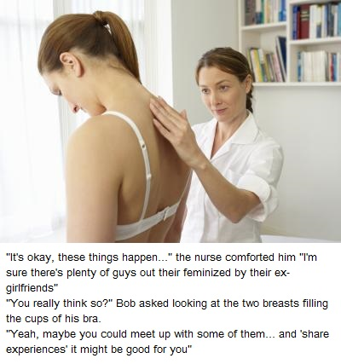

It all happened so suddenly, or so it seemed. My body hair fell and my muscles wasted away in only a few weeks. And then my breasts started growing. It still seems weird to call them my breasts, but nobody can deny that is what they are.

My hair was my own. I had always worn it long. When I looked like a man I wore it tied back at the neck, or sometimes loose , but now I wear it is a high ponytail or even a messy bun. I have come to terms with the way I look, you understand? We have to, looking the way we do.

It always helps to know that you are not alone. The doctor put me on to Kaylee, and between we put out the word and two others in the same neighborhood joined our group. We call ourselves BRETHAW – Boys Radically Emasculated by Their Heartless Alpha Women. We meet regularly.

What do we talk about? Oh, the usual stuff – learning to cope with breasts and with moods, learning makeup skills and how to style our hair, keeping up to date with fashions.

But most of all we learn how to be independent. We have all learned how to leave them behind, the women who did this to us – now very definitely our EX-girlfriends. Not just because we hate them for what they have done, but also because all four of us have found ourselves suddenly interested in boys.

The End

© Maryanne Peters 2021

