Mother Daughter Not  Inspired by a Captioned Image  By Maryanne Peters  After my oldest son went to college it was just me and Sam. He was nothing like his older brother. He was small and gentle, and less interested in sport and being a winner. We were not as close as we should have been, and I was keen to put that right. The truth is that I had more in common with his older brother. Sam was his mother’s son, but she had died in his first year in high school. I was his only parent and for him I was not the parent I should be. Perhaps that is why I went along with his crazy idea.  The school had run one of those mother daughter pageants the previous term and Sam was one of a small group of guys who protested alongside mainly girls that this was sexist. He floated the idea of there being a womanless mother daughter pageant. That meant him dressing up in drag, and me doing the same!  It just seemed like it was the opportunity to do something to get closer to my boy, but as the day drew near it dredged up all the old feelings that I had suppressed for decades. | 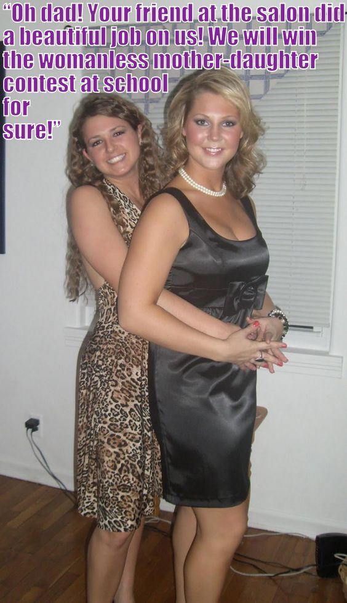

I had never mentioned anything about my experimentation with crossdressing when I was young. Why should I? It was a part of my life that was over. I was a man, a husband to my late wife and a father to my sons. The truth was that dressing was not a kinky this for me, so it seemed easy to just quit doing it. What I did not fully understand was what it had all been about.

But I did say to Sam that I did not want for us to look like a couple of drag artists. To me that would be demeaning to women, and my late wife in particular, because it was her clothes that we pulled out of the attic as our costumes. The leopard print for Sam was perfect, but for me the black dress was a little too revealing to work. I needed to have breasts.

As it happened I was carrying a little too much weight, so I went on a crash diet but I did my best to keep my “man boobs” by dosing myself with my wife old birth control drugs. It sounds stupid, but it was just that I wanted to wear that dress and I wanted to honor the memory of the only woman I had ever loved.

I told Sam that we should get full body makeovers including waxing and hair extensions. If we were going to be a male mother daughter pairing, we were in it to win it. Sam accused me of getting carried away, but he went along with it.

We were a knockout. The photo tells the story. Sam’ friend Jack and his father Paul barely even tried and even slipped of their wigs and frocks straight after the show, then washed their faces and put on male clothes.

“Sorry, these are the only clothes we have,” I explained with a smile. “We will just have to totter home in our high heels.”

“Actually, as you look so good it would seem a waste not to continue this evening a little longer,” said Paul. “Why don’t we all go for a late supper on me?”

I have only loved one woman in my life, but I now understand that I was waiting for the right man, and he could only appear when I accepted that I was truly a woman and presented myself to the world as that. My desire to wear women’s clothing was not driven by a fetish but by the desire to live in my true gender. It all became clear that night.

But the crazy this was that Sam discovered that he was just the same as me. It turned out that we were as close as a parent can get to their child.

And he has ended up close to Jack as well. We are talking about becoming a blended family, and a very unusual one at that.

The End

© Maryanne Peters 2023

Cadette  Inspired by a Captioned Image by Tiffany  By Maryanne Peters  We don’t normally accept girls with penises, but in the case of Victoria I was prepared to make an exception. I knew her mother, and I knew something of the huge problems that her boy Victor had created for her.  He had fought the notion of discipline, and he was not about to get his long hair cut off. As it happens it was just the right length, and it took the perm well.  All I required of her was that she put the lad on “vitamins” for at least 4 week prior to the intake. If I was bundle Victoria in with the other girls I needed to make sure that penis was purely decorative, and stayed snuggly concealed in the pantyhose under her dress uniform. | 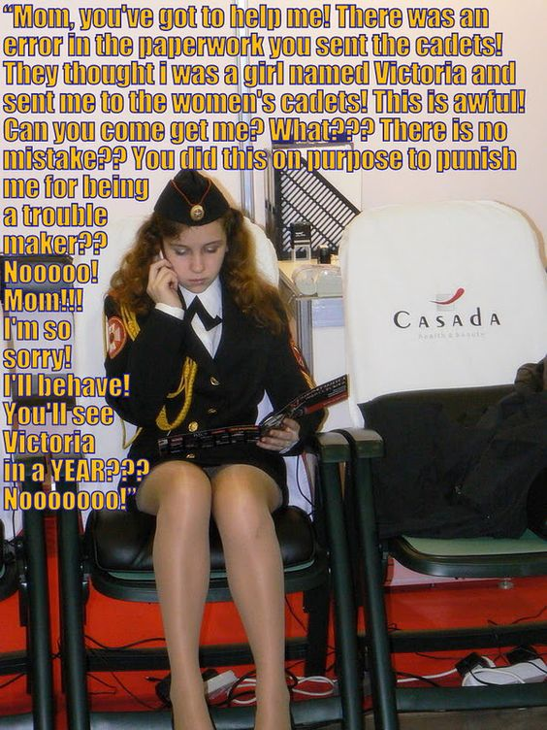

Of course, Victoria was horrified when she discovered that her only way out was blocked by her mother’s firm resolve, but as I impressed upon the new girl, it is not a full year, and time will pass quickly so long as she is prepared to fit in.

As it turns out, she has responded remarkably well. That hair certainly helps. The girls love to arrange one another’s hair. You could almost be forgiven for forget that Victoria has something in her panties that does not belong there.

Anyway, I suspect that I may not be there for much longer.

The End

The Hoover Effect
Inspired by a Captioned Image by Tiffany
By Maryanne Peters

I didn’t know much about J. Edgar Hoover when I signed up for the FBI. I just knew that he had set up the Bureau, and that he was known as a conservative hardass. I certainly knew nothing about him dressing up as a woman and being “married” to this guy Clyde Tolson – his deputy. I would not have believed it of the man I thought he was.

Then we heard that this guy Edwin Hoover had taken over as head of the Bureau. It was said that he was the grandson of J. Edgar, but I knew enough to know that was not right – Hoover had no wife and no kids. He was not interested in women, except being one of them, as I learned.

But Edwin was a Hoover and he was obsessed with the man. It was like he believed that J. Edgar’s weird inclinations were the key to his success. He seemed to think that having agents emulated his relative (if he was related) would somehow make us better – “The Hoover Effect”.

It was not alike all the agents were asked to cross dress – just the ones who could pass; just the wones who made attractive looking women. It turns out that I was one of those. I never would have believed it until it was done, but I had to agree. I was a knockout!

“I have high hopes for you, Tom,” said Edwin. “But you will need a new name … Tina. Tina Smith. When you get out there into our counter-espionage team, I am sure that the Hoover Effect will reap rewards. I believe in it – don’t you?”

What was I going to say? “Hey, you’re crazy!” Hell no. “Yes, Mr Hoover. I believe.” I have always wanted to work for the FBI and now I do. And I look pretty good doing it.

But if Edwin is related to J Edgar he sure didn’t inherit the man-loving thing. That guy has fallen for a woman. It is just that the woman in question is me. I mean, who wouldn’t go for somebody who looks as good as I do.

It seems his high hopes were right. It must be the Hoover Effect.

The End

Rich’s Girl
Inspired by a Captioned Image by Tiffany
By Maryanne Peters

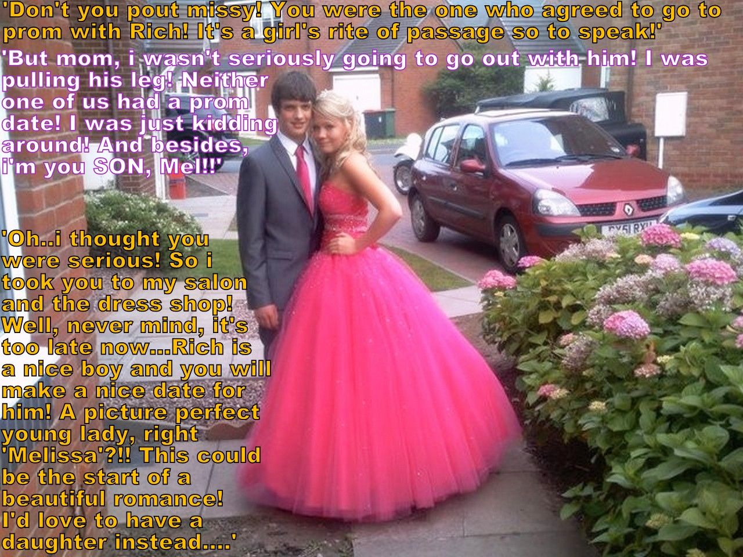

My mother said that I was being deliberately cruel, and that I needed to carry the consequences of my awful behavior. I pretended to be “a secret admirer” who would go to the prom with him, revealing myself just before the big night as the practical joker who was always teasing him, and leaving him without a date. I was never going to go to the prom anyway, so it did not seem like such a big deal.

Rich was the kid next door, and he was always being helpful to the neighbors. Mom thought he was great. She kept saying stuff like “if only you were a son more like Rich – he is such a nice boy”. It ground my gears whenever she said it, and that was all the time. He needed to be taken down a peg or two.

Rich and I were different. We did not get on. I guess I was trouble. I was withdrawn, I suppose, tied up in myself, inclined to troll people and send out mean anonymous tweets and posts. It was like I did not really know myself, but what I did know, I didn’t like.

So Mom’s idea of just was that I should be the secret admirer that I pretended to be. She said it was only right that I fix things for Rich and suffer bit for it. She arranged everything.

Why would Rich agree to that? Because she had gone to all the effort, is what he said. Like I said, he is a nice guy and always trying to please. If my mother and his thought this was the way to go, he was ready to go along.

He tried to please me too. He said that I made a beautiful girl – more beautiful than all the real girls at the prom. It seemed like he meant it. He tried to please me and he did.

When we posed for that photo Mom told me to smile. She said that she had always wanted a daughter. She said that going to the prom as Melissa with Rich could be the start of a beautiful romance. I just sneered, but when Rich pulled me in close, I did smile. There was something about the strength of his arm and the smell of his neck that made me feel good.

I don’t know whether Mom could have known just how right she was, or perhaps mother’s do. I was depressed as a boy, but after that night at the prom, and what Rich did to me afterwards, and don’t think I will ever be a boy again.

I am not withdrawn and mean anymore. I am out and I am happy. I am Rich’s girl!

The End

Her Fault
Inspired by a Captioned Image
By Maryanne Peters

She has her own idea of what happened and why, but let me explain what really went down.

Yes, it was that Halloween outfit that did it. Frank was bowled over, and for the first time I realized that I could make it as a woman – the woman I had always wanted to be.

It was so weird the following day. He asked whether he could speak with me privately. He told me that after last night, he didn’t think he could look at me the same way ever again. All he could think about was the woman hiding beneath the man sitting in front of him.

I confessed to him then and there. I told him that I was transgender, but had been fighting it all my life. My proposed marriage was just one way to suppress the person I truly was. I burst into tears, and he held me close. That was how it started.

The problem was that I cared for my fiancée too much to just leave her. If we were to call it off then it would be her choice. I am proud to say that I honor my commitments.

That was when Frank suggested that I dress as a woman once a week. He said – “Tell her that I am making it a condition of your continued employment, and it is her fault for turning you into such an irresistible woman.”

He also said that he had another line of attack in mind. He could introduce her to a wealthy friend of his – not as wealthy as Frank himself, but wealthy enough to impress her. “From your description of her she strikes me as that kind of woman who might be interested in men like that.”

Frank offer to help me fund my transition. I got started with HRT straight away and within weeks I ceased to function as a man in bed, and that was when she started to look elsewhere. I then told her that Frank had set new conditions and now not only was I taking hormones but I could only present at work as a female, and it was all her fault.

The truth is that laying the guilt on her this way was getting me down so I told her that Frank had proposed marriage but that I had told him that I was committed to marry her. She did not go for it immediately but it seemed to me that it was only a matter of time. Regardless of whose fault it was she was engaged to a man who was rapidly turning into a woman.

So she finally admitted that she was seeing somebody else and released me to get engaged to Frank. Bt it will be a long engagement as we are agreed that I need bottom surgery to be fully healed before the wedding. Until then I am happy to double date with her and her new man. I am sure that she will find out in due course that it was not her fault at all.

The End

© Maryanne Peters 2023

