Objecting  Inspired by a Miles Cap  By Maryanne Peters  Lots of guys say worse things than I did. I mean women like being looked at by guys. They like to dress up and paint their lips and make their eyes look big. They like to style their hair and toss it in our faces. They wear short skirts that just invite us to think that their pussies are only just underneath. They are trying to attract guys – right? It’s not me; it’s them.  I am just a regular guy. Or at least I was when all this started. I just looked at a few sites. Not real porn. Maybe some slapping and humiliation. Not much. | 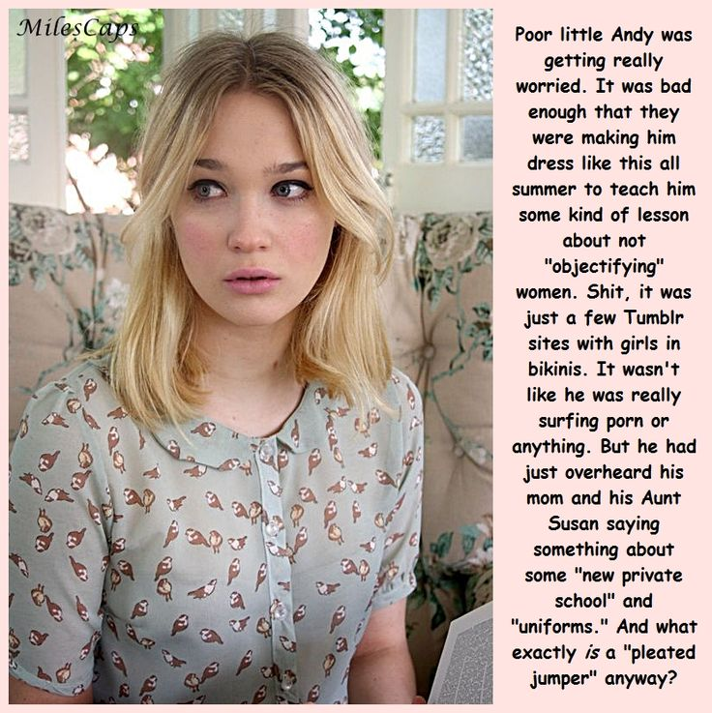

Whatever it was, its sent Aunt Susan off the deep end – big time! I mean, she is a lesbian and a feminist, whatever that is. Mom did warn me not to piss her off. She said that Aunt Susan was to have complete authority over me while she was in Europe for the summer. She said that nobody else would take me in and that she owed her sister for agreeing to take a boy into her home for the whole four months.

So, when Aunt Susan decided on this whole dress-as-a-girl thing just because I looked at some sexy images, Mom backed her and told me over the phone that I had to do it.

My hair was long and bleached by the sun, so Aunt Susan just parted it in the middle and told me that I could not leave the house unless I wore make up, and a dress or a blouse and skirt, with women’s underwear on underneath!

I thought that the worst thing was, was the fact that I actually looked like a girl. I mean no guy likes to look like a girl. But as my Aunt Susan said – “If nobody thinks that you are a guy, what is there to be embarrassed about?”

Not only that, but she said that I could go out with her as her niece, whereas she would never be seen dead with a boy in tow.

At first I thought – ‘why would I go anywhere with this bitch’ but after I while I was getting stir crazy, so I agree to step outside wearing a dress and some girls’ sandals.

“People are staring,” I said. “They know.”

“They don’t know anything,” she said. “They are male. They are looking at you like a piece of meat. They are all the same, men and boys. They think you are a pretty young girl and they are mentally raping you.”

Like I said - she is a lesbian and a feminist, whatever that is.

For a while I could see it from her perspective. Like, I could understand why a woman might not like to be looked at the way I looked at the images on the internet, but let’s face it, nobody was looking at Aunt Susan. She is butt ugly, whereas I am pretty – I guess. They were staring at me.

It didn’t feel like mental rape. In fact, I kind of liked it. And when I could see that fact wound up Aunt Susan big time. I may have doubled down, giving a couple of guys a wink, and tossing my hair a little.

“I saw that,” she said. “That is objectionable behavior. You are leading them on.”

Like I said, that is what women do. Right?

The End

Being Her Bride
Inspired by a Captioned Image from Miles Caps
By Maryanne Peters

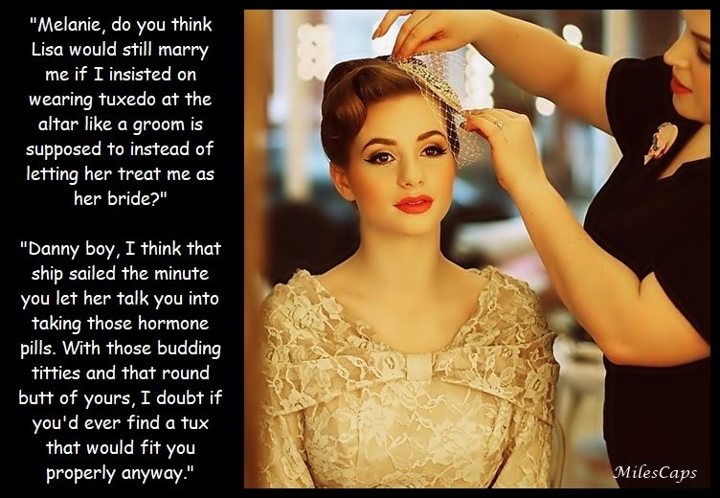

I can’t be the first guy who fell in love with a lesbian – can I? I can’t be the first guy who agreed to perform sex with a lesbian girlfriend as a woman? I can’t be the only one who agreed that if I entered her with my penis I would make girly noises and then receive her with her strap-on? Can I really be the first who agreed to dress as a bride on our wedding day?

Love is a powerful thing. It drives you to do things that you never felt were possible. And it seems that sometimes it can be all one way. I like to think that love only works if she feels the same way about me as I feel about her. Maybe it was that way at the beginning. She saw something in me that made he want me despite the fact that I was a man. Maybe it was my long hair, or my eyes or pouting lips. She said that it was something else - the woman in me that only another woman could see. She said that if I allowed that woman to come out, we could be together.

Like I said, love can drive you to do things. I knew they were female hormones. I just believed that they would make our sex life better. In fact they made my dick all but disappear, and from then on I was only there to receive or to eat her out, which is just the way she liked it.

She would call out my name – “Danny, Danny” … or maybe “Danni, Danni”. Surely we had found a way to be in love with each other, with all that I had sacrificed to be hers.

I thought that she would wear a wedding dress too, but she wanted to wear a white suit. I should be a bride in gold, so as not to clash with her. It was a beautiful dress. And my hair and makeup looked perfect.

All of the guests that were my friends had learned that I was be the bride, and she was … well, I suppose a genderless person. Why couldn’t I be that? I could be a man in a tux just for the wedding and then her sexless plaything on the wedding night and forever after until death us do part. I just blurted it out as the last touches were being made – I suppose the first traces of doubt. Would she have married me if I was the groom?

A wedding day is supposed to be the happiest day of a bride’s life. I just seemed to be in a trance through the whole thing. Some of my old friends could barely believe that it was me. I could not believe it was me. It seemed that I had changed so much.

But by the time my old pal Jake came up to me, I was married. I should have been crying tears of joy like a bride should, but instead I was just confused.

“Why would she want to change you like this,” Jake said. “It seems that you are giving everything away. What has she given away for you?”

“She has found the woman in me,” I said to him.

“She’s a very beautiful woman,” said Jake. I could see his pupils dilate, as if opening up to me in a very different way. “If this is how you want to live your life, I am here for you. I just want to make sure that you are loved.”

I wanted to kiss him, but it seemed that would be weird. I still felt as if I was in some kind of gender neutral place, even though a looked like a woman and my spouse called me her “lesbian wife.”

But I never forgot what Jake said to me, and when the woman I loved finally walked out on me, I knew that I would be a bride again, and not a lesbian one.

The End

Praise the Lord
Inspired by a Captioned Image from Miles Caps
By Maryanne Peters

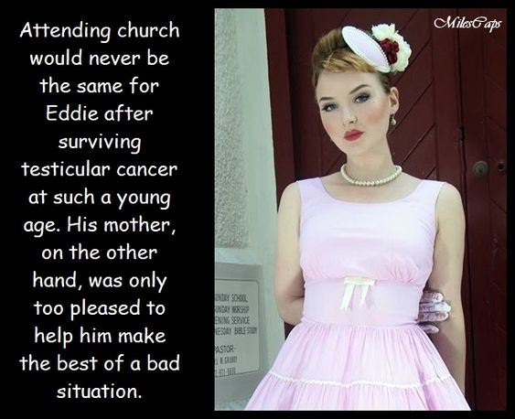

She said that it was God’s plan for me. I could never be a father. Even if I could find a wife, any child would not be my child. I could not “beget” as the Bible says.

“But why would it be any different to pretend to be a woman who would still be infertile?”

“Foolish child!” My mother told me – “The scriptures are full of the stories of barren women, such as Sarah, Rebekah, Rachel, Hannah, and Elisabeth. The matriarchs of Genesis used handmaids to bear their children – Sarah uses Hagar to bear Ishmael(Genesis 16), Rachel uses Bilhah to bear Naftali (Genesis 30:3-8), and Leah uses Zilpah to bear Asher (Genesis 30:10-13).” She knows her scripture, my mother, although the references I found later.

“And there is a facility now available for good Christian children, my Dear,” she explained. “It is called the Christian Feminization Academy, and it exists to help confused young men find their true calling as Christian women. Rather than be a man with no line, would you not prefer to follow the barren matriarchs of the Holy Book?”

I love my mother. I told her that I would follow her advice and at least try the way she was suggesting. I still had a penis then, so I figured that I was not surrendering any option by attending the Academy with others, some of whom were fully anatomically male when they entered.

I suppose that I was a doubter. The men at the Academy were mainly gay men trying to find a way to love who they were driven to love without being in sin by doing it. Some were transgender and using the Academy to assist them in becoming true women in the eyes of God. A couple were like me, attending because their parents believed that it might be better for them to find another sex with which they might serve God.

What impressed me was that the instructors and mentors were so strong in their faith. The key message was that in becoming women we were to become the better sex – the gender favored by God.

“There is such joy in womanhood!” we were told. “Men live a drab life of duty, work and conflict. Women live in a world of beauty, love and sisterhood. The contrast could not be more clear. Turn to your sister now. Tell her that she is beautiful. Tell her that you love her. Tell her that you are her friend. Have you done that? Now, tell me if any man could have said any of those things to another man.”

I suppose that I realized that this might not be such an outrageous idea, especially when we were all dressed up and admiring one another. The Academy was just such a colorful and happy place. Next to this live is in true that men seemed colorless and serious.

I suppose when I first went to church with my mother dressed as a girl in pink and with a “hat” on as she insisted, I was still a little angry with her as the photo may show, but that very day I met Jonathan, and he tells me that on that day he fell in love with me. Whether that is true or not, in the weeks that followed he was relentless.

So it was not really my mother who took advantage of the situation, it was Jonathan and perhaps even me. It makes me think that my mother was right - that it was God’s plan for me.

Praise the Lord!

The End

History Project  Inspired by a Miles Cap  By Maryanne Peters  History was always my strong subject. That was why I ended up in a 12th grade history class when I was still in 8th grade. I suppose that I was naïve, but I fell for Mandy in a big way  She started by coming around to my place for me to help her with her studies. She was smart, but not enough for an A in history. Not without my help.  She then said that I should come around to her place to help her, but as her parents were strange about boys – “Would you come around as Patricia?” | 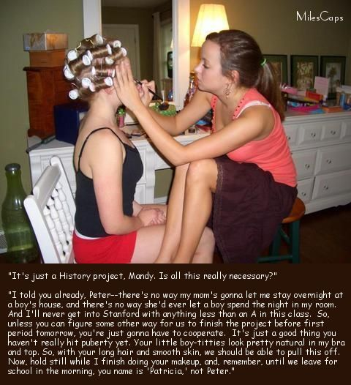

No guy likes to be told that with my long hair and smooth skin I could just walk up to the front door and say “Hi, I’m Patricia, Mandy’s friend, here to help her with her history project.” But I was ready to do it for her.

“Nice to meet you, Patricia. Come on in.” It does not do anything for a male ego.

But the project was already done and lodged, so I really do not understand what I was doing there. That was when she pulled out a box of curlers and started to run the bath.

“I got a message from Stanford,” she said. “The school sent the project on to the university and it has won some kind of prize. We have been invited to the school of history tomorrow … well, I have, but I don’t know enough about this stuff, so you’re coming too, as Patricia”.

I suppose that I should have asked why I should be going as Patricia, but she was just so excited, that I didn’t think to ask. I was excited too. There was no way that they would ever be entertaining an 8th grader anyway. I just figured - ‘How hard can it be to pretend to be a girl for a day?

So off came the body hair and on went the clothes and makeup. In went the curlers and the Mandy brushed them out and the curls fell around my shoulders and I was smitten with the reflection in the mirror.

By sheer coincidence the Professor of History at Stanford who awarded the prize was a transwoman. I suppose that she thought we worthy of support.

I never went back to school. We both got a special admission on the strength of that project.

I never went back to being Peter. I am not sure whether I was transgender before that first night I arrived at Mandy’s place, but having been convinced every day following that it was fine to be transgender, and even a little special, I was happy to agree.

I suppose that I am still a little naïve, but I am young, and now I am female.

The End

Helping Davey Make It
Inspired by a Captioned Image from Miles Caps
By Maryanne Peters

Lisa said that some people do well in life, and some don’t. Let me try to remember exactly what she said, ‘cos it was a bit complicated. Yeah, that’s it – if you are a guy small and smart is good, and big and dumb is okay ‘cos you can do heavy lifting and stuff. Big and smart is super good, but small and dumb is no good at all. Basically she told me that if you are small and dub like me, you are fucked. She didn’t use that word – she says it is a male word and I should not use it, so I try not to.

She said – “Davey, I care about you, so I am going to try to fix things for you. I can’t make you bigger, I can’t make you smarter, but I can give you a chance.” That is what she said, or something like that.

It is like the caption says, every time I went to her place, she wanted me to play dress up, like I was her little Barbie doll. I mean, we had fun, and like, I was not getting fun anywhere else. She just said stuff like “don’t cut your hair”, and “bend over while I stick this needle in your butt”, and “shave down and apply this cream on your skin”.

But it was not all orders. Most of the time it was encore something … encouragement. Saying how good I looked and how I was a natural blonde, which was really, with just a little help. She said that pink was my color so that whenever I wore pink I looked great. I think she is right.

“Congratulations, you are officially a bimbo,” she said.

I felt so proud to be congratulated for anything, but I did not know what a bimbo was until she explained it to me.

Anyway, after a while she said that I needed to step out into the world and see if this was going to work for me. I wore pink, of course.

She took me to a bar and left me there. A few guys came over to make friends with me, but after a while when I got into telling them about myself, they walked off looking very mad. Jeepers, I dunno what is going on.

The barman suggested that I give myself a new name, and don’t introduce myself as Davey. He suggested Danny, and that seemed to work.

Anyway, a guy came over and told his name was Fabian. Strange name, but he seemed like a nice guy. I told him my name was Danny and we got to talking. Then he started getting closer and to be honest my pecker started to get up.

He said – “Hey, you are a guy.”

So, I said – “I was a guy, but now I am a bimbo.”

“Do you know what that is?” he says.

“Sure,” I said. “A bimbo finds somebody who really likes them a lot, and then they do anything he wants just provided that they stay looking really pretty while they are doing it.”

He thought for a bit, like smart guys do, and then he says “I really like you.”

So, basically I do what he wants, and I stay pretty. If he says “don’t say anything, just smile” I do it. If he says bend over while I put this in your butt, I bend over. And I am always pretty. We have been together for a few months now, and I am very happy.

I guess I have made it, and it really is down to Lisa. She is really, and I mean really, clever. I’m not.

The End

© Maryanne Peters 2022

