Immune Response
A Short Story
By Maryanne Peters

What are allergies? An allergy is an immune system response to a foreign substance that’s not typically harmful to your body. Your immune system’s job is to keep you healthy by fighting harmful pathogens – things that could put your body in danger. It does this by attacking those things. The allergic response can be inflammation, sneezing or something much more serious. Shock is the extreme – the body shuts down to destroy the pathogen, even though it might not even be slightly harmful to the body.

Even doctors say that the immune system makes mistakes. It is like they are taking about it being a thinking mechanism, but a flawed one. They are giving it a personality. “Your immune system thinks that pollen is attacking your body”. But an immune system does not think – it does not have a plan. Or does it?

Allergies can emerge quite suddenly, and they can disappear in much the same way. How can that be? What makes a reaction biologically reasonable on one day and unnecessary the day after?

My allergy seemed to appear from nowhere. They spoke about the fact that I had a late puberty, but I was well past that. Then they looked at my late first experience of experience of sex, which was also late. They did all this because they had already eliminated all the usual allergens – in fact all external allergens. They were focusing on something internal – something in my own body that I had become allergic to. This is what is known as an auto-immune disorder.

There are lots of these disorders. Some can be treated with drugs that reduce the immune response, but that is removing the body’s own protection. In other cases they remove the source of the problem. In treating hyperthyroidism for example, they remove the gland that produces thyroxin, and use a controlled measurement of the hormone thyroxin to keep the metabolism functioning.

The problem with me was that the hormone that was slowly killing me was testosterone – the male sex hormone.

“You can live without it,” the doctor told me. “You can’t stay alive without thyroxin, but you can without testosterone – it will just be a different life.

Testosterone is produced in the testicles, so if this was like hyperthyroidism doctors would simply whip those out. That is what they had to do in the end, but the first strategy was to try to keep my balls but giving me high doses of female hormones to try to neutralize the testosterone or its effects.

That went on for months. I watched my body respond as if I was a young woman undergoing puberty. My body softened and my hair seemed to grow faster and thicker, and small breasts sprouted on my chest. I was told that these could be removed in time, but for the initial therapy these should be left for observation and assessment.

I have been taken into hospital in a state of shock. As they searched for a solution they did their best to treat the symptoms which I was basically unconscious for a week. Then I received visitors – my mother, Ollie and Sam two of my closest pals, Walt who worked with me at the hardware megamart, and Amber, who was my girlfriend, I guess. As I said, I was late to sex, and not that good at it. She would only visit me twice. Her interest in me had been waning for some time.

Once I got out of hospital I moved back home to live with Mom and gave up the apartment I had shared with Ollie – at least he let out my room. I still needed some attention as the whole body shock had left me weak. And then after that, I felt too ashamed to go out. I felt that the suppression of my testosterone and the female hormones made me look like a freak.

The hair on my head was long as the doctors wanted to measure growth, and all other hair on my body seemed to be falling out. I had lost muscle all over and my whole body seemed to be soft and weak, and then those little tits on my chest seemed to be swelling. The hormones had shrunk my balls as planned, but also my dick looked smaller, and was constantly limp. I didn’t want anybody to see me – even fully clothed.

My mother said that I should go out. She suggested that I go out with her, maybe just for a walk in the park, or down to the mall.

“People will see me,” I said.

“They won’t recognize you,” she said. Then I think that she realized that was the wrong thing to say – I had changed so much. “If you wear dark glasses and clothes that you wouldn’t normally wear,” she added.

I did want to step outside. I would have been happy to go to the mall as I used to like being around people. But I was not convinced. I flopped back down in the sofa and watched some mind-numbing daytime TV.

Then she appeared with some clothes and a pair of dark glasses. The clothes were hers - a pair of yoga pants and a long loose top. She said that the clothes were unisex – like, gender neutral. She did not say the words, but I knew that was what she was saying I was – not a man any more, but not a woman either. She said that if I would go with her to the mall she would buy me a Jabbaburger with waffle cut fries. It sounded too tempting to refuse.

I wore the outfit with a pair of red trainers. I felt like a fag in it, but I didn’t look like me, or at least how I used to look.

We went to the Mall and it felt good to leave behind the four walls of home for a bit. She was true to her word. We took a table at Jabbaburger and the waitress came to us.

“What can I get you ladies,” she said. It stung me. She thought that I was female!

“I’ll have one of your Mediterranean salads,” said Mom. “What about you Sweetheart?”

She had put me in a corner. She knew what I wanted. A Jabbaburger with waffle cut fries. But now I had to talk and either look like a trannie or sound like a girl. I chose the second option.

“A Jabbaburger with waffle cut fries, please.” It was supposed to be a whisper, but it came out much better than expected. Even Mom looked surprised. I was pleased with myself.

“Carry on speaking like that,” she said. “This might be a way of getting out more often until we get you sorted out. But those dark glasses look stupid in here.”

But it was just as well I was wearing them, as just as we were finishing my pal Jason Harris from school walked in. He saw my Mom and came straight over. I did my best to look small.

“Hi Mrs. Mountford,” said Jason. “I saw you and your friend sitting here and I just to ask you about Dean? How is he doing? We haven’t seen him since he collapsed on the diamond. We heard it was an allergic reaction to something? He is out of hospital, right?”

There was no hint that he recognized me. He looked in my direction and I gave a little wave.

“Oh, forgive me, Jason”, said Mom. “This is Dean’s cousin … Diana.”

“Hi,” he said looking at me. I could see that he was trying to look through the dark lenses, but there was an expression on his face that seemed incomprehensible to me. It was not because I had not seen it before – just not directed at me.

“Sorry,” I squeaked, touching my sunglasses. “Migraine”.

“Nice to meet you,” he said, still with that look. I wanted to shout out to him to stop looking at me like that. Just stop with the X-Ray eyes! But when he said his goodbyes and walked away, I missed his presence.

“You must miss seeing your friends,” said Mom.

I felt like crying. I knew that the female hormones had something to do with that, but I had reason to cry.

“Mom, I am a freak. Here I am hiding in a stupid costume while the world is having fun around me.”

Mom could see how upset I was. She reached out and stroked my face, dislodging the sunglasses.

“You know what I like to do if I am feeling down?” she said. “I get a makeover. There is nothing like it to lift the spirits. Jason did not recognize you. With a makeover you would not have to hide. Quite the opposite. If you look spectacular you feel great and want people to notice you. Let’s do it! My treat.”

Maybe I should have refused? Maybe I should have just asked her to drive me home and lock myself away? I always think that I just moped along behind my mother, but maybe there was something in me that was wondering what Jason saw, or thought he saw.

He was not really a friend of mine. He moved in different circles. He was a year above me and he was a high achiever. I wasn’t.

Before I knew it, I was in the salon chair. And Mom was there beside me.

“Oh how wonderful! A mother daughter makeover treat!” The woman should have known better that Jason, but she seemed to think that I was female too.

“She’s a bit of a tomboy,” Mom said to the lady. “This is her first trip to the salon, but I hope that it will make a real girly girl out of her.”  “There is plenty of hair here for a few feminine curls,” the lady said. And what great cheekbones and such beautiful eyes!”  I just sat back and let it happen. It was like it was Mom’s show and I was just her plaything for the day. So much for cheering me up!  But I was still thinking about Jason. He looked at me in a way that nobody ever had, and it made me feel strange. Could he be desiring me? I had sunglasses on so he could not see me, so what was it about me that he did see. Perhaps the hint of breasts? Perhaps the smooth pale skill? Certainly not the hair. | 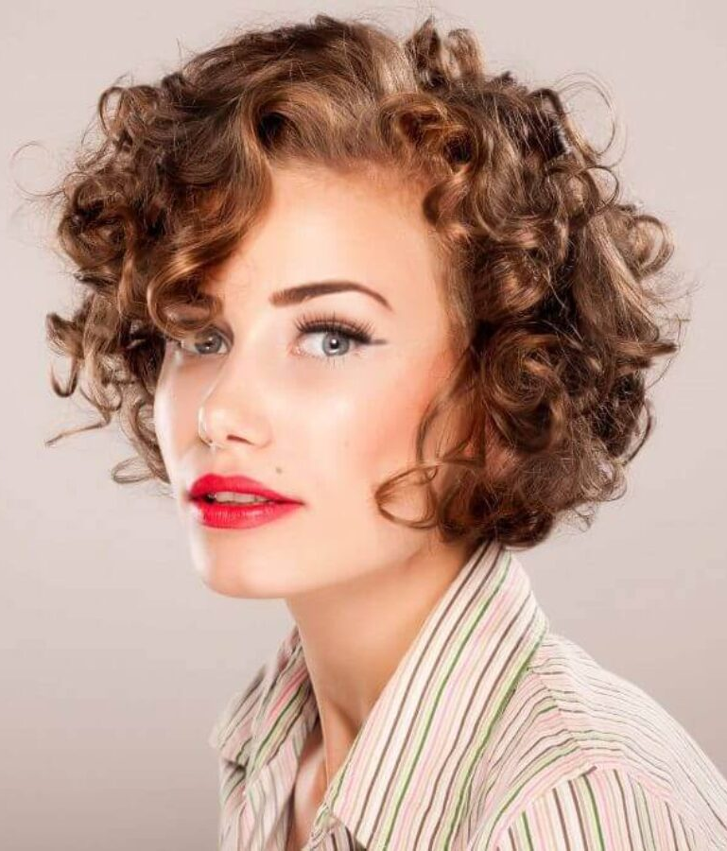

My hair had just been a scraggly mess, but now it had been washed with a color rinse put through it, and it was in curlers, just like moms, and they were working on my face, and Mom’s too. It was only when the last finishing touch was added – bright red lipstick – that I realized just how momentous this experience would be for me.

I said – “Oh my God!” Or something like that. I was shocked and Mom was too, but she was thrilled too.

She hugged me, She said – “”Oh Diana. My beautiful daughter Diana. I always dreamed of a day like this.” And she started to cry. And I did too.

The salon lady said – “I don’t see any tomboy anymore.” Nobody did. Nobody could. I just stared in the mirror.

“Don’t stand around, Honey,” said Mom. “We need to buy you a dress and some nice shoes. But first we need to get you fitted for a bra and get you some … some suitable panties.”

It turned out that Jason Harris was working at mall doing stock deliveries, so perhaps it was not so surprising that we should run into him again, just as Mom and I were stepping out of the shoe shop, me in those new shoes and the dress Mom had just bought for me next door.

“It’s Diana, isn’t it,” he said. He had clearly committed the name to memory. “You have recovered from your migraine?”

“All it took was a new hairdo,” I said scrunching my curls a little in a playful way. It was as if I had suddenly become a natural flirt, although in truth for the last few hours I had been practising a thousand moves and looks – a mall has a million mirrors – right?

“If you are not doing anything tonight …?”

It was as if a door had opened. I had been in a very dark place, like a dungeon with any doors or windows. It was an affliction without cure that was going to kill me, but in the meantime would ravage my body and destroy what life I had.

Now the very things that I dreaded had suddenly become my best assets. My breasts now nestled comfortably in the cups of a new bra. My pale hairless skin now glowed with excitement. My legs with muscle wasted away were now the perfect length and shape. My fine soft hair now bounced around my ears and drew the attention of everyone who saw me strut past in my new heels.

The following day I went into the hospital for my scheduled meeting, but I had been told that there was going to be some bad news and that both my parents should be there. I did think about dressing down to so in – like finding some boy clothes to wear – but I figured that the best way to hear bad news is in good humor. I sure felt good when I was Diana, so I put on a dress and tidied my hair and makeup.

I just glided into the consulting room with my parents behind me. The doctor seemed puzzled to start with, but then I saw the moment of realization and I had to smile.

“I am ready for the bad news,” I said.

“Well maybe it will not be,” the doctor said. “I was going to tell you that we a recommending a bilateral orchidectomy. Removal of both of your testicles. They are effectively the source of your problems, and we have resolved that there is no other way. It is a step of major consequence for any young man, but perhaps less so for you?”

“Let’s do it,” I said. “And perhaps some other modifications down there at the same time?”

The End

© Maryanne Peters 2021

Erin’s seed: “There really is such a thing as an acquired allergy caused by the immune response to something like a bug bite or chemical exposure and they do usually go away eventually. It's also possible for the body’s immune system to attack almost any part of the body, like testicles so they shrivel up and disappear?

