Notes before starting:
[TONES]
For the purposes of this report, I state that I made no alterations to the save files and had “Always Dash” set on in case this is relevant information in regards to any problems I encounter.

I will be starting on a new play through and seek to try and achieve as much content as possible, meaning getting as many of the characters fat as possible and finding any and all secrets that I can.

Bugs will be separated by the chapters they occur in, if a bug is persistent between chapters it will be added to the “General/Multiple Maps” section near the top.

I will actively note minor issues as well as the major ones, such as apparent missing dialogue or strange tile placement.

Any time I notice a bug that I’m unsure of as being a true bug or an intentional decision I will preface it with a question mark(?).

At the bottom of this report is the “Suggestions” section, if you have an idea that isn’t directly tied to a bug/glitch please leave those notes in this section.

To all testers, if you would not mind please mark your notes with your name so Bobo will know who to direct questions to.

I encourage you to read all previous notes from other testers for any given chapter you are currently in as to avoid repeating issues already listed.

[BOBO]
Bobo’s commentary/annotations will be bolded and/or [bracketed]
When referring to issues in discord chat, please format as x.y (1.1 = Chapter 1, Bug 1)

OLD SAVES WILL BREAK THE HUD–this is a known issue. A qualifier was added to the HUD so that it wouldn’t show up on the Disclaimer page. Save files from before this was implemented will have this issue, but ones created afterwards will not.

[Please mark game-breaking bugs in red]

General/Multiple Maps:

1. Namebox data was reverted to an old version - leave a list of characters who don’t have names listed here:
  - Dr. Balala [FIXED–v0.9.1.0]
  - Fat Tora [FIXED–v0.9.1.0]
  - Fat Tia [FIXED–v0.9.1.0]
  - All Bunny Sisters [FIXED–v0.9.1.0]
  - Jenna, the Guest Fighter [FIXED–v0.9.1.0]
  - Shady Merchant [FIXED–v0.9.1.0]
  - Fat Remi [FIXED–v0.9.1.2]
  - Fat Greta [FIXED–v0.9.1.2]
  - Fat Shirewood Heiress [FIXED–v0.9.1.2]
  - Dead Patron 2 [FIXED–v0.9.1.2]
  - Delilah (all sprites) [FIXED–v0.9.1.2]
  - Metta [FIXED–v0.9.1.2]
  - Ashani (Fat) [FIXED–v0.9.1.2]
  - Fat Fairy [FIXED–v0.9.1.2]
  - Vegetarian Fairy [FIXED–v0.9.1.2]
  - Padget Fat Faces [FIXED–v0.9.1.2]
  - Ginny Possessed [FIXED–v0.9.1.2]
  - Gabby the White [FIXED–v0.9.1.2]
  - Griselda (Blob) [FIXED–v0.9.1.2]
  - Bobo the Hobo [FIXED–v0.9.1.2]
  - Calahree Blob Face [FIXED–v0.9.1.2]
2. [forestifre][Sparty] On booting game: 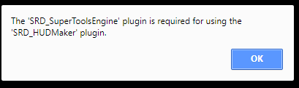
[FIXED–v0.9.1.0]
4. [TONES][FIXED–v0.9.1.0]
5. [Exiting Dead Inn after making a Fat Housewife Delivery will send you to the Epilogue version of Pandemonium.]
[FIXED–v0.9.1.2]
6. [Adjusting drop rates of Mechanical Components for mimics]
7. Developer’s Chest will close after each map - dev room remains unlocked, but chest doesn’t act like it.
[FIXED–v0.9.1.2]
8. Where Applicable, Gates now open with appropriate sound effects. Specifically the Church in Aemple (the Mountain Church is on a different tileset where the gate is too small) and Lady Death’s Castle.
[FIXED–v0.9.1.3]

Chapter one:
- [sparty] I think when Freya gives Gabby the turkey there should be a sprite?
[FIXED–v0.9.1.0]
- [forestfire] After giving the food to Bunny, she doesn’t face the food.
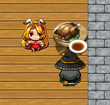
[FIXED–v0.9.1.2]
- [sparty] Sprite has no food sprite
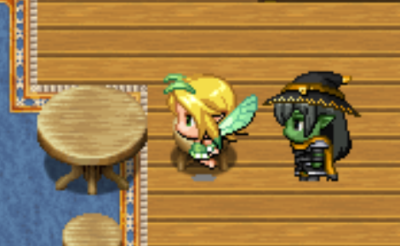
[FIXED–v0.9.1.0]
- [Maximar]Deity is misspelled as “diety” in opening crawl and first conversation between the sisters.
[FIXED–v0.9.1.3]
- [Maximar]Gabby's sprite briefly overlaid Bunny Bombshell's sprite when I gave her the turkey, but I was able to walk off of her.
[FIXED–v0.9.1.3]
- [Maximar]In the tavern, Gabby is able to walk off the left and right sides of the stage without using the stairs
[FIXED–v0.9.1.3]
- [Maximar] Gabby can walk into the black space in between the curtains so her head clips into the wall sprite.
[FIXED–v0.9.1.3] [Addendum: the space behind the curtain uses the same tiles as doors, so they have to be able to be walked on. But the “upper” level of black space has been blocked off so it can’t be walked on.]
- [Maximar] It is also possible to climb the rope hanging from the banner on the right
[FIXED–v0.9.1.3]
- [Maximar] In the first conversation with Cahlaree in her crystal, the sentence “Since the day that Griselda first opened my tome, I have taken note [of] her... exceptional potential.
[FIXED–v0.9.1.3] [That’s there - it just got clipped out of the word bubble.]
Chapter two:
- [forestfire] Delivery dialog triggers before starting the quest if you speak with Dinero
[FIXED–v0.9.1.0]
- [forestfire] Black screen on Servitude spell at bar. Still intended?
[FIXED–v0.9.1.1]
- [forestfire] Can still talk to item shop owner about the Hero’s Axe (Ongoing in more chs.)
[FIXED–v0.9.1.0]
- [forestfire] Meal 2 references an L-shaped house, but it isn’t L-shaped
[FIXED–v0.9.1.0]
- [forestfire] Talking to Paulie after completing town quests still tells you to do town quests
[FIXED–v0.9.1.0]
- [forestfire] No goblin girl in dev room. Intentional?
[FIXED–v0.9.1.2]
- [sparty]
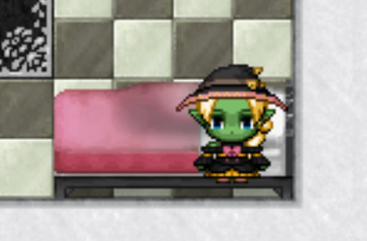
clipping on pink bed (all three actually, may be intended)
[FIXED–v0.9.1.0]
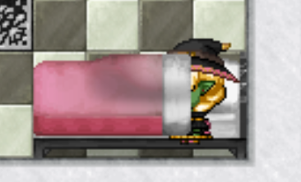
- [sparty] Still having bed issues
[that’s unfortunately the limit of what I can do as far as tilesets go. It’s either she’s on top of the bed, under the bed, or whatever this is. The covers are a separate layer to the actual bed.]
- [sparty] papers have dialogue but book does not
[FIXED–v0.9.1.0]
- [sparty] During Ginny’s show, I think at “Holy moly what a babe” there is an emotion bubble over the wall
[FIXED–v0.9.1.0]
- [sparty] the transition up the stairs is a little weird, and Bunny is in both rooms
[FIXED–v0.9.1.0]
- [sparty] Ginny doesn’t actually deliver the food to the Fat Housewife
[FIXED–v0.9.1.0]
- [sparty] game locks up after saving Remi, animations still run but can’t move or interact
[FIXED–v0.9.1.0]
- [Ginny faces right when doing bad end instead of left.]
[FIXED–v0.9.1.2]
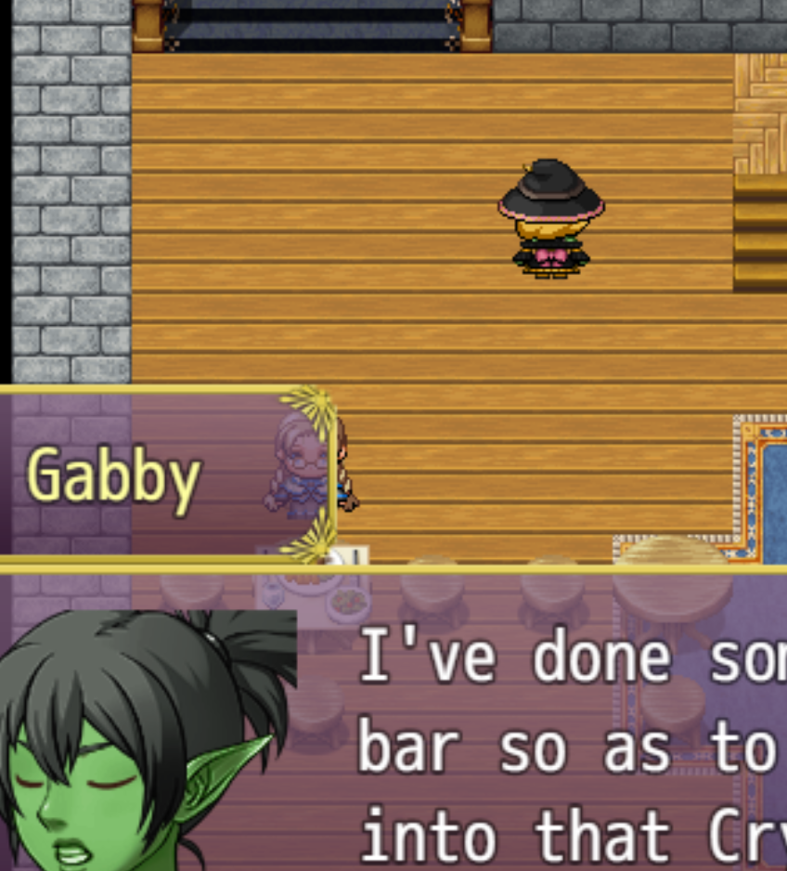
- [sparty] Gabby disappears during this dialogue
[FIXED–v0.9.1.2]
- Can begin the Fairy Quest without talking to Kara.
[FIXED–v0.9.1.2]
- Ginny will continue to move after saving Remi if you fastforward the dialogue.
[FIXED–v0.9.1.2]
- [Maximar]In the “You sure do have a big breakfast...” dialogue choice with Griselda, the section with “...I must keep my Mana pools up if I ever want to make [headwind] on my studies,” [headway] would be the appropriate word; headwind in that context would be a stall in Griselda's progress.
[FIXED–v0.9.1.3]
- [Maximar]The sign immediately to the left of the entrance to Aemple with the passage from Sister Mary has “who keep[eth] us safe in tall grass-
- [Maximar]In the conversation with Kara in the “do you need help” dialogue, Kara says “Remi was supposed to go help our aunt-” instead of grandmother.
[FIXED–v0.9.1.3]
- [Maximar]When delivering the Door Dash to Malory, the sentence “After that, leave the [premesis].” The correct spelling is 'premises.'
[FIXED–v0.9.1.3]
- [Maximar] Harriet Bombshell: “What's a baird [gotte] do tae get some feckin' biscuits, then?” Obviously this is a comedy brogue but I still think that [got tae do tae] or [gotta do tae] sounds more natural.
[FIXED–v0.9.1.3]
- [Maximar] During the dialogue leading to the option to bind Padget in Servitude, Lady Cahlaree: “From your own [diety]-”
[FIXED–v0.9.1.3]
- [Maximar] I was able to step onto the chimney of the abandoned tower and some of the roof in the Badlands.
[FIXED–v0.9.1.3]
- [Maximar] Dr. Balala, on delivering the Mechanical Components: “Mimics can be [difficult? Hard?] to fight,”
[FIXED–v0.9.1.3]
- [Maximar] Talking to Griselda after achieving the 5 tasks, in the dialogue option “You've been eating a lot”:“-I wouldn't expect someone [whose] managed to [coax] by on sheer talent-” The first bracket should be [who's] as in “who has” and the second bracket should be [coast].
[FIXED–v0.9.1.3]
- [Maximar] In chapter 2 and 3, when you return to the cave you can still trigger Gabby's textboxes from chapter 1; one going towards the area where the minotaur was, the second when you inspect the fairy door; in chapter 3 the door works with Griselda as intended, naturally.
[FIXED–v0.9.1.3]
- [Maximar] Ok going back to to Chapter 2, Palomina Bombshell calls her Granny Boony instead of Havana. Sable Bombshell says that the oldest sister is Buffy who lives in the mountains, instead of the current name Thrianta.
[FIXED–v0.9.1.3]

Chapter three:

- [sparty]
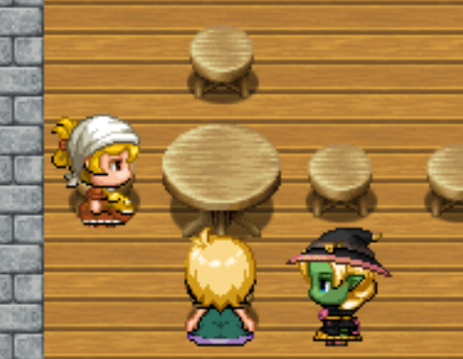
sister are eating but there’s no food
[FIXED–v0.9.1.0]
- [sparty] Jae’s heart reaction bubble is over the doorway
[FIXED–v0.9.1.0]
- [sparty] two of the meal deliveries (the guard) are the same
[Intentional.]
- [sparty] clicking Malary’s book in the cottage gives Malaray/Calahree dialogue and teaches Hellfire
[FIXED–v0.9.1.0]
- Can get crystal shards before the Shirewood heiress asks for them.
[FIXED–v0.9.1.2]
- Tavern stays dark.
[FIXED–v0.9.1.2]
- Fixed a typo in the script. Lake now no longers you to activate it a second time after putting in all three ingredients.
[FIXED–v0.9.1.2]
- [Maximar] Towards the end of the opening dialogue between the sisters, Griselda:
“A-after I finish dinner of course... [wouldn'] of this food to go to waste.” Multiple options here but one could be [wouldn't want this food to go to waste.]
[FIXED–v0.9.1.3]
- [Maximar] Talking to Calahree in the “What is my task?” dialogue:
“To consider a race as powerful and long-lived as the Fae a mere [neusance]-” should be spelled [nuisance]
[FIXED–v0.9.1.3]
- [Maximar] When talking to Jae in the tavern, in the “Who's the cook?” dialogue choice the heart emote pops up in the doorway instead of over her head.
[FIXED–v0.9.1.3]
- [Maximar] Minor vestige of Chapter 1: when talking to the Item Shoppe owner, Griselda can still ask about the Hero Axe.
- [Maximar] going into and out of the dojo in chapter 3 sets the map to the version in the Epilogue, but at night!
[FIXED–v0.9.1.3]

Chapter four:
- [forestfire] Collision issue on pink bed
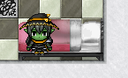
[FIXED–v0.9.1.0]
- [forestfire] Asking Jae about the cook has the heart response trigger at the entrance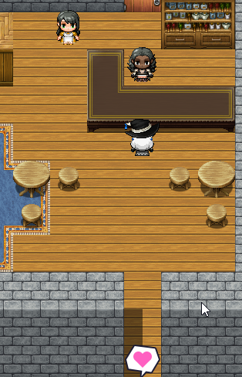
[FIXED–v0.9.1.0]
- [forestfire] Fat Housewife sisters’ house says that they’re in the tavern. They are not in the tavern.
[FIXED–v0.9.1.0]
- Gabby is invisible at the start of Chapter 4.
[FIXED–v0.9.1.2]
- Can’t use bed in Dead Inn
[FIXED–v0.9.1.2]
- [Maximar] While you are playing as Gabby briefly in the start of the chapter, you can interact with the astrolabe and it displays Malary's text box.
[FIXED–v0.9.1.3]
- [Maximar] In the “Griselda?” dialogue option with Paul, “Y-You most certainly [cannont]! Typo, [cannot] or [can't].
[FIXED–v0.9.1.3]
- [Maximar] The Item Shoppe Hero Axe dialogue is still present.
- [Maximar] Another minor dialogue suggestion to change [li'l] to [lil'] in Kara's text box in the tavern.
[Li’l is the (or at least a) correct abbreviation of little.]
- [Maximar] Going into and out of the dojo in chapter 4 sets the map to the version in the Epilogue.
[FIXED–v0.9.1.3]
- [Maximar] Becky's gf is the Lazy Guard, but she doesn't have a name in her Chapter 4 textbox when talking to her in the house. At the same time, the Lazy Guard sprite wearing a helmet with that name is still on duty at the guardhouse.
[FIXED–v0.9.1.3]
- [Maximar] Grandmother: “I even like doing [this] dishes,” should be [the dishes]
[FIXED–v0.9.1.3]
- [Maximar] I was able to talk to the Shady Merchant from the right side, which is adjacent to her tile but is graphically on a different elevation level.
[FIXED–v0.9.1.3]
- [Maximar] Malary, to the Shady Merchant: “Lady Calahree's favor [is abound],” should be [abounds]
[FIXED–v0.9.1.3].
- [Maximar] Shady Mercant: the diety/deity misspelling/pun, twice.
[FIXED–v0.9.1.3]
- [Maximar] When checking Malary's spellbook in the abandoned house, Calahree says “You're going to need every skill at your behest in order to [acquire] this particular opponent, O Acolyte.” I feel [defeat] or a synonym may be a better choice.
[FIXED–v0.9.1.3]
- [Maximar] During the Aurelian/Fat Housewife cutscene, both of the sisters turn to the right, instead of facing each other to talk about the couple right before they become intimate.
[FIXED–v0.9.1.3]
- [Maximar] Now, the innkeeper in the Deadlands prevents you from going upstairs to interact with Delilah demanding payment, but there doesn't seem to be a way to initiate the transaction which locks you out of the Delilah subquest.
[FIXED–v0.9.1.3]
- [Maximar] In the Bombshell book, Harriet Entry “Palomina's harsher [tyrades],” should be [tirades]
[FIXED–v0.9.1.3]

Chapter five:

- [forestfire] Interacting with the inn in the fairy world gives mixed messages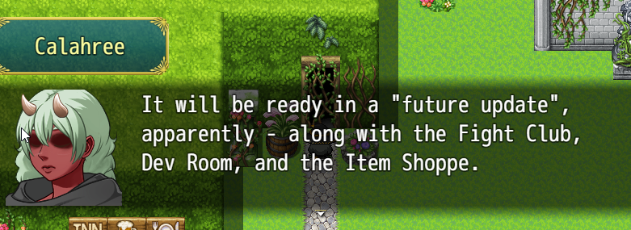
[FIXED–v0.9.1.3]
- [forestfire] Does the outfit change also do a character change? I equipped some items in waitress form and they changed once back into witch form. Possibly unequip all those items at the switch so items aren’t lost?
[Waitress Gabby, Bunny Ginny, and Skinny Griselda are all different actors in the game’s script, so yes. Will try to remedy this.]
- [forestfire] Interacting with the dullahan gives you Malary dialog
[FIXED–v0.9.1.0]
- Lady Death Delivery teleports you to the epilogue
[FIXED–v0.9.1.3]
- Griselda gives green shards in Chapter 5.
[FIXED–v0.9.1.2]
- Script doesn’t remove party members at start of chapter.
[FIXED–v0.9.1.2]
- Can’t use bed in Gabby’s Extra Room in the Tavern.
[FIXED–v0.9.1.2]
- Waterfall sounds continue outside of Titania’s Castle.
[FIXED–v0.9.1.2]
- Lots of collission issues in the Fairy Realm Tilesets.
[FIXED–v0.9.1.3]

Chapter six:

- [forestfire] “What’s the story here?” And “Anything weird going on?” Option with weapon merchant in mountain down has no dialog.
[FIXED–v0.9.1.0]
- [forestfire] “Mountain Weaponeers” doesn’t sell weapons, only armor.
[FIXED–v0.9.1.2]
- [forestfire] Pixel gap in fat sprite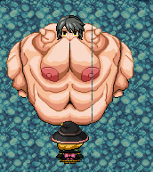
[Still have no idea how to fix this - it only happens on this map for some reason.]
- Yellow Crystal is not destroyed when Ginny destroys it.
[FIXED–v0.9.1.2]

Chapter seven:
- [TONES] Screen doesn't fade back in after teleporting to Calahree’s main chamber, leaving it black throughout the entire ending. Screen fades back in after moving to the epilogue.
[FIXED-v0.9.1.2]
- [forestfire] Annoying invisible wall here
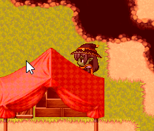
[FIXED–v0.9.1.0]
- [forestifre] No dialog
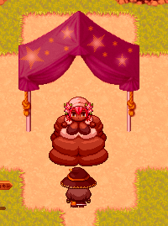
[FIXED–v0.9.1.0]

- [forestfire] Maybe some path indicator here? Throughout the game there are many map sides that aren’t traversable
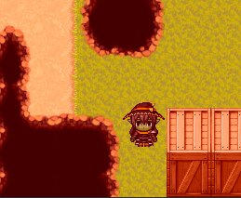
[FIXED–v0.9.1.0]
- [forestfire] Collision issue
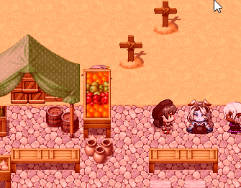
[FIXED–v0.9.1.0]
- [forestfire] Once you enter Lady Death’s castle, you can’t leave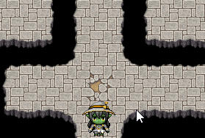
[Intentional]
- [forestfire] Is this still intended? 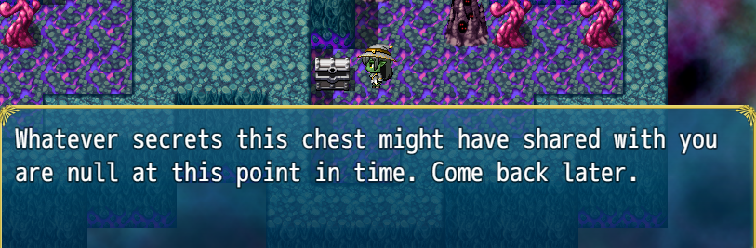
[Yes, intentional - entering the Dev room would kill the flow of the story.]
- [forestfire] After the third boss fight in the tower, it says Belladonna heals you. Does she actually?
[FIXED-v0.9.1.2]
- [forestfire] Same as above but fourth fight and Lady Death
[FIXED–v0.9.1.0]
- Y’all were missing a lot of dialogue from Chapter 7 because my dumb ass put them on player touch instead of autorun.
[FIXED-v0.9.1.2]

Epilogue
- [TONES] Can’t leave the fight club after entering.
[FIXED–v0.9.1.0]
- [TONES] Alma is still in your party despite building a house.
[FIXED–v0.9.1.0]
- [TONES] The sky is set to be shaded to afternoon still, I don’t know if this is intentional or that it wasn’t set to change back correctly. Going in the shope changes it to normal.
[FIXED–v0.9.1.0]
- [TONES] Talking to the cat gives you Ginny’s text.
[FIXED–v0.9.1.0]
- [TONES] You can enter the grandma’s house despite her being at the new farm, you get stuck inside because the game thinks you’re doing the save Remi side quest.
[FIXED–v0.9.1.0]
- [TONES] You can’t get to the new version of the Outskirts, it takes you to an old version.
[FIXED–v0.9.1.0]
- [TONES]
Copy of this bunny sister outside walking around.
[FIXED–v0.9.1.0]
- [TONES] Warps in general are all mixed up.
[FIXED–v0.9.1.0]
- [forestfire] Malary layer issue
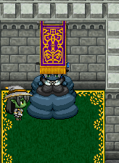
[FIXED–v0.9.1.0]
- [forestfire] Can’t interact with Malary
[FIXED–v0.9.1.0]
- [forestfire] All beds can be walked on
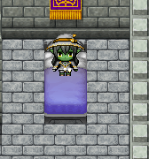
[FIXED–v0.9.1.0]
- [forestfire] Can’t interact with Griselda
- [FIXED–v0.9.1.0]
- [forestfire] Can’t interact with bunnygirl
[FIXED–v0.9.1.0]
- [forestfire] Can’t interact with Ginny
[FIXED–v0.9.1.0]
- [forestfire] Massive clipping issues in kitchen area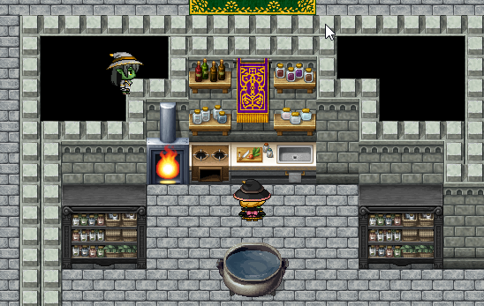
[FIXED–v0.9.1.0]
- [forestfire] Entering the town from the tower and trying to return gives you this message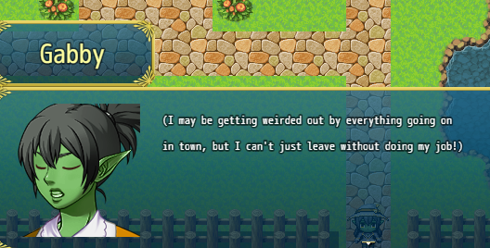
[FIXED–v0.9.1.0]
- [forestfire] Entering the town from the tower skips the camp area
[Intentional - there’s no point in going there now]
- [forestfire] Turning down the Fight Queen’s fight offer gives you an skinny sprite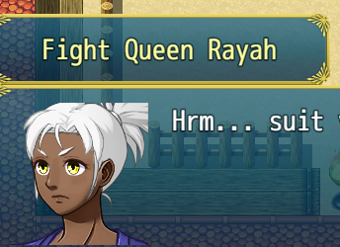
[FIXED–v0.9.1.0]
- [forestfire] Feeding tube doesn’t align correctly with sprite
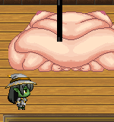
[FIXED–v0.9.1.0]
- [forestfire] All of Jae’s interactions are null
[FIXED–v0.9.1.0]
- [forestfire] Wrong Gabby portrait talking to black-haired waitress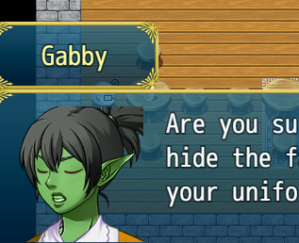
[FIXED–v0.9.1.0]
- [forestfire] No interaction
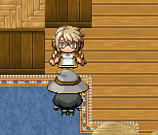
[FIXED–v0.9.1.0]
- [forestfire] Interacting with the well gives you Ginny dialog/portrait
[FIXED–v0.9.1.0]
- [forestfire] No hole in item shop exterior wall for the door animation
[FIXED–v0.9.1.0]
- [forestfire] Gemkin elf seems to have a fat sprite but skinny portrait and no dialog that reflects this
[FIXED–v0.9.1.0]
- [forestfire] Dinero still won’t take items. Can’t leave the house.
- [forestfire] No interaction with the shipping heiress
[FIXED–v0.9.1.0]
- [forestfire] Padget sprite breaks from the side
[FIXED–v0.9.1.0]
- [forestfire] No interaction with bunny girl outside of bunny house
[FIXED–v0.9.1.0]
- [forestfire] Redhead bunny doesn’t change direction to talk with you
[FIXED–v0.9.1.0]
- [forestfire] Entering the cave teleports you to the temple
[FIXED–v0.9.1.0]
- [forestfire] Exiting the dev room exits you to the mountain
[FIXED–v0.9.1.0]
- [forestfire] Teleporting to the fairy realm gives you this and restarts that chapter scene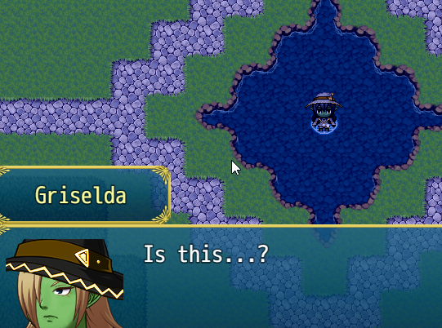
[FIXED–v0.9.1.0]
- [forestfire] Elise in deadlands gives original dialog
[FIXED–v0.9.1.0]
- [forestfire] Thanya gives original dialog
[FIXED–v0.9.1.0]
- [forestfire] Undead Shopkeeper still shopkeeping
[Intentional - the one at the table just represents another skeleton.]
- [forestfire] No deadlands NPCs except above have interactions
[FIXED–v0.9.1.1]
- [forestfire] Deadlands tables have no collision
[FIXED–v0.9.1.0]
- [forestfire] Interacting with Lady Death’s castle turns you invisible
[FIXED–v0.9.1.0]
- Cannot enter Purified Temple in Cave.
[FIXED–v0.9.1.2]
DIENRO HOUSE:

1. Dienro does not give receive commentary from different characters.
[FIXED–v0.9.1.2]
2. Dienro's crystal ball cannot be read.
[FIXED–v0.9.1.3]
3. Dienro moves around at her first “huge” size.
[FIXED—v0.9.1.2]
4. Dienro House will spit you all over the story towards the end - keeps sending me to Chapter 5 in particular
5. [Maximar] I think I saw this in the Patreon post for this part, but the Dienro House in Chapter 4 is a little weird. When she is blobbed up after giving her the Idol, leaving and coming back in, you can activate a dialogue box below her and to the left of the hallway from the Epilogue.
[FIXED–v0.9.1.3]
6. [TONES] If you enter Dienro’s house you can’t leave.
[FIXED–v0.9.1.0]

SUGGESTIONS:

1. [forestfire] Unique face sprites don’t change in fatness
[This is because they’re unique - I would have to draw them, and I’m not an artist. Bunnies were gifts from another artist and the pre-loaded sprites came with the game.]
2. [forestifre] Suggestion: unequip items from characters at chapter transitions
[Looking into a script for this]
3. [forestfire] Rubber and Mechanical Components are usable items that do nothing
[They shouldn’t be consumable - and while they don’t have a direct use, you can sell them at the pawn broker for a little extra money.]
4. [forestfire] Alma’s lighting punch is very bad
[FIXED–v0.9.1.0]
5. [forestfire] Maybe some visual indication to interact with the shrine in the church?
[FIXED–v0.9.1.0]
6. [TONES] Gabby’s special move, Middle Child Complex has too high of a cost, its use is fairly rare. Suggest a slight TP cost decrease, maybe 40 or 45.
[ADJUSTED–v0.9.1.1]
7. [TONES] Bad land monsters are too weak, with your beginning armor they can barely touch you, Imp can’t do any normal damage and Muck Slimes can only do 1 damage at a time.
[ADJUSTED–v0.9.1.1]
8. [Maximar] Potions aren't worth buying from the Item Shoppe; for the same cost you can get a mana potion and use the heal spell on yourself several times for much more effect. They would still be appropriate as monster drops however.
[I’m gonna keep them there, but I understand what you’re saying. Maybe I’ll just whip up some “better” potions for sale at his shop–healing half health or something like that. Good for when characters are in a pinch.]
9. [Maximar] This probably comes up a lot and it doesn't matter unless you want to focus on character balance, but the multi-strike attacks are definitely the most powerful attack in the game which makes the Sisters and Malary's magic less impressive by comparison.
[FIXED–v0.9.1.3]
10. [Maximar] Personally, I think getting the Rubber in Chapter 2 is tedious, even using the small patch of grass near the Sister's tower to fight blue slimes. The Glittering Hat Charm doesn't double Rubber or Mechanical Parts either, which would be a way to alleviate some of the grinding. The drop rates for Mechanical Parts seems to be much higher as well, so I usually end up unbalanced by the time I end grinding.
[FIXED–v0.9.1.3]
11. [Maximar] It's helpful for getting gear for blazing through the game fast with each update, but I would argue that being able to sell the Delivery Notes and other relics to the pawn shop in Aemple and the Underworld for 5000 gold apiece makes the game economy somewhat unbalanced; you can acquire all of the useful items pretty early on and make the fights trivial even without melee characters like Padget or Alma.
[FIXED–v0.9.1.3]
12. [Maximar] The maid near the Shirewood Mansion comments that the new church of Belladonna is even bigger than the old Dienro place, which feels like it should be “old Shirewood place”.
[FIXED–v0.9.1.3]

