Dad’s Style
An Illustrated Vignette
By Maryanne Peters

We always thought of my father as being the most masculine of me. He was fairly big with a square jaw and a strong nose, but people will always say that the features that made him stand out were his bright blue eyes and his huge mop of grey hair.

Our mother always said that it was a crime that a man should have so much hair on his head, and that statement became all the more pitiful when the chemotherapy made her beautiful hair fall out. Cancer is a tragedy for many families, and that was the case for ours.

I don’t think any of us witnessed such love and devotion as our father gave her in those last months. I guess that made it all the more strange when Dad announced only a few months after she passed that he was going to something that he could never do when Mom was alive – he was going to change his sex.

If you had met my father, you would have said that the idea was ridiculous. If you knew him well you would have laughed at another one of his classic jokes, but he was serious.

“I have always believed that I was female on the inside,” he said. “I told your mother before we married, but she asked that I never let my secret out. I loved her and I so wanted a family, that I agreed. But now I have to be the real me.”

I can tell you all about the disbelief and the refusal to accept, and all the hardship that we felt we suffered in having to explain things to our friends. But it was nothing compared to Dad having to tell his friends. Some who he thought that he was very close to just walked away. Some wrestled with a way to remain friends, but found they could not. Only one close friend remained – Charlie.

It seems funny that those who were not as close found it easier to be accepting and supportive as all of us became in time. To family he or she will always be family. For friends other than Charlie Dad had just gone, and they did not know the woman she was to become.

Charlie wanted to stay and meet the new person. He told me that he was not sure that they could be friends as they had been, but that he owed Dad at least trying.

Dad did not suddenly turn up wearing a dress. He changed his clothing a little to what you might call “gender neutral” while he grew out his hair and started on hormones. He also had all his body hair removed, and his beard removed permanently, and he started to study how to appear and sound more like a woman.

As I said, Dad was always blessed with a good amount of hair, and when that was long enough, Dad was ready to dress as a woman. His first style was to have it arranged in soft curls. It really was perfect for Dad – a little old fashioned but the softness of the hair seemed to take the hard edged masculinity out of his face.

“But I want to grow my hair longer,” is what he said. “I have always wanted long hair but living as a man I have been forced to cut it. Now I would like to grow it down past my shoulders.”  Who could argue? Dad simply recognized that in a mature woman dangling grey locks are not a good look. But some soft curls worn up on top of the head looks so much better.  Dad discovered early that those blue eyes appear even bluer with good mascara and eyeliner, and good lipstick and blusher add color. Dad never bothered too much about his jaw line, just so long as it was smooth. | 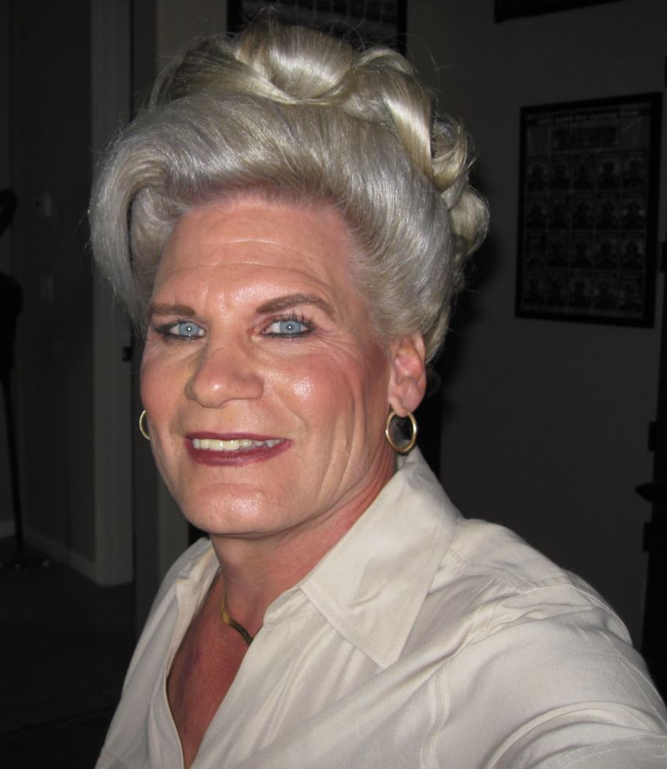

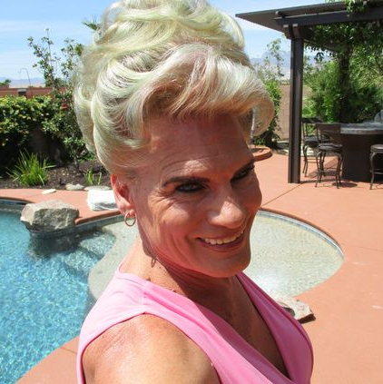 | The hormones did their work in good time.  “These breasts have always been here,” he would say. “They have been hiding all these years, just waiting to be released and bloom large.” It was no surprise to him that he achieved this size without implants.  “I can save the money for my bottom surgery,” Dad laughed.  It is always hard for a family to accept that the organ that brought us into being was about to be cut away and discarded, but we had learned to be understanding and reassuring. We told him that he should go for it when he felt the time was right.

The hormones also affected male muscles, but Dad still maintained strong shoulders. It was suggested that he wear tops with even just a little sleeve but Dad proudly wore sleeveless tops in all but the coldest weather.

“This is who I am,” he said. “A big strong woman, with a great hairdo.”

He was right. Great hair always made him look like a woman.

His first experiments with color were some highlights that he added himself. He taught himself to put in his own roller sets and he was very proud to get them perfect.  “I am not about to learn how to sew or knit, but sure as hell I will learn how to set my own hair,” he said. He is a very determined woman - now that is what he is. Nobody is going to argue.  But Dad knows that sometime the occasion calls for a trip to the salon – with some specialist color and a more glamorous style and some special makeup with false eyelashes.  “This is for Charlie,” said Dad, flashing his legs under the purple dress with the plunging décolletage. “Just to remind him that he is having dinner with a woman, not just an old pal. | 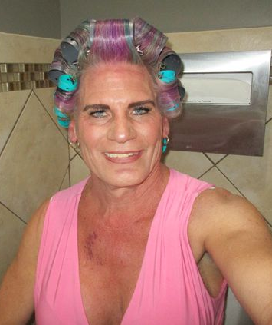

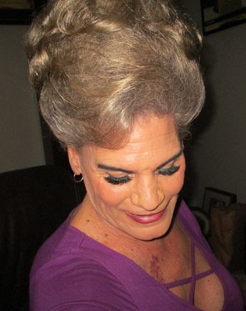 | 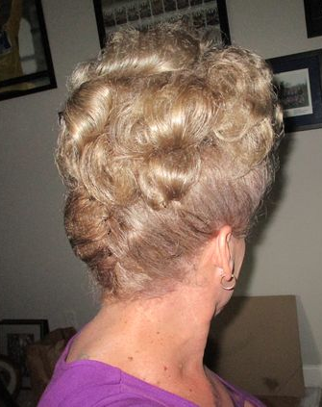

Like I said, Charlie was ready to accept his old friend as being a new new person, while still being somebody that he had known for years. But I don’t think that either he or Dad knew that it was going to turn out so well for both of them.

Maybe it was the dress? Maybe it was the new hair color and flash updo?

Anyway, Dad is pushing through that bottom surgery. He says that Charlie is hanging out for it.

It is always a bit weird thinking about a parent having sex, but in the case of Dad it seems doubly so.

The End

© Maryanne Peters 2022

