My Hero
A Short Story
By Maryanne Peters

It was that period in a hotel cocktail bar when all those who were going to dinner had gone, but before those returning might catch a night cap before going up. Drake was at the bar because he had nowhere to go. The attractive woman was a late arrival.

She sat at the opposite end of the bar. It signaled a lack of interest far too familiar to Drake. He would not force himself upon her. He would whisper to his liquor instead – the kinds of things men talk to their drinks about – ungrateful women and lost opportunities.

He had moved to the end of the bar so he could avoid seeing himself in the mirror. It was better that way. He did not like to look at himself the way he did. It all seemed to have been to sudden – the slide into ugliness. More belly and less hair than any man his age should have, at least not somebody who had been an athlete not that long ago.

Was that why she had left him? Shallow bitch! Or was it the job that went first? Greedy bitch! He was still working, but now the job was shitty. Beggars can’t be choosers. Had he ever had choices? It seemed that life was a machine, and he was being extruded through it.

But she was looking at him. He could see that the woman at the end of the bar was looking in his direction, as if she knew him. There was a time when he would have gone up to her and tried to pick her up, but it seemed like those days were far behind him now. Still, he was drunk and alcohol makes fools of us all. He smiled in her direction.

To his happy surprise she picked up her drink and start to walk down the bar towards him.

She was gorgeous. Even in his inebriated state his penis wriggled a little in his pants as if to reassure him that it was still a living thing. He long brown hair shone and her green eyes twinkled. Her lips were full and so were her breasts. He skirt was short and her legs were long. She was a centerfold come to life.

“It’s Drake, isn’t it?” she said.

He was not sure if he was pleased or crestfallen. Pleased that she knew him, or destroyed by the fact that the person she once knew was now this pitiful creature. Still, he hand the presence of mind to say – “Yes, so we have met before?”

“We went to school together,” she said. He suddenly realized that she could be his age, but she looked youthful despite those years. “My name is Kendra, but that was not my name in school.”

She looked at him as if challenging him to recognize her. Did she wear glasses at school? Was her hair a different color?

“I’m sorry,” he said. “It seems so long ago,” he said, with adding the words ‘and I am drunk’.

“I was Kenny. You remember Kenny. You were my hero in those days.”

Kenny! His mind collapsed into a series of snapshots of those years. Kenny. Now Kendra. It was incredible! But somehow not.

“Wow,” he said. “You look great … Kendra.”

“Thank you,” she said. She raised her glass to him and added – “Maybe some of what you see is down to you?”

“How so?” he asked, raising his own glass with a hand so shaky she must have seen it.

“Don’t you remember when I was doing first aid at the side of the field when you came off with that knee strain? As I taped you up you said that I would make the ideal girlfriend if only I was a girl.”

Kenny. Pretty boy Kenny. The only boy ever to make him say something like that. The only boy to have him question his sexuality. He was right all along, and here was the proof sliding her wonderful bottom onto the barstool beside him.

“I remember,” he said. “And now you are that girl. Isn’t life strange.”

“Life is wonderful,” she said. “To think that we can change when we want to.”

Change? We can fade. We can rot. That is change. That was him. Now beside him was the opposite of that. Positive change.

“You are very beautiful,” he said. It was spontaneous. Alcohol had removed thought from the equation. He saw and he spoke.

“Thanks.” She dismissed his growing desire with a single word. He did not want gratitude. He wanted her body. He hoped that there would be no penis besmirching this gorgeous creature.

“I was your hero?” he asked. Could he call upon the past to help?

She laughed with perfect teeth and a toss of perfect hair. “It was a bad case of hero worship of an older boy,” she said. “There you were the top jock and captain of the football team. I am sure that I was not alone. And of course, all the girls as well. I suppose you married one of them?”

“I did,” he said. “But that ended some years ago.” And then there were two other failed marriages, but they need not be mentioned.

“It was not a gay thing,” said Kendra, as if she felt she needed to explain. “I was not gay.”

“Nor me,” said Drake. But now as he recalled it, it was damn close to that. He had told the boy taping up his knee that he would be interested maybe if he were a girl. What was that?

“I am not gay now either,” she said. She was looking over his shoulder. It forced Drake to snap his head around to see what she was looking at.

A man had walked into the bar. He was older than Drake and Kendra with a big mop of greying hair, but he looked as if he had just stepped out of a gym, despite his smart tailored suit. It was in the cut showing the breadth of his shoulders but also in his walk – like a big cat with his eyes on the prey. He was looking at her, and he was grinning.

“This is my husband Milo,” said Kendra. “Darling, this is Drake. We went to school together.”

He was the same height as Drake, but as Drake slid off his seat slightly stooped, he seemed taller. His hand seemed bigger. Drake would grip it firmly to assert his masculinity, but Milo already had it by the fingers squeezing Drake into submission.

“Pleased to meet you Drake,” said this monster, in a voice that sounded like warm molasses might, if molasses might spoke.

“Likewise,” said Drake, nursing a sore hand.  “I would love to stay and talk, and I am sure Kendra would too, but it is getting late.”  Drake looked at Kendra in desperation. Kenny would stay?  Kendra looked at her husband. He had seen that look before. Women used to look at him that way. It was a look that cried out ‘Take me to bed and fuck me delirious’, as loudly as a scream. But not for many years. No. It seemed so long since a woman looked at him like that.  “Let me give you my card and you can call me to get back in touch with Kendra.” | 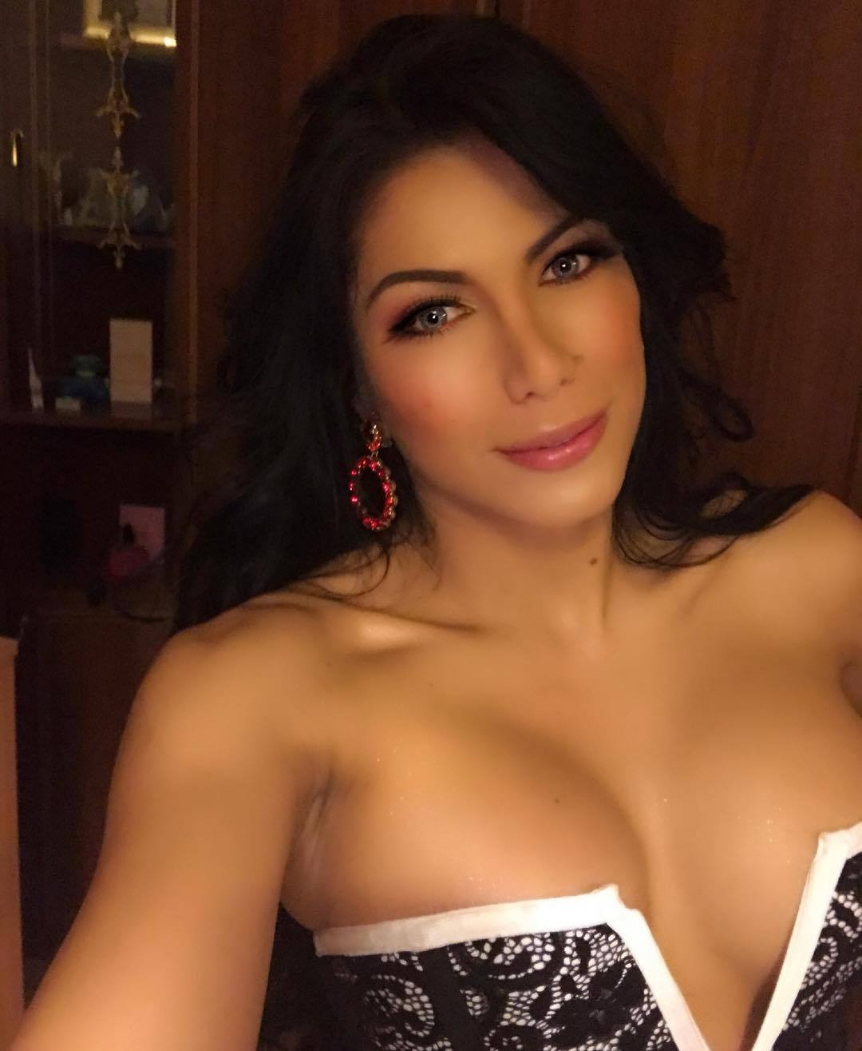

He read the card. It was some massive enterprise and under Milo’s name was the title Executive Chairman. Drake knew that by giving him this card he was not expecting ever to receive that call.

“Please do,” said Kendra. “I would love to reconnect. But for now, wifely duties call.”

She smiled and Drake’s heart seemed to crack a little.

As she walked by him she gave him a small peck on the cheek, mixed with fragrance that seemed to be the smell of love itself, that faded just as quickly once they had left the room.

“You had better give me another,” he said to the barkeep.

The End

© Maryanne Peters 2021

