Never to Old  A Vignette  By Maryanne Peters  I suppose that I had the good fortune to have a good head of hair even approaching my sixties. My surgeon said that where it was lacking it could be pulled forward once the brow bone was ground down and the wrinkles pulled out. Not all the wrinkles mind you - a woman my age does not want to look like a stretched drumskin. A few wrinkles add character.  I told nobody when I went on the hormones. The only thing that they noticed was that I was growing my hair. But when a man retires, he can do as he likes, and as my daughter said – “You do have an awful lot of hair, Dad, and it seems to be getting even thicker rather than thinning”. | 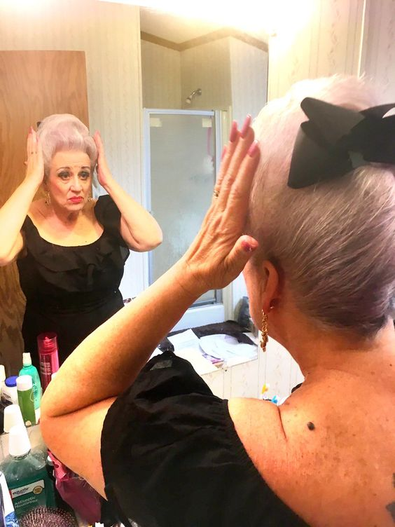

I put it down to the hormones – the female ones, and the absence of male ones. If a man wants a bilateral orchiectomy, then that is his business. I don’t have to tell my kids. In fact, I chose to tell them only when I was ready to step out in front of them as Hannah.

I gave them some prior warning. I sent them some material about transwomen transitioning later in life and told them that I was ready for them to meet the real me. God knows what horror they expected to step out in front of them, but I was determined to surprise them. I was a woman, not a man dressed like one.

I went to the salon and had a nice pink grey rinse put through my hair and then I had it put up in a French roll that has sort of become my trademark do. I wore something sensible in black so that they did not have to see the breasts I plumped for – probably a little too large for starter breasts, but most women my age are pulling theirs out of their waistband.

They all just stood about with open mouths as I gave them a little twirl.

I said, in the new voice I had spent months perfecting and testing over the telephone – “I just want to explain that this is who I really am, and that the man who was your father was a lie. I have no regrets being a father and raising you as a man. It is just that now I must live as the woman I truly am.”

Of course, they were surprised. I gave no inkling of my gender dysphoria. I think that it is important that when you raise children you do not place upon them the added distress of your own condition. I think of that as selfish. I was a good parent.

As to my look of surprise, well that was the brow bone gone and the feminine hair line, which has lifted my eyebrows up my forehead. But I am not complaining. I can no longer furrow my brow as I used, but why would I? I have nothing to worry about these days except what to wear.

My surgeon went to work on my chest too. I wanted breasts and I am too old to wait for them to grow like those of a teenager. He suggested a size more modest than what I chose, but I am a woman, and a woman needs good sized breasts – don’t you agree?

And they are not sagging because they are new. I am not about to let them sag even though they might appear a little incongruous on a woman of my age. Get over it!.

It turns out the woman I am has been living as a man too long and needs so desperately to be accepted as a woman that she might be forgiven for going over the top a bit. So, the black leather bustier and pants with high heels and full length gloves might be considered as going a bit too far, but after two dates with Rodney I felt that he needed to get the message that I did not spend thousands of dollars on a vagina to have it tucked away in my crotchless panties all night.

I might be guilty of coming on a little strong, but I think that a man my age needs a woman that a man would want. I am very positioned to know what that is. Somebody stylish and feminine, and hungry for sex – but gentle sex given our maturity. People our age have learned the value of taking time over the good things in life.

Be honest with me, I look like I am ready to have some fun, don’t you think?
For the ultra-feminine look, I go for color. Men never get much choice when it comes to color, so perhaps I go a little overboard. Pink hair adds a little joie de vivre, and in contrast to that blue it is just perfect – I think. A little see though fabric helps me to strike the pose to show off that body I have strapped in so tightly.  But as I have explained to Rodney, it unfastens at the front, and so does the bustier. He does not have to wrestle with it. I am conscious that at his age he does not need the frustration of fiddling with arthritic fingers to get to the tender flesh of his lady. And when he is aroused the last thing he needs is to get so flustered that he goes soft on me. It’s a horrifying thought for both of us.  Having been in his position I well know the importance of encouragement and foreplay, and taking advantage of the moment to get things moving as vigorously as he is able, for a mutually satisfactory outcome. | 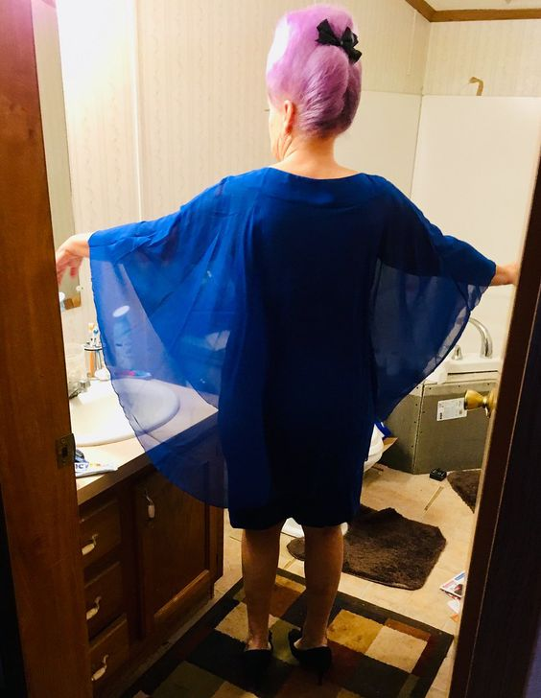
And fur is so feminine, don’t you think? It is from farmed vermin so there should be no issues with a lady experiencing the luxury that only natural fur can give. It is so much more luxurious when the only thing that you are wearing underneath is your white peignoir set and self-supporting white stockings.  I am sure that Rodney will agree that a mature woman can be so much more exciting that some silly young thing with no experience of life. And when it comes to experience, I have the added advantage of having played on both teams.  Proving that you are never too old for love and sex, and never too old to chose to live your true life.  The End  © Maryanne Peters 2022 |  | 