Nipples Don’t Lie
Inspired by a captioned image (Mister to Missy)
By Maryanne Peters

I am her little project. She is a behaviorial psychologist. She knew that I was a cross-dresser when she married me. Many women would have turned my away, but she was curious, and I was a curiosity.

So long as we were having sex, she would not have pushed me further, other than have me grow a little longer. But then she seemed to go off having sex with me, and instead suggested that I look more seriously at becoming more feminine.

I worked at the same university in the English Literature Faculty, so there would be no problem at work. I would be no stranger that many of the staff if I started wearing more gender-neutral clothes. If only that was as far as it would go, but she would not stop there.

The hormones were her idea. She knew they would render me impotent in the doses she administered, but she did not seem to care. She was interested in the effect that they might have upon my behavior.

“We only have the evidence of there effect on male to female transsexuals and the occasional medical anomaly,” she said. “Do this for me. I am thinking of turning it into a thesis. This could get me that PhD.”

The dresses were her idea too. Just practical garments. Very light tee shirt dresses that slip on in one piece with underpants underneath. She bought me several in different colors: pale green, powder blue, lilac and rust. As a cross-dresser I could hardly object, but now there was no titillation, just the appreciation of comfort and freedom of movement. Pants can be so constricting.

She suggested that I color my hair a little – just lighten it to a shade of blonde – ad start wearing a little makeup. It was hardly like dressing up. No thrill there, just a feeling that this was normal.

But it is not normal for a cross dresser to live this. Something seemed to have changed. It was more than just a redistribution of body fat – I seemed to be becoming somebody else.

“Sexual orientation will not change,” she said. “That has nothing to do with your endocrine system.”

It sounded right, but then she brought Mike around to our place. He would be assessing his thesis and wanted to “observe the subject matter of the research first-hand”. I should have been insulted – in fact, I was. I had become a mere object. I wanted to dislike him. The look on my face might show that. But he was a very good looking man. He was taller than me, strongly built and hirsute whereas I seemed to have lost every hair on my body except the long blonde hair on my head.

“The nipples don’t lie,” she said to me after he had gone. “He turned you on”.

She should know. I discovered later that she had been sleeping with him for months, starting even before she put me on estrogen. That was her route to the PhD she was pursuing.

“I don’t want a PhD,” I told Mike. “I just want you.”

It turns out that Mike respects honesty. He knew that was the truth. A man prefers to be desired rather than manipulated. I did desire him and he could see it. My nipples don’t lie.

The End

© Maryanne Peters 2020

Special Gift  Inspired by a Cap  By Maryanne Peters  I have a special gift. People say that you can learn how to hypnotize, and that is true to an extent. But when it comes to the ability to manipulate the mind to the extent I can, that is a gift.  When you have a gift like mine, you take it to Vegas. There is a place where a man can make money. The trick is to use what you have to get the maximum return. That was my objective. | 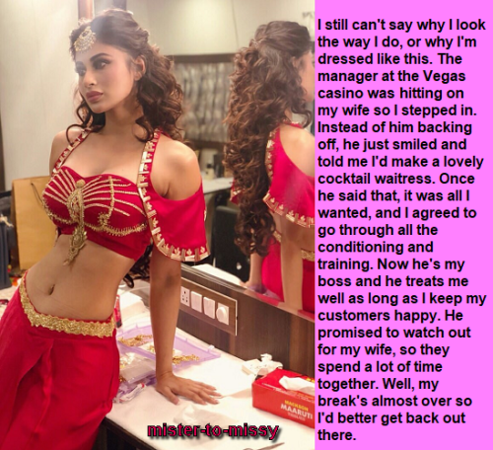

I found the right casino in “The Medina” which was financed with Arab money and had a Middle Eastern theme. I sold them into my show as “Al Sahir” – the sorcerer. It was no accident that they loved the concept. I used every persuasive technique.

So I was given the job of Entertainment Manager which meant that all talent was selected by me. But even I can succumb to temptation, and I have to say that I fell for a young singer and I pursued her. As a rule I do not use my talents to seduce women. A woman without vigor is unattractive to me. But I could certainly use my gift to divert her jealous husband.

The strange thing was that I found something unusual in his face, even in anger. He had wonderful big brown eyes, quite wasted on a young man, and a big mop of dark brown hair. It was exactly the look that I wanted for those serving cocktails in my act, except they had to be women of course – sexy women.

I suggested to him that he would make a lovely cocktail waitress. My suggestions are often accepted, as you might well guess.

I had others who had been recruited, so he was not alone, except for the fact that he was the only male. But somehow, he never even noticed that. He agreed to everything that the others agreed to. Peer enthusiasm is a powerful driver, perhaps more so that hypnotic suggestion. And, as I reminded him, he would be working in the same casino as his wife – although she was singing in the lounge and my act was in the auditorium.

Some of the girls needed breast augmentation. Most of them needed hair extensions. All of them needed a thorough beauty treatment. His wife hardly noticed. Without too much effort and without applying my gift I was able to win her and have him relegated to living in the staff quarters with the other harem girls.

But true beauty is in the eyes. The Arab know that best, when they can only see the eyes above the veil. I had seen it when she lived as a man, and no that she was Alisha, I found those eyes bewitching. Those eyes were her special gift. Eyes that can take control of a man as surely as I had taken control of the man she once was.

I can’t even remember the name of the wife, although she still sings in the lounge. All I want now is Alisha.

The End

© Maryanne Peters 2020

New Older Daughter  Inspired by a captioned image  (Mister to Missy)  By Maryanne Peters  It really was a mistake to marry a younger man. I thought that he would be good with the kids, but he was only concerned about himself, and he started to become increasingly aggressive towards me.  Divorce would mean a pay out that I could not afford. Short of pushing him under a bus there seemed no way out. | 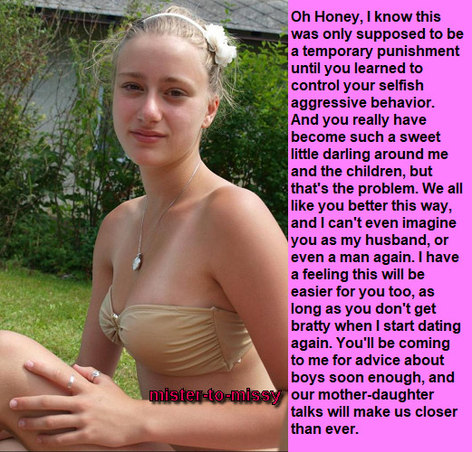

If only I had just hired a nanny instead of marrying this guy. What my children needed was an older sister figure, not a young stepfather. If only … which got me to thinking. My business gives me access to the drugs I would need to curb his aggression and more; and my sister runs a salon and spa renowned for miracle makeovers. Could it be done?

Well, this is the result. Pouty maybe, but passive, and with a slim weakened body and a pair of breasts any teenage girl would be proud of. My sister and the hormones did the job on his face and body, and those same drugs and some others, and a little help from my children, did the job on his mind. My son, who is so close to my husband in age it is almost indecent, reminds him that he is no longer male, and my daughter reminds him that it is good to be female.

So I am ready to move on. I will be dating men again, but I will have to explain to those I might meet that I am already married, and I am not available. I will not be making that mistake again.

So I guess it is an open relationship. How could I deny my pretty little husband the joy of intimacy if I am to pursue it elsewhere? Just not another woman. That would be an affront. But another man who can give him what he needs, whether or not he might like it – that is another matter.

Will he be my new older daughter? I hope so. I still care for him in my own way.

The End

© Maryanne Peters 2021
Trigger  Inspired by Mister to Missy  By Maryanne Peters  I was a basket case before the treatment. My mind was full of conflicting emotions that sometimes exhibited as violence, often towards Susan – but nothing physical. My frustration was all about not be able to be my real self. It was something that I could not talk to Susan about. I knew that she would never understand.  The idea was Dr Nalder’s. She was a brilliant analyst and it was her idea that we make Susan believe that I could be controlled by hypnotic suggestion. At first I did not like the idea of deceiving my wife, but I decided to go along. | 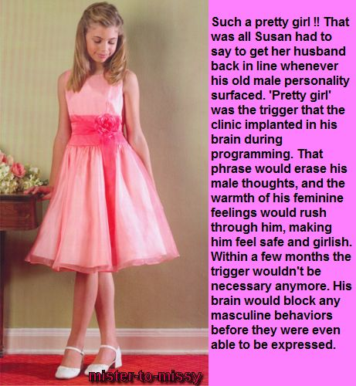

“His behavior is hyper-masculine,” Dr Nalder explained to her. “If we place a suggestion in his mind that neutralizes those thoughts on your command, you can control his behavior, if that is what you want. It might result in feminine behavior, but if that is what you are prepared to accept to put an end to these outbursts, that is your choice.”

Susan asked for the doctor to explain. I listened to the tape.

“When you say the trigger out loud it will cause a rush of feminine feelings. He will feel safe and girlish. After using this over time we would expect his behavior to modify so that you would not need to resort to using the trigger. Is this really what you want?”

She was ready. She was prepared to modify the mind of her own husband for her convenience, disregarding whatever internal turmoil I was suffering under. I knew then that she did not truly love me.

But thanks to Dr. Nalder I never had to explain. I never had to tell Susan that my hyper-masculinity was my internal battle against gender dysphoria, a condition I had endured as long as I could remember. But now the only one I could not come out was her, and she did not care what was wrong with me.

I did not fake it. I got angry. She said the words and they really did work. When I heard them, I knew that I could begin on the path towards transition. I sat on the sofa with my knees together and my hands in my lap, and tilted my head and smiled, lisping: “I feel better now, Susan.”

But that was just the beginning. It was the starter’s pistol that set me off, and my wife could only look on with dismay as my femininity just spilled out. She contacted Dr. Nalder and even threatened to sue his clinic.

Dr. Nalder started with: “I did explain the risks of any attempt to modify behavior”, but then went on to: “You should accept the possibility that your husband was always transgendered and that what you did just triggered him to seek transition”.

My response was just to smile at her sweetly and say: “I will never hurt you again. We can be besties together, you and me. I will be such fun.”

The problem with being besties was that as girls we had little in common, you see. My wife is a woman and I am still just starting out, as if I were a little girl. I tend to go a little over the top with pink flared dresses and sashes with rosettes, and I just adore my new hair extensions. But I do look so young. I guess it is just become I am freshly female.

Susan finds it all very annoying, but I love the new me.

The End

Author’s Note:
I guess people who know my stuff know that I am grounded in reality, and I do not believe in hypnotic feminization, and of course age regression is fanciful nonsense, but when I find a cap like this I find myself searching for a way to make it real.

Personal Assistant
Inspired by a captioned image
(Mister to Missy)
By Maryanne Peters

The problem was that I had blown all the money on an investment that was never going to succeed. That is what I got as my share of the settlement. She got the business. I had to watch that go from strength to strength under her management while what I watched what I had ended up with crash and burn.

I begged her to be allowed back. I told her that I knew the business better than anybody. She knew that was right. But it was her business now and she wanted everybody to know that. If I came back I could not come back as me. I had to be somebody else completely. Somebody nobody would recognize who worked closely Laura as her P.A.

Have you ever heard of a “Feminization Academy”? I hadn’t. Apparently the one that I was sent to is not the only one in the country. Some people go there because they want to – the genuine transgenders. Others say that they are only there because they were forced to be, but they are really there because they want to be – the fantasists. And then there was me.

The tutors said that it was wrong to force the female role on to me. I tried to say that it was my call – I had accepted it.

“Switching gender under duress is something we do not do,” they said. But there was no getting back into the business unless I completed the course. So I had to say that I was transgender after all, but a fantasist. Treating it as being against my will was a turn-on, but I really want to be a woman.

A man must believe that the most demoralizing thing in the world must be to behave like and be treated as a woman. But why? The first thing that we learned at the Academy was that being a woman was choosing the better sex, and we should be proud to called women. I may have hidden a snigger, but if I did I was the only one there. Everybody else welcomed womanhood with enthusiasm.

Maybe that had something to do with it. Maybe it was the fact that I made such a stunning woman. I mean it was mainly the legs and my slim build, but my breasts turned out pretty well too.

When I went back to the office I learned that she had told everybody that her new PA used to be her husband, and that I would shortly be undergoing a sex change. But with everything that I had learned at the Academy instead of being embarrassed I was proud.

“Yes, I am a transwoman, and proud to be one.” What is more, my co-workers, who are all women, make me proud to call myself one of them. They are a great bunch and we get on like a house on fire, at work and outside work too.

Laura will never understand. I simply told her that I don’t care, and nor does anybody else. She can live with her pettiness. She may be in charge but if people want to know what is really going on or what to do next, they come to see her P.A.

Yesterday she said to me that I could drop it, I could lose the dress and fake breasts and have my hair cut.

I told her. “Fake breasts. These are implants. And I love wearing a dress. And I have moved on. I am having hot sex with Hamish from Accounting and we are saving up for my vaginoplasty. But in the meantime I am happy to remain your personal Assistant.

The End

