Working His Body(Suit) - Part III
By Soul-Controller
Upon realizing that he had been caught in the midst of jerking off by his new boss, Martin gasped in shock and tried to explain himself. This was the worst possible scenario, especially as the new bodybuilder’s mind couldn’t help but consider the concept of being immediately fired and being forced to take the bodysuit off and go back to his incredibly average form. “I- uh, Tony, this uh, this isn’t what it looks like I swear,” he exclaimed, stuttering over his words as he tried to pull his hand away from his cock but found that he couldn’t stop himself from continuing to slowly stroke up and down its increased length.

For a moment, the man was increasingly panicked as Tony stared at him expressionless. But after a moment, Martin felt a sigh of relief begin to form as he watched the young curly-haired man’s lips begin to curl into a slight smirk. Making his way closer to the nude bodybuilder, the manager looked Martin up and down a few times before stopping and resting against one row of lockers.
After a few moments of prolonged silence, the confusing tension was finally broken as Tony began to speak. “No, I think this is exactly what it looks like,” he began, a light chuckle escaping from his lips as he continued to look at the terrified bodybuilder. “Go on and finish what you started…”

Despite how clear his smirk was, the bark-like tone in which Tony delivered the words told Martin that it wasn’t so much a simple suggestion but actually an order. Instantly, this realization caused his mind to become overcome with lust as he restarted his passionate and frantic stroking. Although he hadn’t intended for his eyes to maintain their longing stare on the attractive manager, Martin was unable to pull away as he finally reached climax and began bucking his hips as a shower of cum began to shoot out of him and hit everything in front of him from his normal street clothes to the lockers on the other side of the hallway.

Given how extreme his climax was, Martin was understandably exhausted for a moment and thus leaned back against a row of lockers and attempted to catch his breath. While he was doing so though, he watched as Tony disappeared for a moment and returned with a wad of toilet paper in hand. Although he tried to tell his boss that he would clean up his own mess, the manager seemed determined in his plan and thus refused to stop as he quickly wiped everything down and sterilized it before making his way up to Martin.

Given how heavy his breathing now was, Martin’s sight was a bit hindered as he watched Tony lean down and be completely hidden by his new plump pecs. Upon watching as the man returned to an upright position in front of him, Martin looked to see two interesting sights. Not only was his right hand holding wet toilet paper that was clearly used to clean up the puddle of cum that had spawned on the floor, but his left hand revealed that two of his fingers had been coated in the new bodybuilder’s seed. To the man’s shock, he watched as Tony gave a light smile before opening his mouth and using his tongue to lick off the remnants.

Instantly, Martin found his cock beginning to harden once more as he immediately took the action as a clear as day sign that Tony was attracted to Martin’s new form. Despite realizing the countless possibilities that this could create given how Martin himself had also been instantly attracted to Tony, he forced himself to try and maintain his composure given how jumping his manager’s bones on the first day posed a risk of losing out on this incredible new body.

To his annoyance though, this attempt was challenged as Tony ordered the new employee to sit down on the bench. Opting to obey orders first and ask questions second, Martin took his seat on the freshly-cleaned bench in the middle of the aisle and watched as Tony walked behind him. “Is uh, is something wrong,” Martin asked a minute or so later, his question spurred by the poking and prodding that Tony’s fingers were making against his immensely broad back.

“Nah, I’m just making sure that the suit sealed itself properly,” Tony quickly responded, punctuating his sentence with a few more pokes and prods further down Martin’s spine. After this process continued for another couple minutes as the man triple-checked the entirety of Martin’s back, Tony suddenly leaned forward so he was cheek-to-cheek with his new employee. Upon flashing a smile towards the jock, he told Martin that the suit was good to go and that he could stand back up.
After doing so, Martin watched as Tony reached inside the huge box that had once contained his bodysuit and pulled out a shiny black thong. The manager then told Martin to put it on to help “cover himself up”, pointing out the still rock-hard boner that was jutting out from his crotch. Rather than feeling embarrassment about his obvious attraction to this entire scenario, the man instead felt proud of his new form and thus felt no shame as he grabbed onto the poser and began to pull it on. To his amusement though, his burly new legs and arms provided a bit of an issue of struggling to pull the skimpy piece of fabric up his body. Luckily, Martin was able to receive help via Tony, who helped complete the job and tucked the man’s cock into the tight poser and helped make sure that the fabric fit tightly into his ass crack.

Although he didn’t want to be annoying and ask all of the questions that were frantically coming to mind, Martin found himself unable to stop himself from turning to the handsome young manager and asking him the most important question. “So uh, about this whole suit thing. Are you wearing one? Or are you just, uh, naturally that buff and handsome?”
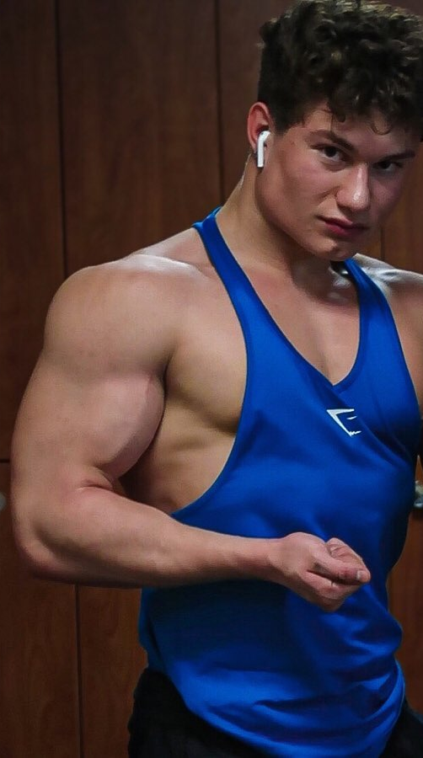
Although Martin hadn’t intended to be so direct, the question itself didn’t seem to offend the young man as the manager let out a light chuckle and flashing an inviting smile to the new employee (which only made it harder for Martin to not rush forward and plant a kiss on those plump lips). “Oh yeah, this is 100% a suit. This is about the polar opposite of what I usually look like,” he began, stopping himself as he looked down at his arms. To Martin’s relief, he watched as the jock lifted one arm up and flexed the muscle. “I definitely much prefer this body though.”

For a few moments, Tony found himself distracted by his muscles as he gave an unintended show to Martin as he flexed his biceps a few times and moved the straps of his tank top to pop his pecs and enjoy the musculature his job had gifted him. Upon finishing up with his mini flex session, the gym manager couldn’t help but smile and begin speaking once more. “Thank god it will only be a few more months until this is no longer just a suit…”

While Tony had simply stated that last sentence as a passing remark to himself, the words had instantly caused an insurmountable level of intrigue and excitement to permeate throughout Martin’s broad body. The concept of having this body permanently seemed like a dream come true, so much so that he couldn’t help but ask a few more questions. “Holy shit, there’s a way you can keep these bodies? What do you have to do?!”

For the next few minutes, Tony spent his time explaining to Martin what he meant. In hopes of boosting team morale and rewarding employees for their hard work, the company had started an initiative in which employees were able to permanently wear the suits and thus be given a new identity to live their new lives after a year at the company. Tony then revealed that although S-C Fitness doesn’t require the employees to maintain their positions at the company after receiving the bodysuit, they do aim to remain a constant influence in their workers’ lives. As a result, they require that the employees that do leave use their social media accounts to promote future S-C Fitness products and membership deals in hopes of a mutually beneficial relationship that will just foster the company’s continued growth.

Throughout the entire conversation though, Martin was confused by the fact that Tony kept referring to his form as his “new identity” rather than his “new body”. As a result, his inquisitive mind was unable to stop itself from asking more questions. “What do you mean by new identity though? Like they just give you a new body and that’s it right? It’s not like you become somebody else entirely…”

To Martin’s horror though, Tony shook his head to deny that idea. “Nah, it’s an entirely new identity bro. New body, new name, new everything. They do some witness protection level shit to give you an entirely new identity so no one could possibly know who you used to be. Hell, I heard they even have the ability to make sure that you forget about who you used to be to make sure that the company’s secrets never become unveiled.” After reaching deeper into the box that had once contained Martin’s bodysuit, the man then pulled out a shiny new name tag. “Ah see, when you’re working here, you don’t even go by your real name anymore. Like, my name isn’t even Tony! From now on, it seems your work name is gonna be Emmanuel,” the manager revealed, grabbing onto the name tag and holding out for Martin to see.

Upon doing so, there was a bizarre sense of both panic and excitement about this reveal. Although he was quite happy with his name and family and thus didn’t want to lose that aspect of himself, the concept of turning into this hunky bodybuilder seemed like a dream come true. Hell, even his new name sounded hot to him and fit his new body much better than Martin!

“Ok, before we have you get out there and start working,” Tony began, ”we should run through some basics so you’re not completely thrown to the wolves out there.” This caused the nervous new employee to eagerly nod his head in agreement. Upon doing so, Martin listened as Tony gave tons of pointers about how to appropriately help their members do their best possible workouts like reminding him to have them lift with their legs rather than their backs.

Upon finishing up after rattling off a few more tips, Tony then ended his lesson by pulling off his shirt and revealing his ripped physique. Martin unintentionally gasped at the reveal, which caused Tony to chuckle and give a friendly wink in his direction before continuing to speak. “Alright, so we also have a bunch of bodybuilders that love to come in here and get help perfecting their poses before their shows. This is most likely going to be a popular task for you, especially given how incredibly large you are,” Tony explained, looking the man up for a moment and slyly licking his lips. Grabbing a hold of Martin’s callused hand, Tony led the duo to a large full-body mirror so they could both stare at their muscular physiques.

Out of nowhere though, Tony began to rattle off countless poses and tell Martin to do them. Although his mind had no idea what he was talking about, it seemed as though the bodysuit had some sort of muscle memory as it began to immediately move on its own accord and make Martin to do the desired poses. This initially freaked out the young man, causing him to frantically ask what’s going on until Tony explained that it’s all natural. Upon asking what he was talking about, Martin learned from his manager that the suits were embedded with a breadth of fitness knowledge that would allow any employee to effortlessly assist any gym member without having to stutter and be unsure of an answer.

“While working here, Tony explained, “there’s nothing you need to worry about. Just sit back and enjoy every perk of that incredible body of yours.”

After hearing this, Martin found himself taking a deep breath and starting to savor the experience of perfectly executing the poses that Tony was continuing to bark at him to do. So for the next several minutes, this exercise allowed any fears and nerves to alleviate from Martin’s mind as he found himself really getting into the posing and enjoying the positive affirmations that Tony was offering about how “perfect” his poses were looking.

Although Martin could have continued doing this process with Tony for hours, a quick glance at his watch caused Tony to immediately end the posing session. Upon giving Martin a playful but firm slap on the ass, the manager told him to hurry up and get dressed so they can begin working. As soon as he nodded his head, the man wasted no time grabbing onto the S-C Fitness branded clothing and pulling them onto his burly frame. After giving himself a quick little glance in the mirror and seeing how immense and handsome he was, the brand new Emmanuel gave a quick smirk in the mirror before turning and following his manager out to the busy gym floor. Tony had completely calmed his nerves, causing the bodybuilder to become quite eager to get started on his job. He was going to fully commit to this new role, especially if it meant that he would one day be able to have this body permanently for himself!

