Kasumiko’s Mask Mayhem
It was a Day like any other at Kasumiko’s store many customers came in today and Kasumiko has sold a lot of CD’s again. It was exhausting but seeing her Customers being Happy gives Kasumiko an really good feeling and she couldn’t be other than being happy herself. Then suddenly a new Girl comes into her Store and Kasumiko happily said: “Welcome to Kasumiko’s Music store. My Name is Kasumiko how can I help you?”
Then the new Girl said: “Hi I’m Ray, I came here because a good friend from me has said you’re an expert for Japanese Music and Figurines and I’m on the Search for the Limited Sexy Nine tails Kitsune Figurine from the New Anime called Fun with the Kitsune.”
Kasumiko: “Oh that’s great. And yes, I have the Figurine here you’re Lucky because I only got two of those.”
Ray: “Yay that is cool!” then Ray looks closer at Kasumiko and noticed that Kasumiko looks like she is a Kitsune herself and asked: “Pardon me but I noticed you’re looking like a Kitsune is this your normal Work Outfit? ^^”
Kasumiko: “Yeah you could say that. Actually, I’m a Real Kitsune Girl. ^^”
Ray: “O////o Really? Y-you look g-great and really s-sexy. >////<”
Kasumiko: “Thanks Ray! You’re making me blushing with your Compliments. ^///^”
Ray: “A-anyway how much cost the Figurine? I hope it’s not too expensive.”
Kasumiko: “Don’t worry for a Limited-Edition high Detail Figurine she is actually really cheap she costs only 60$ and they are limited to 500 pieces Worldwide and Hand Painted and you get a nice Wall scroll of the Main Character Asuka with it. ^^”
Ray: “That’s nice but 60$ is a little bit expensive for me because I have only 55$. >.<”
Kasumiko: “Don’t worry because a Friend has sent you to me, I can give you a 5$ Discount. Just tell me the name who has send you to me and were good to go. ^^”
Ray: “Oh cool, ok her name is Akira. Akira Miyasaki. ^^”
Kasumiko: “I see. Moment did you say Akira Miyasaki?”
Ray: “Yes. ^^”
Kasumiko: “If that’s the case I give you 10$ Discount on the Figurine because Akira is also a close friend from me too. How small the World is? ^^”
Ray: “R-really you know Akira too? That’s cool and you seem to be a really nice Person too.”
Kasumiko: “Yeah, she is really good Friend of me and you seem also like a nice Person why not let’s be Friends from now on? ^^”
Ray: “Yeah sure! I would be totally happy about that also you’re the first real Kitsune Girl that I meet too.”
Kasumiko: “So the Figurine costs 60$ minus the 10$ Discount that’s 50$ please. ^^”
Ray: “Here you go.”
Ray gives Kasumiko the 50$ and gets her Hands on the Figurine then Ray happily said: “Finally I can hold the Asuka figurine in my hands. Thank you Kasumiko.” then she hugs Kasumiko.
Kasumiko: “No Problem Ray. ^^”
Ray: “Please come later to me I must show you my Figurine Collection. Here is the Address. ^^”
Kasumiko:” Ok when I have closed my Shop, I come to your house. ^^”
Ray: “Cool see you Later Kasumiko! ^///^”
Then ray left the Store happily and Kasumiko was also Happy that she has one more Friend.
Later at the Ray Mansion
Ray was in the Mansion and unpacked happily her new figurine to place it on the Shelf then Ray looked at the Figurine closely and she said: “What a great Figurine Asuka looks really Sexy with her Nine tails in that Bikini. She is worth every Penny that I paid for it. ^^”
Ray looked at the clock and said: “Oh it’s Time that I get ready Kasumiko should come soon.”
Then Ray leaves the Room and getting ready for Kasumiko’s visit.
Outside of the Mansion
Kasumiko just arrived at Ray’s Mansion and said: “Wow! Look at that Mansion it’s Huge! Ok this should be the Doorbell.”
*ding dong* the doorbell rings and Ray opens the Door.
Ray: “Hi Kasumiko is nice that you have come. Come in. ^^”
Kasumiko:” Hi Ray ^^ I didn’t know that you live in such an huge Mansion.”
Ray: “Yeah I hear that often. ^^ How about we talk first an little bit and then I show you my Collection of sexy Figurines. ^/////^”
Kasumiko: “Yeah sure why not. ^^”
Then the two of them going to the Living Room and they talked for about two Hours and then ray said:” Ok enough Talk, let me show you my Collection. ^^”
Later at the Collection Room
“Here this is my Collection Kasumiko” said Ray.
Kasumiko:” That is really an Impressive Collection of Kitsune Figurines that you got Ray.”
Ray:” He he, thank you Kasumiko.”
Kasumiko: “Looks like you also got you hands of the Rare Kitsune no Story Fun Figurine. This is one of my favorite Figurines and I have it in my apartment too. ^^”
Ray:” Oh cool, then I’m not the only one of us that got this sexy Figurine.”
Suddenly Kasumiko sees an old Mask on a Stand on the desk and Kasumiko thinks: “What? The Mask of Loki? That can’t be! How did she get her hands on Akira’s Mask?”
Kasumiko: ”Could I ask you something? What is that an old Mask?”
Ray: “Oh that’s just an old wooden Mask that I have found in the see and I have decided to keep it just for the Collection. And I have decided to give her the Name Massa. ^^”
Kasumiko: ”Ah ok! Looking cool can I hold it on my Face for a Moment?”
Ray: “Yeah of course……. I mean no that’s not an good idea.”
But it was already too late Massa happily jumped out of Kasumiko’s hands and stretched around of Kasumiko’s head and Kasumiko starts to feel a great pleasure as Massa continued to change her.
“Oh no! Not again! >////<” Ray said as she panicked a little but at the same time Ray’s heart was racing and she was curious how Kasumiko would look after the Transformation.
Then Kasumiko starts to moan louder and louder as suddenly her already big breasts getting one Cup size bigger and her Ass getting bigger and firmer too.
As the Transformation continues Kasumiko grows 5 more Kitsune Tails but they were different in Color. Three of the Tails are Abyss Black in color with Blue hair tips and the other two Tails are white and having Black hair tips. But that was not all as suddenly two large Succubus wings growing out of Kasumiko’s Back too.
As the Transformation is Completed a completely new Kasumiko in an Sexy Dress stands in the Collection Room.
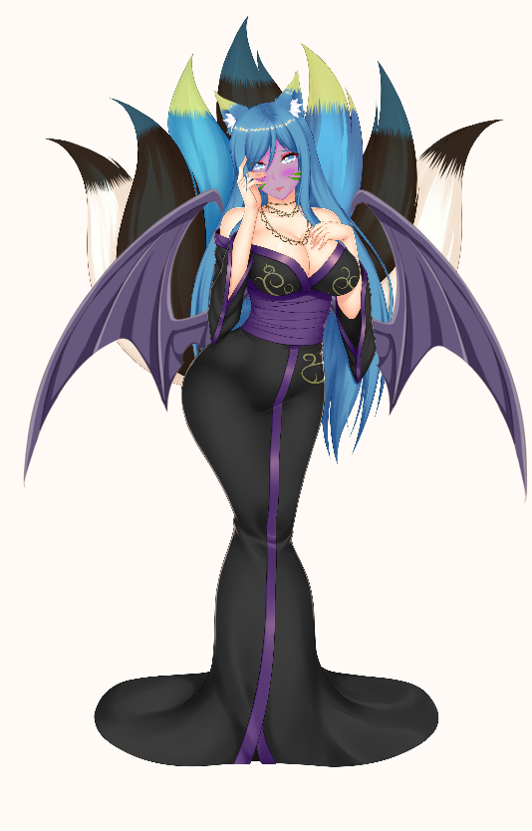
Ray:” K-k-kasumiko? Are you alright?”
???:” Oh, I never felt better sweetheart! And I’m not Kasumiko, just call me Diamond. <3”
Ray:” O-o-okay! D-diamond >////////<”
Then Diamond hugged Ray and pressed her closely on her enormous chest and said:” Ok cutie! Now let’s have some Fun!”
Diamond then gives Ray several Kisses and Ray enjoyed all of them. Being hugged by a Sexy Kitsune Succubus was one of her secret dreams.
The two of them then headed to the Bed and having a really hot night together.

Credits: RayDark for Massa and Ray
I hope you enjoyed this little Story. ^^

