S-C Escapes: Austria (Part II)
By Soul-Controller
In the aftermath of taking a swim in a lake and coming out of the water as a muscular DILF, Luke DeAn was understandably quite conflicted by what he had endured. Although he personally wasn’t upset about the end result given just how much he often thirsted over muscular older men like the one he had seemingly turned into, the lingering fear that he was being transformed against his will caused him to become quite fearful. Even after frantically looking around and seeing no one hidden amongst the trees of the forest, Luke still assumed that there had to be an individual responsible for what had occurred to him. So in hopes of preventing further changes from happening, the man mentally made a plan of keeping himself amongst a large group of people. like the group by the pool would work.

As he finally made his way out of the woods with his clothes and other items in hand, Luke traversed across the grass of the resort. Upon looking over and seeing that the pool was still quite active, the new DILF realized that it would be the perfect place to have safety in numbers and thus made an immediate beeline in its direction. While it would also be a good group to keep himself amongst, the new bodybuilder also thought about how he could use the close proximity to the hidden trail as a way to sit and see if he could find the culprit of his transformation try to secretly make their way out of the woods and avoid detection.

Before he could make his way over to an available pool chair though, Luke’s attention was suddenly stolen by a deep booming voice that seemed to be addressing him. “Hey daddy, looking good,” the gruff voice cried out, causing Luke to stop dead in his tracks. At first he thought he must have misheard, but the continued dialogue from the voice proved that he was correct. “Yeah you, what’s a stud like you doing all alone,” it cried out, which caused Luke to finally turn towards the pool in search of the person speaking. Given how active and hectic the pool was, it took a few moments before Luke’s eyes finally picked up on the bearded hunk who was sitting at the edge of the pool’s deep end.

As Luke took a moment to observe the man, a bashful reddening began to emerge on his cheeks as he noticed just how attractive the man was. Beyond his general thirst for DILFs like the one he had just become, Luke also had an intense thirst for buff and hairy hunks like the man talking with him. Plus, the smattering of a few tattoos across his arms was the perfect cherry on top to make the man absolutely irresistible to Luke. In fact, he was so enraptured that he instantly forgot about his plan about searching for the culprit of his transformation and instead made his way over to the edge of the pool.

Upon seeing that his directness had worked, the man swam across the pool until he was right in front of Luke. “Glad to see that the approach worked. The name’s Alexander,” he said, offering up a coy smile that instantly caused Luke to blush even more.

“Oh uh, hello,” Luke said, offering up an awkward smile and wave as he moved to introduce himself. “My name’s Luke, it’s great to meet you Alexander.” With their introductions now out of the way, Alexander invited Luke to join him in the pool. Despite not initially wanting to go back into water given what had happened to him last time, the instant attraction he felt for Alexander along with the other man’s obvious thirst caused him to go along with it. He had never been so actively desired and Luke was eager to explore this new dynamic for himself. Upon setting his clothes and items on a nearby chair, the new DILF made his way down the ladder and into the water.

After the initial shock of the cold water wore off, Luke finally got accustomed to the temperature and allowed the rest of his body to submerge as he made his way over to the corner that he had first seen Alexander at. Upon meeting the man there, the bashful 23-turned-50-year-old was eager to keep the conversation going. “So, what brings you to Austria?”

Not surprisingly based on the accent, Luke learned that the man was a New York City resident who had decided to take a little European vacation to destress after a huge art exhibit he did as a photographer. “Oh that sounds awesome,” Luke began, suddenly clearing his throat as his voice felt momentarily dry. Upon finishing up his cough until his throat didn’t feel so scratchy, the man opted to continue speaking. “I’m from the US as well actually, I got entered into this contest and ended up winning an all-expenses paid trip here!”

Upon finishing his speech though, Luke was suddenly caught off-guard by the slight chuckling coming from the bearded hunk. The man didn’t seem to think anything was amiss, but that soon changed as Luke continued to look at him with a confused stare. “Oh uh, you weren’t joking when you said you were from the United States?” Alexander began, “Based on that accent of yours, you seemed like a tried and true European!”

“Wha- you think I’m European?” Luke instantly responded, stopping himself from speaking further as he took a moment to realize how his voice sounded. Rather than his normal voice, he could suddenly pick up on the way the words were spoken differently as different letters were suddenly given precedence. It seemed odd at first, but it really sounded like he was European now!

Despite instantly feeling panicked over the realization that he was changing more, his own thirst for the young hunk left him eager to conceal that fear. He didn’t want to blow his chance with the clearly interested hunk and thus opted to just go along with the change. Sure it was strange to suddenly speak like a European rather than an American, but after the intense changes that had occurred to his body while swimming in that lake, an accent change was the least of his problems.

“Oh yes, I’m absolutely European,” Luke responded, instantly going along with what Alexander had said to avoid any confusion or discussion that wasn’t flirty. “I was just messing with you a bit! Good ole European humor,” he continued, mentally scolding himself for ending with such a hokey response.

Despite his annoyance with his dialogue, Luke found that Alexander didn’t mind it at all. In fact, he found it funny as he loudly chuckled before making his way closer to Luke until they were both in the corner of the pool.

“So, what do you do for work then Luke?” Alexander inquired, leaning back against the tiled side of the pool while extending his arms out across the concrete of the walkway.

The question was often a simple answer given the fact that Luke was still in college and had a part-time job as a result, but that wouldn’t work given his new appearance. Plus, due to Luke’s own desire to impress the attractive hunk, there was no way that he would say that his burly 50-year-old self was just a college student and part-time worker. As such, he decided to embellish and instead state that he instead had the career that he was going to college in hopes for. “Oh uh, I’m actually a lawyer,” Luke offered up, reaching up and scratching his head as he hoped that his answer would be accepted with no real questions asked.

“A lawyer huh?” Alex asked, pushing himself off of the wall and instead making his way closer to Luke. “Not gonna lie, I’m a bit shocked by that.”

“Oh really? What did you think then?” Luke instantly retorted, his eyebrows raising while awaiting an answer.

Shrugging his shoulders, Alexander took a moment before answering. “Honestly, I thought you were just some meathead bodybuilder who made money from personal training or something. A lawyer though,” he continued, “you truly love to surprise me!”

Although the assumption that he was just an old himbo originally stung due to how educated Luke was, he couldn’t deny that a part of him was feeling strangely confident and loving Alex’s assumption. His eyes weren’t deceiving him, he truly had the physique of a bodybuilder! Before he could further savor the unintentional perk of his transformation though, Luke watched as the man suddenly leaned in and began to whisper into his ear.

“I know this is a bit direct, but I can’t deny how turned on you make me. What do you say you and I go somewhere a little more private? Maybe your room perhaps?” Alex said, pulling away from Luke’s ear and showing off a seductive and sly smile.

Despite how calm and collected Luke was pretending to be on the outside, his mind was running rampant with panic and anxiety. For 23 years his romantic life was practically nonexistent, but now that he was a 50-year-old hunk he was already being propositioned for sex by one of the hottest men he had ever seen. Although he still presumed that he had somehow been cursed by the age progression that had occurred to him, he couldn’t deny that he was starting to accept the situation given the perks it provided to him. “Oh, I think I like that idea,” Luke responded, the words accidentally coming across as seductive although in reality he was truly unsure of what to do or how to feel.

Upon hearing confirmation in regards to his idea, Alexander maintained a smile on his face as he quickly swam over to the ladder of the pool and made his exit. While still shocked over what was happening, Luke closely followed behind as he made his way up the ladder and back onto the firm concrete pathway. Upon making his way over to the nearby chair where he had left his stuff, the DILF met Alexander over at a towel rack where they each grabbed one and quickly dried off before wrapping it around their waist.
With each passing step that the duo took as they made their way into the hotel, traversed through the lobby, and entered the elevator, Luke’s heart was exponentially beating faster. Although the concept of physical intimacy was enough to ramp up his heart rate, the sudden sensation of feeling Alexander wrap his fingers around Luke’s own until they were firmly holding hands left Luke completely overwhelmed. The towel wrapped around his waist was certainly needed as their continued hand holding would have caused an obscene display of his thick manhood pressing against the fabric of his shorts to any passerby.

Although his cock was growing increasingly turned on the point of beginning to have pre-cum seep into the tight swimwear, Luke failed to notice as the tight quarters and privacy of the elevator caused the duo to become much more intimate as Alexander laid his head down onto Luke’s broad shoulders. Despite how eager the new bodybuilder was to interact with the hunk, he was in total awe and just allowed Alexander to take the lead as he looked up into Luke’s eyes before placing a hand at the base of his neck before pulling him into a kiss.

As soon as their lips met, butterflies emerged in the pit of Luke’s stomach as he felt like he was ascending to the heavens. Having the physical touch from such an irresistible stud was quite the feather in Luke’s cap, although he mostly had his new “daddy” physique to thank for that. Although the duo could have continued to kiss, the ding of the elevator doors pulled their attention away as they realized that they arrived on Luke’s floor.

With extreme anticipation for the impending events, both men were practically skipping down the hallway as they made their way to the room and Luke pulled his wallet out of the pair of pants slung over his burly forearm. Upon grabbing it and finding his keycard, the man held it up to the door handle and watched as a bright green light lit up and allowed them entry.

Despite how eager Luke was to peel off both of their clothes and fall into his bed, this plan was temporarily foiled as the door finally opened and revealed a room that was far different than the room he had earlier placed his stuff in. “Wha- what the fuck?” Luke stammered out, his eyes widening as he made his way into the room while Alexander oohed and ahhed while exploring the area.

Rather than the relatively small room that seemed like a normal hotel room, the new area that Luke found himself standing in the middle of was a huge, spacious place. Based on how extravagant and spacious this room was, it was clear that this had to be some sort of executive suite and something that was far outside of his budget. With this realization that his room had undergone its own transformation, panic soon started to spread through Luke’s mind as he realized that there were more ripple effects that were affecting more than just his body and voice.

Before Luke could explain that the room wasn’t his and confide to his guest the bizarre situation that was occurring to him, he heard Alexander state that he needed to use the restroom. As he tried to stammer and tell the man to wait, he could only watch as his guest rushed off to explore the room in search of a bathroom. After a good 15 seconds, the loud slam of a door informed Luke that Alexander had finally found his destination.

For several minutes, the man’s mouth remained agape as he struggled to comprehend what was going on. A quick exploration of the room revealed a closet that was full of hanged-up attire that he had remembered packing. But rather than his normal size of a large, the shirts now bore a size of 3XL and the pants were now humongous to properly conceal all of Luke’s new muscular physique. While he remained in a stunned silence, the man’s frantic inner thoughts were once again thrown for a loop when he heard Alexander’s voice fill the spacious room.

“Damn Luxe, you must be one wealthy man to afford a room like this,” Alexander loudly exclaimed, smiling as he sauntered closer to Luke.

Although he wanted to correct the man and state that this wasn’t the room he was meant to be in, the man was more focused on the name that Alexander had addressed him as. Luxe wasn’t a real name and it certainly wasn’t his own! “Uh, why did you call me Luxe?” he inquired, his voice wavering and growing higher pitched as panic overtook every morsel of his body.

Despite the obvious panic on the bodybuilder’s face, Alexander seemed unfazed and confused by such a question. “What are you talking about dude, that’s the name you told me down at the pool…”
This statement instantly caused intense confusion to course through Luke’s mind as he attempted to figure out what was going on. But as he thought back to the memories he had of the encounter at the pool, his mind told him that Alex was right and he had introduced his name as Luxe. But that couldn’t be right… could it?

Eager to prove that this wasn’t the case, the man moved around in search of his luggage to find the luggage tag that would prove his real name. Since his clothes had remained the same beyond changing their sizes, clearly the magic wasn’t working fast enough to change his suitcases or the small tag that listed his name and address. But after looking around for a few moments, the man was shocked to discover that a set of designer suitcases were there in place of his old, hand-me-down set he had inherited from his family. To further add to his horror, the luggage tag further proved that reality had altered once more as the name Luxe DeAn was listed instead.

Although the man wanted so badly to break down and cry over the shock of what was happening to him, Luxe found himself suddenly comforted by Alexander’s hands rubbing along his broad and bulky shoulders. As he turned around to face the younger man, Luxe suddenly found himself passionately kissing the man. For several moments he savored the scratch of the young man’s beard against his cheeks as they kissed. By the time they finally ended their kiss and Luxe pulled his head back, the bodybuilder suddenly found himself oddly content upon looking into Alexander’s eyes. Despite how cheesy it sounded, the rest of the world and the shocking transformations over what was occurring to him seemed to instantly fade away to the point where all he could focus on was Alexander and his gorgeous body.

After an intense longful stare between them, Luxe finally pulled his eyes away to observe the rest of the man’s hairy and ripped physique. But as he made his way down to Alexander’s waistline, he noticed the beginning of a large block of untanned skin. Continuing to look down revealed Alexander’s nude crotch, with his manhood jutting out towards Luxe a good 5 inches.

“You have no idea how badly I want that daddy dick inside me,” Alexander softly moaned, taking a moment to reach his hand out and pull away Luxe’s towel. Upon allowing it to fall to the floor, the man’s hand began to cup the clothed bulge and squeeze it with an amused expression on his face.

The intense fondling from Alexander was the ultimate drug to Luxe, causing a larger stain to begin emerging in the spandex fabric as more pre-cum continued to gush out. Despite how desperate and needy he clearly was, the bodybuilder opted to return the favor by allowing his hands to feel up the younger man’s body. As he squeezed his biceps and fondled his firm yet much smaller pecs, Luxe moved his attention down to Alexander’s rear as he used his burly mutts to firmly grip onto the young man’s asscheeks.

Emboldened by the nickname of “daddy”, Luxe used his new strength to pilot Alexander’s body by using his hands to pull the man closer until their cocks were touching and their front torsos were rubbing against each other. “Oh really,” Luxe responded, a pearly white smile forming on his face as he looked seductively into Alexander’s eyes, “you really think you can handle this daddy dick?”

“Oh yes sir, I need it!” Alexander purred, chuckling as he felt the rugged hands continue to grip and fondle his perky ass. While Luxe continued to feel up the man and enjoy the close physical touch, Alexander continued to refer to him as daddy which only further pushed him closer to the edge. Luxe wanted so badly to just take his mind off of what was occurring to him, instead wanting to focus on the one great thing that had happened beyond gaining this incredible physique. As a result, the man was eager to move onto the main event and used his innate strength to push the hairy stud to the edge of the bed.

With a gruff tone in his voice, Luxe was quick to order his companion to follow his rules. “Get on the bed then and bend over,” he growled, his own cock throbbing as he watched Alexander nod his head and immediately follow orders. With such a plump and inviting ass now staring up at him, Luxe licked his lips before pulling down his shorts and moving towards the bed to begin a long and loud night of intense intimacy…

* * * * *

With the sound of birds chirping to wake him up rather than the shrill ring of his phone’s alarm, Luxe slowly peeled open his eyes and let out a sigh of contentment as he finally awoke. Upon opening his eyes though, the buff DILF found himself blinded by the bright sunlight coming through the balcony door. Giving a huff at his annoyance of forgetting to pull down the blinds prior to his sexual escapades with Alexander, the man turned to his side in hopes of finding solace from the sunlight.

After completing the motion and turning onto his other side, a large smile manifested onto Luxe’s face as he found himself staring into the unconscious and mouth agape face of Alexander. As the younger and hairier man continued to softly snore, Luxe found himself both relieved and happy to see that his guest had opted to stay the night. Thinking about just how much they had the night prior, the memories that rolled through the man’s head were quite an erotic and glorious sight to recall. But as he continued to filter back through the events of the day, Luxe’s eyes widened as he found foreign memories beginning to manifest.

Instead of stumbling across Alexander amongst the crowded pool, new memories had Luxe recalling the duo holding hands as they traversed past the pool as if they had never met there. This was such a confusing visual given what he could recall experiencing yesterday, made even more puzzling as Luxe’s entire trip to the hidden lake now had Alexander in tow. No longer alone, the events of the day changed even further as the man underwent no transformation, instead being this buff DILF all day that swam in the water with Alex while they made small talk.

While these false memories continued to play through his head, Luxe was stunned to recall the new dialogue that the duo had during their lake excursion, with Luxe explaining that the lake was one of his favorites to visit during family vacations as a kid. Understanding that his reality was altering to new extremes, the man picked up on the even stronger accent he now spoke with and realized that it no longer seemed odd or foreign to him. In fact, thinking further back through his life caused Luxe to realize that he had now always been an Austrian man as his memories of childhood had altered to make sure he had never even touched foot in America until he was in his late 20s.

The realization of what was occurring to him caused Luxe to drop his peaceful mentality and instead sit up in shock. The retooling of every memory in his head was quite a dizzying experience for the impressively sized man, made evident by the light-headed sensation he felt as he turned to his side, pulled the sheets back, and allowed his feet to dangle over the bed. While he closed his eyes and massaged his temple for a moment, Luxe let out a slight groan as he mentally prayed for the intense sense of confusion and concern to leave his body.

But as he finally pulled his hand away from his forehead and allowed his eyes to travel to the end table next to the bed, no relief came as he noticed how his cell phone and wallet now had an addition amongst it - a large gold band. With his hand shaking from the sheer confusion of what was occurring, the man reached out before grabbing onto the piece of metal.

As he lifted it up and allowed his eyes to observe all of the details of the band, Luxe picked up on the small engraving on the inner area of the band: Zippe x Abramov. Although the text instantly felt recognizable to him, Luxe knew that this was a brand new detail in his life and thus forced himself to travel through the new memories for meaning behind this reveal. Upon doing so, butterflies began to flutter in his stomach as he recalled how he had seen the text before - on the countless wedding invitations that he had proofread and helped design.

With the reveal that he was now married, Luxe found himself smiling as he realized that he had seemingly found true love and settled down. This smile quickly evolved into a full-blown grin as he envisioned himself at the altar and found himself staring directly into the gorgeous eyes of Alexander. While his mind played through the entire event as the duo exchanged their vows, Luxe maintained a smile as he grabbed the ring once more and slid it down one of his thick ring fingers. Upon watching as the ring slipped right into place and covered up the slightly lighter skin that was evident of a long-worn wedding ring, that sense of much-desired relief and contentment finally returned.
No longer afraid or concerned over what had happened to him, the newly calmed man reached out towards his phone and grabbed it. Upon allowing the screen to come to life, a slight blushing appeared amongst Luxe’s cheeks as his lock screen was a photo of himself in a business suit passionately kissing a casually-dressed Alexander. Immediately, the man was able to recall not only the day in which this photo was taken (it was from the surprise birthday party that Alexander had planned for Luxe’s 50th birthday) but the reason behind his snazzy suit. In this new life and reality of his, Luxe had actually achieved his dream of becoming a lawyer. Although being a hard-working lawyer would have been enough to make him happy, more memories revealed that Luxe was a partner of a global law firm that provided him a salary of tens of millions dollars every year.

Instantly, the realization that he had somehow achieved all of his aspirations at life caused the loose cock dangling over the bed to begin hardening. At first, Luxe had believed that he had somehow been cursed by this transformation, but becoming his ideal kind of DILF while also achieving his dream career and finding love made him understand that he had somehow been blessed. He had everything he could ever possibly ask for, which left the hunk eternally thankful and turned on as he looked down and realized that the broad and muscular physique staring back at him would be his forever.

Just as he found himself shifting attention to his impressive manhood and beginning to play with it, Luxe found himself interrupted by the sound of sheets rustling. Before he could turn to react, the DILF let out a light gasp as he felt Alexander’s hands beginning to run along his broad shoulders and back.

“‘Lix, are you ok?”

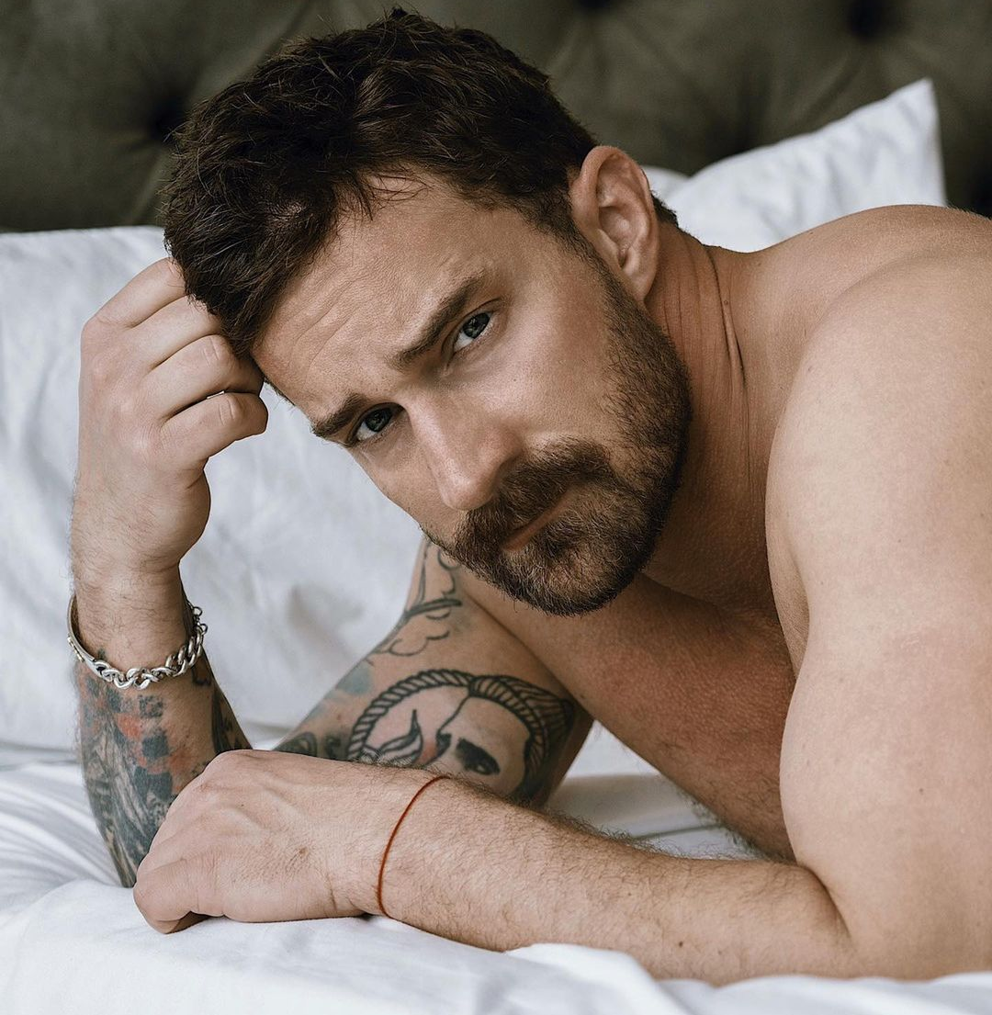
Instantly, Felix Zippe felt a shiver run throughout the entirety of his broad and buff body as the final piece of his new life - his name - finally slotted into place. Now relieved and eager to explore every facet of this new identity, the 50-year-old lawyer turned his head back and flashed a wide smile towards his wonderful husband. “Of course, why wouldn’t I be,” he inquired, leaning back and offering his lips up.

Alexander was quick to pick up on what Felix wanted, so he sat up in bed and leaned his head forward before puckering up his lips until they met Felix’s. As soon as the contact between them began, the duo were overcome with absolute lust for each other. So rather than pulling back and just giving a soft kiss on the lips, they kept the contact intact as they each put a bit more force into it. Before long, their lips began to part and allow their tongues to start invading each others’ mouths in a sloppy yet contained way.

With the intimacy quickly ramping up between them, Felix found himself eager to get closer and thus turned away from the end table and pulled his impressively large legs back underneath the hotel’s silk sheets. Rather than stopping this motion upon turning to stare face-to-face with Alexander, the bodybuilder continued to move until he was now laying directly above his smaller yet still quite buff husband.

As the duo took a moment to lovingly observe their partner’s features (with Alexander savoring Felix’s slightly wrinkled and matured visage while Felix lusting for his husband’s luscious beard and bright blue eyes), both men found their lips pulling back to adopt more jovial expressions. But while Alexander looked with an expression of pure amazement and admiration, Felix stared at his husband with intense lust and desire.

Given just how much they adored the close proximity of each others’ visage, neither man had paid much attention to the pleasurable sensations they each felt from such direct contact. While Alexander enjoyed having the hefty weight of his husband’s physique on top of him, he also adored how Felix’s firm cock was snuggly nuzzled between his taint and lower ass cheeks. As for Felix, he adored feeling Alexander’s soft hands explore his impressive musculature as well as noticing how Alex’s modest manhood prodded against his sculpted eight-pack.
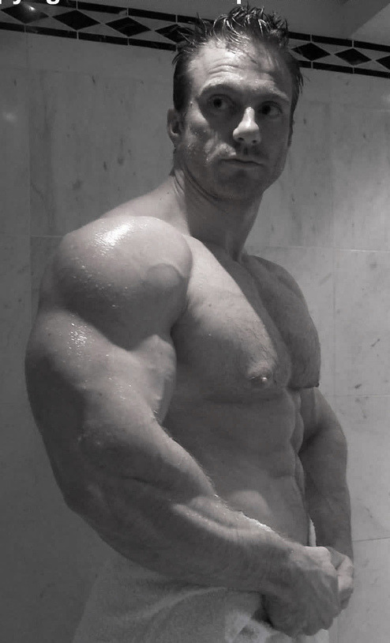
With a newfound cockiness emerging within his psyche, Felix allowed his callused hands to begin traversing down Alex’s body as they continued to stare into each others’ eyes and give the occasional kiss. After gripping onto the man’s modest pecs and giving them a slight squeeze, Felix’s cock throbbed as he heard a mix of a gasp and chuckle emerge out of Alex’s mouth. With a wide and knowing smirk on his face, the man continued to traverse down Alex’s torso and feel every tender inch. Upon allowing his fingers to slightly bob up and down across his husband’s toned six pack, Felix allowed his hands to rub along the man’s hips and upper thighs.

“You know, before we go out and explore more of the town,” Felix began, talking slow and seductively as he used his hands to continue exploring Alex’s body, “I think there’s something very important that we need to do as soon as possible…”

With a light and airy voice due to just how badly he was enjoying the touch of his husband, Alex finally began to speak once more. “Oh yeah? What’s that?”

Felix gave a slight chuckle as he heard his husband’s stammering and realized that Alexander was truly putty in his hands. Eager to truly send him over the edge, Felix leaned forward to whisper into his ear just as he reached up and wrapped his hand around the shaft of his husband’s cock.

“Fuck.”

