All Grown out  By Maryanne Peters  I knew I was in trouble the moment I had done it. It was a crazy thing to do, but my sister had been driving me nuts for weeks. There it was. Snip, snip. I was for it. Grounded forever. Or should I say, until my hair had grown as long as hers – down to waist length. That seemed close to forever. You remember when it happened. I told you that I was grounded so we could not meet after school. I did not share the details, but it was my fault. | 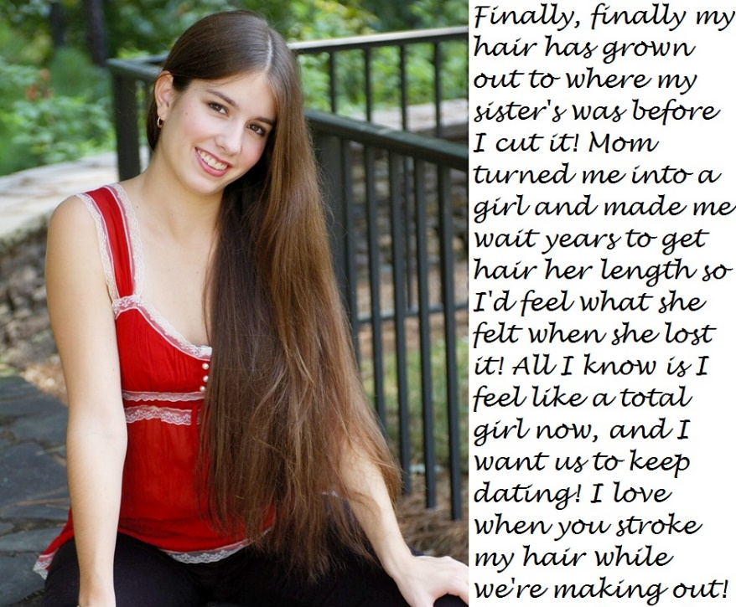

I think that they call it petticoat punishment – girls’ clothes at home after school and girls’ underwear under my clothes at school. Thankfully an exemption from PE so that nobody would catch me. But that was bad enough, because (as you know) I was quite keen on sports.

It could have been my sister exacting revenge, as she was in charge of dressing me, and feminizing me. With no friends after school, I could watch TV or play on my PC, and any other time it was compulsory girl stuff with her. That sometimes meant helping her with her sewing, either as mannequin or doing some machining or fine needlework.

But she was growing her hair back as well, so when I started to see some progress I thought I could see an end to this nightmare. We decided to work together to grow out our hair.

We started close to even. After my slash job she had her hair tidied into a bob, and my hair was what you might call “shaggy” to start with. She suggested that we use growth-promoting shampoos and have a program of nightly brushing. The only problem with this was that my hair did look pretty girly during the day, even before it got longer. I did get some ribbing.

When that happens you can get mad or just ignore it. I developed a sort of hair toss “I don’t care” kind of thing, which got more difficult as it got longer. It was so soft and silky that it would drape into my eyes. My sister could use a barrette to keep it off her face, but I couldn’t. At least not until I got home. There I could use barrettes, hair bands or a scrunchie while I was helping my mother and sister do the cooking. She seems to want me to do that. What else can you do when you can’t go out?

Remember I told you that it was just a contest with my sister – a boy against girl hair-growing contest. I didn’t want to say I had been forced into it. It makes it sound like I was weak. It was just that despite it all, I am really close to my mother. I knew I had done a terrible thing. I just had to take the punishment. I didn’t want you to think my mother was that mean.  So after a few weeks my sister was pulling ahead with hair touching her shoulders. She told me that she had read on the internet that hormones would lift the growth rate. My mother had a prescription for hormones (HRT pills) which she was not taking anymore. So my sister suggested I take them and check to see whether they worked. When I did I found it was true, my hair did take a growth spurt. And it was getting lighter and softer at the roots. It was already lighter at the tips just from the sun. So it was then down to my shoulders – see this photo. | 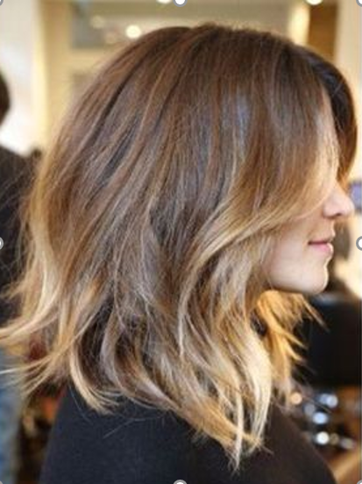

I was taking the pills daily and they were clearly working, but they ran out in less than four weeks. I was so keen to continue that i called through for a repeat on the prescription and called in to the pharmacy to collect it “For my mother.” It was the first time that I had been mistaken for girl. I had sneaked out. I was just wearing jeans and sneakers and a big jumper over my T-shirt. My hair was just hanging loose. I was waiting for the scrip and just browsing through displays, and the assistant said “that lipstick would be perfect for your colouring”. It was crazy, but I ended up buying it!

Some of your friends said that I had “girly hair”. I fought it off for a while, but then I just couldn’t be bothered. So I had to agree. I said it was my style – so what? And you know, sure I was being forced into this, but I did kind of, like it. It did look good. I like pretty hair on girls, so I could appreciate it in the mirror as I brushed it.

You know me. Before this I never had a girly thought in my head. Maybe it was the hormones. Or just being stuck at home with my sister. I started to pick up some effeminate mannerisms. Not just brushing and checking my hair, but looking at myself in the mirror over my shoulder, or blowing kisses at my reflection. I was becoming fascinated with the girl in the mirror and I wanted her to be a girly girl. Is that so weird? It was like I had my own pretty chick who flirted with me every day, from the other side of the mirror.

My sister had lots of girly magazines and I started reading them. There was nothing else to read and not much else to do. I was not looking at the pictures of the boy bands, but I was looking at clothes and hair and make up – stuff that girls did to make themselves pretty. I wanted the girl in the mirror to be as pretty as she could be. Is that so weird?

I was going stir crazy at home, so my mother agreed that I could go with my sister to the spring fair out of the city. My sister said that I could go only if dressed as a girl. It is funny, but I never even thought about that. I was so happy to be going out, I didn’t protest. I just asked my sister what we would be wearing.

She gave me a choice – I could wear jeans and a plaid shirt only if I had my hair up. I was not ready to wear a dress, so I chose that look. Of course she put my hair up in a fancy style with a bow. And the shirt was tight and over a bra filled with breast forms, and the jeans were tight and rolled up at the calf with high heeled sandals, but I had made my choice.

So what changed that day was that I realised that I could go out dressed as a girl and that nobody would even think of me being a boy. In fact, boys would stare at me with lust. I could feel their eyes on me. I know the look. You look at me like that sometimes. But it feels kind of good to be appreciated like that.

By midway through the summer break my hair was much longer. It is hard to believe how quickly it was growing. Part of it was down to the hormones, I am sure. But I was using good quality shampoos and conditioners, and some special treatments to promote growth. And 100 strokes with the hairbrush very night to keep it healthy and shiny.

For the first time I was starting to think whether I would keep longer hair after it was all over.

I am sure that is when I noticed that your attitude to me had changed. You looked at me differently. I thought it was strange to start with, but then I realised that I like the way you look at me. You look at me as though you want to be with me. Who wouldn’t like that?

So what if our friends thought it was queer? I know that it was harder for you than it was for me.

So do you remember the first time I wore a dress. I only did it for you. I so wanted to go to the fair with you but it just seemed to go as your girlfriend than as your pal.

I have a photo of that day. It was really a hot day, and when it is hot there is nothing like a lightweight sundress. I borrowed this dress from my sister– a sky blue polka dot sundress. I looked so good in it she gave it to me!

I remember that you were taken aback to see that I had breasts! They looked bigger than they actually were. I was using a push up bra with “chicken fillets” underneath. This dress really looks much better if there is a bit of cleavage showing. As I recall, you really liked it with me in this dress.  I borrowed the chain, rings and bangles from my mother’s glory box. I think I look really stylish.  Because it was hot I just put my hair up in a loose bun myself. I was getting really good at doing my hair.  Remember that you bought me the sunglasses? They look really cool. I really loved that day together.  I remember that you held my hand some of the time. Maybe so you just didn’t lose me in the crowd? |  | 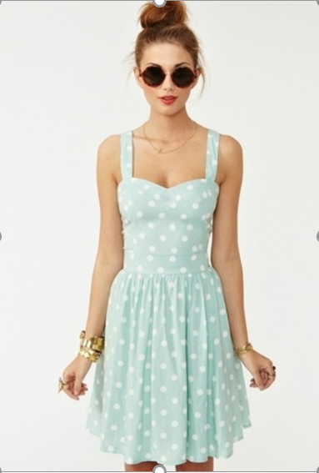
 | 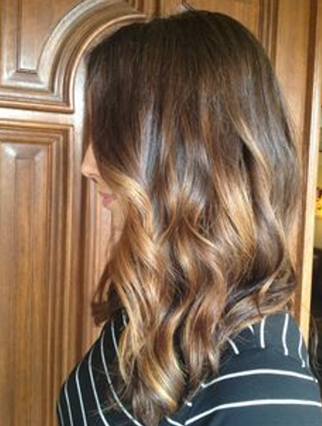 |  | So I was ready to go back to school, but the problem now was the breasts. Even though they needed pushing up to dress as a girl, I found that I could not press them down to dress as a boy. That is why my mother arranged to discuss the situation with Principal Davis. That was why the whole “transgender” thing was dreamed up. I was not really transgender – it was just the easiest explanation why a boy had longhair and breasts. Principal Davis was really understanding.  Do you remember this photo. It was taken the day I went back. I was wearing a top and jeans, but my bust is pretty obvious. I had intended to appear sort of neuter gender. So I don’t know why I put some curls in that morning.  I remember that you liked the look. You did, didn’t you?

So here we are now. My hair is at the length my sister’s was before I cut it. She has cut hers since. I think that she concedes that my hair looks better than hers. I think that I look after it better. Its all about taking the time to wash and condition it properly. And you need to brush it every night – a minimum of 100 brush strokes.

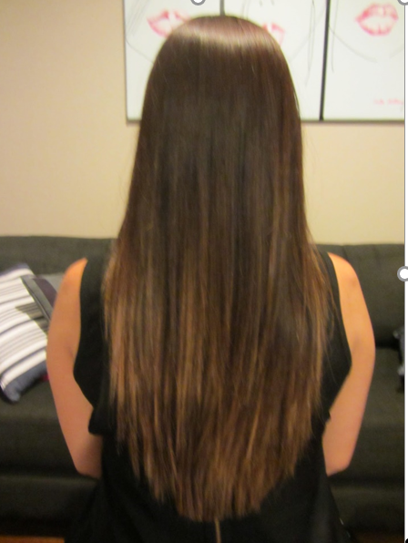 | I know you like it. I can tell when you run your fingers through it when we kiss. If you don’t want me to cut it I won’t. To be honest I am not sure that I could anyway. I like it too.  The End  © Maryanne Peters 2018

Notes on this Story:
I guess people understand that I have a long hair thing. When I was 5 or 6 I had a security blanket that I would put on my head with a hairband and pretend that it was long hair cascading down my back. Not the thing a little boy should be doing, but if anybody asks when I first knew what I was, I could always point to that. I always wanted to be a girl.
This was the first time that I ever wrote a story out of a captioned image. I am not sure where the cap comes from, so if anybody knows, please tell me. Anyway, it just begged for a longer story that just 70 words. I wrote 1,840 words and added some images.

Consulting
A Short Story Inspired by a Captioned Image
By Maryanne Peters

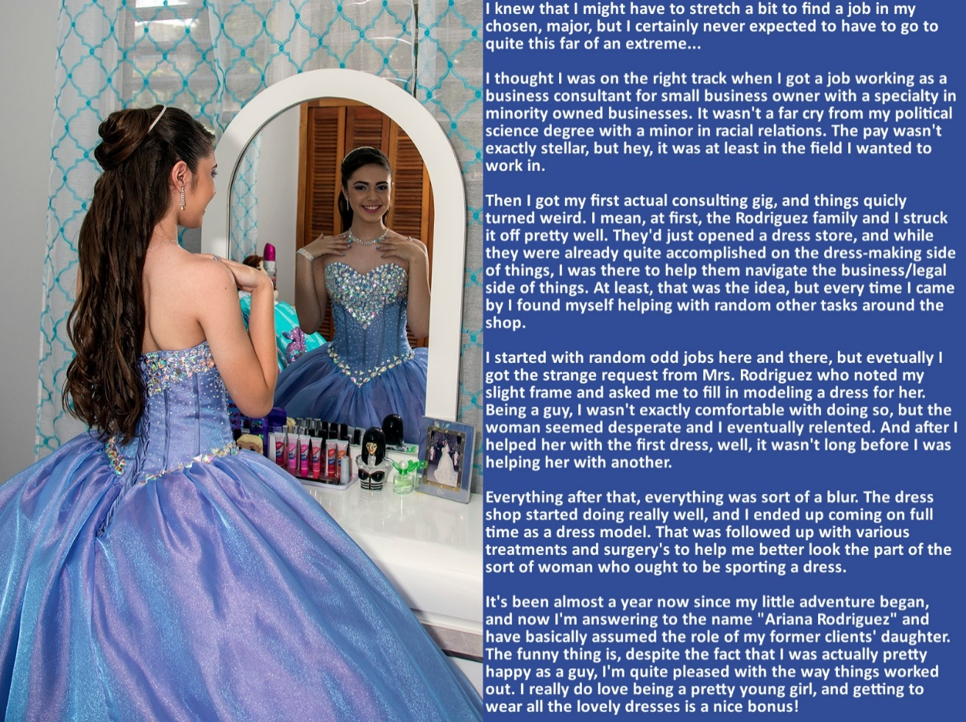

When you first set forth on your career, you wonder whether what you can do is going to make a change in the world, or whether the world might change you.

I was a young man with a college degree, but not with a major of any real relevance. It was the race relations minor that helped me get the job I did, and out of that, my first consulting job.

I studied up hard on what was required, and I was sure that I could help them to grow their business. They had already made huge progress from when Mrs. Rodriguez (Momma) was sewing at home and had a small shop. By the time Mr. Rodriquez (Pappy) joined the business, she had 5 other Mexican ladies sewing for her. Then, because they had no more room, she turned her garage into a cutting room, and sent sewing out to women to work on at their homes – a total of 12 machinists.

The first thing that I did was to persuade them to rent space. They needed a much bigger cutting table, and a specialist cutter, and sewing machines on site for better supervision. We still had “out-work” but with machinists on site at the new factory, we could produce more and better products.

Momma did her best, but the next thing I suggested was that she needed to hand over supervision and quality control to another specialist. The truth is that Momma was just too kind-hearted to stand over the workers. The garment trade is tough, and she was not the right person for that job.

I suppose that I had become really attached to Momma after on a couple of months working with the Rodriquez family. I was worried that she was getting overly stressed. What kind of an adviser would I be if my first client worked themselves to death? I had to be very persuasive. I told her that if she accepted my advice and we hired the new supervisor I had found – somebody that she did not like at all – I would work with her in any capacity she wanted.

She finally agreed. The good thing is, that it meant that she could go back to the work doing what had started it all, communion and prom dresses. That is what she loved to do. She said to me: “Amada,” (that is what she liked to call me) “we can work together to make the most beautiful things.”

I never really had any interest in clothes before I came to work with the Rodriquez family, let alone women’s clothes. But if you are going to advise on a business, you have to know the product. You have to know what is beautiful and what is not, and why. And then there is gorgeous. Something that is beyond the eye – an outfit that makes you feel good just to look at it. And then when you wear it, it does something special to you. It makes you somebody else. You have to know that feeling.

But I am getting ahead of myself. That is not how it went. She just needed a model.

Momma was more than a seamstress, she was what we call in this industry a pattern maker. That meant that she could look at a garment, or imagine a look, and draw a pattern. She knew instinctively how the fabric should be cut in two dimensions to achieve a look in three dimensions. She did her best work when she and I were together. Of course, she had a dressmakers’ mannequin, but anybody will tell you that this is a limited tool. It does not allow for movement. And for prom and ball dresses, movement is important.

It was not as if I had any kinky desire to wear women’s clothing. It was not that at all. Gorgeous dresses would give me special feelings, but not sexual feelings. Well, not really, but almost. When you look at yourself in such a dress, you feel like a princess. I mean, I don’t know what a princess feels like, but you feel special, and in a way that you feel that everybody else thinks you are special too.

So, to my surprise, it turned out that I had an eye for how others looked in a dress – not just me. That sort of became my skill. I spent more time in the dress shop, not just modelling but also looking at a customer and being able to say: “I know what would be perfect for you!” and actually know that.

Somewhere along the line I became Ariana. Probably quite early. No girl is going to take advice on her clothes from some guy. She wants to hear it from somebody who knows what it is like to want to be beautiful. It turns out, that’s me.

My hair grew, but it could not get as long as it needed to be without some help from the salon. Momma and I figured that we needed to have the right look to present to the customer. Then I suppose, the next step had to be to adjust the shape of the mannequin to fit the shape of the customer. You do that all the time with the one on the stand, but to adjust me required the assistance of a surgeon.

I suppose that it might seem crazy that I submitted to all of this, but I really felt a part of this business by that point. In fact, I contacted my boss at the business consulting company and told him that I wanted to work with the Rodriquez family direct. He was not happy, as he was charging them twice what he was paying me. He told me that I was contractually bound. Momma and I went to see him. She told him that I was now part of her family – her daughter Ariana, and he could see that. He was shocked, I suppose. Anyway, Momma offered to pay him off and he agreed.

I was just so happy I burst into tears. I suppose because I had just had one of my monthly injections, I was just full of those girly chemicals. Sometimes you just cry because you can, now.

The funny thing is, despite the fact that I was actually pretty happy as a guy, I’m quite pleased with the way things turned out. I really do love being a pretty young girl and getting to wear all the lovely dresses is a nice bonus. Could you see yourself living my life?

The End

© Maryanne Peters 2019

Notes on this Story:
Just a simple tale about somebody who found a place for themselves. Simple, but a favorite of mine. And yes, I did have some involvement in the garment trade in advising a friend who was a small time manufacturer.

Rescuing Roberta
A Very Short Story Inspired by a Captioned Iage
By Maryanne Peters

I will admit it, Robert Kradel Junior was a prick, back when he had a prick. But he did not deserve what he got.

Jose Berganza had reason to dislike his boss, but what he did was way beyond that. It became clear to me that there was real hatred on display. Venal, viscious hatred to warrant this level of degradation.

Marrying Robert would provide a path back to citizenship, but Jose could have done that in any one of a number of states as a gay couple. To marry Robert as his transvestite bride was all about demeaning the man who had once been his boss. Demeaning him and making sure that if he ever were to be forced back to his country of birth he would be marked for open abuse given Putin’s policies towards gender variants.

I suppose that Jose could not resist the irony, that he, constantly teased by Robert as “an Illegal”, could use his status as a true American, to allow Roberto to stay.

So I was invited to the wedding, along with all manner of people who had known Robert. And it seemed to me that all who turned up, turned up to laugh at him. Who could guess that a man would have so many enemies?

I should have been one of them. God knows that man made my life a misery. I paid for a space on the dance card. I wanted to get up close to this man – close enough to spit in his face.

But that is not the way things turned out.

It was slow dance. I pulled him close. I had my hand on his ass, burried in the ruffles of that ridiculous wedding dress. People who looked on could see, and they laughed.

“Doc, I’m desperate,” he whispered. “There is nothing left of me, and still Jose wanted every last drop of my blood.”

It was hard to disagree, so I listened.

“I am married to him now, but I need a way out. I have done not just bad things in my life. You know that. Please help me.”
A few good things, maybe. So I told him: “Well, you cannot go back to being you, that is for sure.”

“How could I,” he said. “Look at me.”

I have to say, that in that moment I looked at him and I did not see Robert at all, but only the new Roberta. It was a wig on his head, with the flowers and ribbons in it, and the makeup was caked on thickly, but there was a real femininity in his eyes. Those eyes spoke of vulnerability. There was nothing of Robert Kradel Junior left.

“I can get you some tablets,” I told him. Tablets that will ultimately make you unattractive to Jose. He is gay after all. He likes his men femmy, but not fishy. If he abandons you then your immigration status will hold up. If he does, come to me.”

I did not stay until the end of the reception. I had seen the humanity in Roberta and could not stay on to watch her further humiliation.

I dispatched the pills, and several repeats, and like everybody else, it seems, I saw nothing of either Robert or Roberta for over a year. Then I checked my online diary and found that I had an afternnon appointment with Mrs. Roberta Berganza.

When she walked in, I immediately thought how stupid it was to think that this could be the pathetic creature I had danced with a year before. The woman was tall and attractive, with honey blonde hair that was clearly her own, and a stunning body clothed in the skimpiest little black dress.

She waltzed in and put an emmpty jar on the table.

“You were right,” she said, her voice high and clear, but with the barest trace of the voice I knew. “He hates my breasts.”

“Of course he does,” I said. “He is gay. But what do you think of them?”

“I love them,” she said. “They make me feel … right, somehow. But what do you think of them?”

“Well, I am a doctor,” I explained. I thought they were wonderful, but I gave a professinal opinion: “I think that they are surprisingly advanced if they are only from hormones.”

“They are,” she said. “But I understand that a girl like me can expect breasts a size one or two sizes smaller than my mother’s, and she had very big breasts.”
“Well, congratulations,” I said. “But are you here seeking my professional assitance.”

“Yes,” she said. “The next thing I want is to have bottom surgery. To get rid of these awful dangly bits and get myself a neat and tidy front for summer.”

“If Jose is no longer interested in you, then why would you bother?” I asked.

“Well, now that he has moved on, back to his drag queens, I have been considering my future, and I have decided that it should be as Roberta. And I have decided that Roberta should share her life with somebody that she respects and admires.

“Do you have anybody specific in mind?”, I asked.

“Yes,” she said, smiling sweetly at me. “Yes I do.”

The End

© Maryanne Peters 2019

Notes on this Story
When I started doing these cap extensions, I decided that it would be more interesting to go off in a different direction rather than just expand on what was started. Here the doctor is a new character picking up the story, which is just a classic Disgruntled-employee-feminizes-boss theme. The image is of a bride in extreme drag which would not normally attract me, and the story is longer than I would normally like. But that story has all the elements to make the tale broadly credible so long as you can answer the question as to why this is the torment chosen?
Then, there must be a happy ending – right?

Forensic Accountant  Inspired by this Captioned Image  By Maryanne Peters  The first time that I tried I was not trying to look pretty. Book keepers are not always the prettiest girls. The most important thing is to look like a girl. I had a blunt shoulder length bob wig, with bangs, and glasses in my prescription that were heavy framed. I wore lipstick and eye makeup, a long-sleeved blouse up to the neck, and a skirt down below the knees, with pantyhose and sensible heels. The lady book keeper’s uniform. | 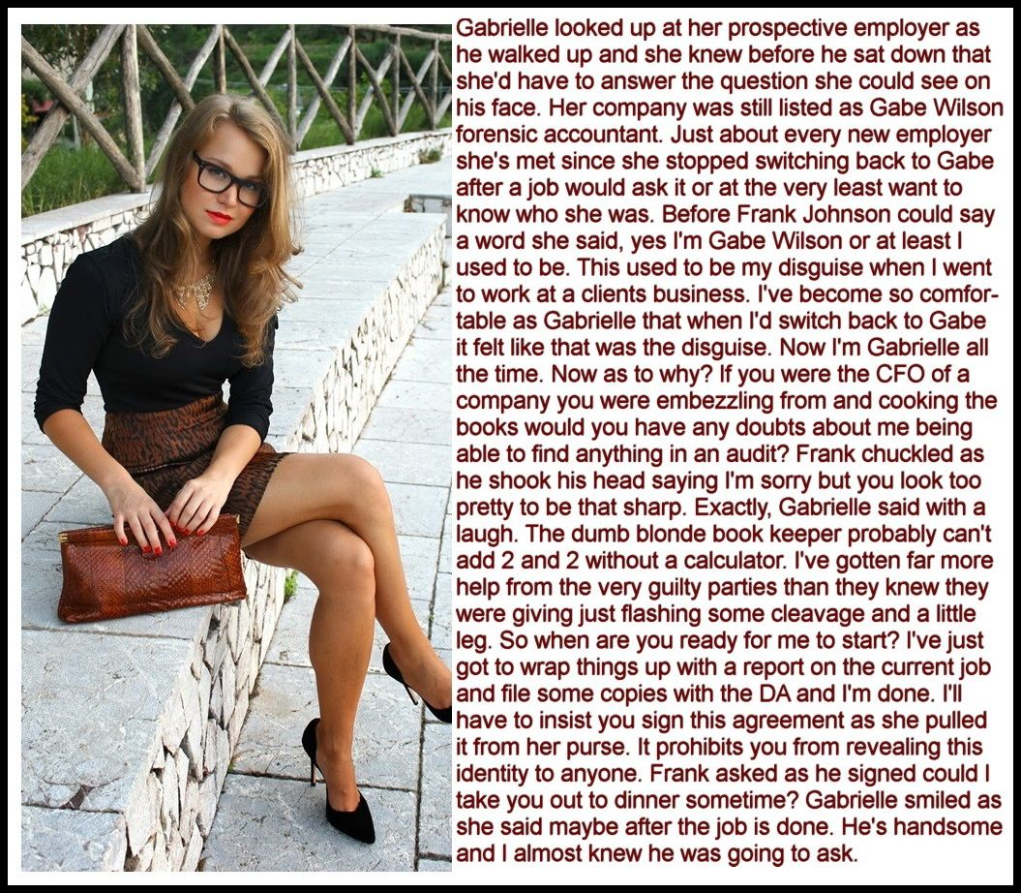

I refined the look over time, with the purpose of eliminating suspicion. A good (undercover) forensic accountant must be able to join the staff of the target business but not make the criminal feel at all uncomfortable. I quickly understood that most men (and they were invariably men) believe that the prettier you are, the dumber you are. Or, at the very least the pretty ones can be manipulated by the force of masculine dominance.

Embezzlers are wary of plain bookkeepers. Perhaps they think that they are bitter and therefore cynical and skeptical. Somehow if you are pretty and act trusting of these men, they not only accept you but open up to you. If you are pretty.

So, I decided to take some radical steps to make my disguise truly effective. That meant growing my hair (and adding extensions) and having some minor procedures to change the shape and appearance of my face. Then, later, more radical procedures to change the shape of my body. And drugs too.

It meant that the disguise could not be shed as before. Sure, I could take the dress or skirt off when I got home, but I still had breasts so I still needed to wear a bra. If I went out at night between jobs, I suppose that I could be Gabe Wilson, a guy with long hair and tits? I don’t think so. It was just easier to be Gabrielle.

But the truth is that I did not go out that often between jobs, because there was really no time. I would barely have time to file my report before the next job, and when you are constatntly undercover any kind of life outside the work would just get in the way.

When I did go out it would either be to socialize with the accounting team and pick up leads, or to work on the mark – the target of my investigation.

Looking as I now did, I would get the invitation, and after a show of resistance I would agree to a dinner date, or any opportunities to get him relaxed and off his guard. Sometimes, I would go to the ultimate. I don’t mean that, because I keep myself safe by being fully prepared. I have a stash of a well known “date rape drug” which I can sneak into his drink if I am invited to second base. If I can’t get the juice that evening I would jack him off while he slept and I would spend most of the following day hinting at the great sex we had last night.

That is how far I go to do my job. That is how committed I am. If I have to stroke his cock and then stroke his ego to get the leads I need. Then the real work begins. Once you have the leads it is just old fashioned accounting that will bring in the hard evidence. Do the numbers, add and subtract, complete the renconcilations. It is not all glamor.

And then I was engaged by Johnson Industries. They knew things were not right, but they had a big accounting team and had no idea what was going on. So I was called in to meet Frank Johnson, President and CEO of the family business.

I introduced myself as Gabrielle, but it led to a question I get now and again: “So if the business is Gabe Wilson, then who are you? His sister? Don’t tell me you are his wife? That would be very bad news.”

“I’m Gabe Wilson, or at least I used to be,” I explained. “This used to be my disguise when I went to work at a client’s business undercover. But I’ve become so comfortable as Gabrielle …”.

He looked a little shocked, or maybe dissappointed, but he was also intrigued. He told me that he was aware that I had a serious record of success. After our discussion on my methods he commended me on my approach. He signed the engagement letter and I agreed to start the following Monday.

It did not escape my attention that Frank had taken the time to have a close look at my body. I think most women would be conscious of it, but because I am not a woman, I definitely was. In some way it can be treated as a compliment on my disguise, but it can still be unsettling.

I started on Monday as the new junior accountant Jenna Kelly. Like most juniors I was put on bank reconciliation, which is always a good place to start looking for skimming. The problem was that too many people had the access to records needed to conceal theft. Way too many people, even considering a business on this scale.

The two most likely targets were both typical in their way. Gareth was a quiet bookish type, but was easy prey to my charms when I used the “little-girl-lost” approach. His hunger to impress me made me think that he might be the kind of man who would have appetites that might need money to satisfy.

Manuel was far more self-assured and fell for my “vamp-behind-the-glasses” line. There was no doubt that he was the kind of status-driven macho guy who could easily draw from the business. He was harder for me to control, so I needed to take care not to be too close to the stationery room when he was on the prowl.

But neither had any direct links to the money that appeared to be disappearing. What was needed was a meticulous approach to payment of regular invoices at a figure that was small enough not to draw attention but large enough to accumulate to a number wort stealing. It would take time.

Even I need the opportunity to relax a little, and it would not be with either Gareth or Manuel.

Frank surprised me by inviting me out to dinner. He knew who, or rather what, I was, but he said that I should treat it as a date. We would not be talking business. It would be a true release from the pressures of work for both of us.

I decided to go all out. I went to a salon after work and had my hair put up with curls on top. I bought a new dress with plenty of cleavage on view. I wore contacts. I have to say it – I looked spectacular. Frank thought so too.

We talked and we ate, and we drank and we laughed. And I realized that this was what was missing in my life. For the sake of my work I had sacrificed any meaningful social life. I was stuck in a disguise that I had carefully constructed to be a successful forensic accountant, but at the cost of being a man who could lead the life of a man. Somewhere along the way I would need to make a decision as to when this would end.

But in the meantime, Frank took me out again, and again. Not just to restaurants in town, but weekends away.

“I am almost ready to say that I don’t want you to find the embezzler,” he said. “I just like having you around, looking for him.”

But I am too good not to produce a result. I got to the bottom of it eventually. Rather than file a full report, I decided to tell Frank over dinner.
To my surprise he took what I told him very calmly. He even smiled as I stared at him.

“It’s a family business but most of the family do not care about it,” he said. “Only I care and I do not get rewarded for it. What goes missing has no impact on the business but might allow the person taking it to live a slightly better life, and provide comfort and pleasure to those that he cares about.”

“So you are admitting it?” I said. “You are the embezzler.”

“Well,” said Frank, “Do you really care if I am going to share it with you?”

“What do you mean?”

Frank dropped to one knee. He took my hand and looked up at me. He said: “Gabrielle Wilson, putting to one side for a moment what I would regard as a surgical imperative, but based upon my genuine and total love for you, and in the hope that you might feel just a fraction of what I feel for you, would you consent to be my wife?”

It is not the kind of proposal that any man expects to receive. But the accountant in me persuaded me to at the very least, consider a cost benefit analysis.

Benefit number one: Well, provided that he desists from criminal behavior here is a man of ability as well as his obvious wealth. If he was to resign his unpaid position the independent board would need to pay three times as much for somebody at the same level, I had seen that by now. He could be hired back or live of the handsome dividends like the rest of his family.

Benefit number two: Here is a person who shares much of the same interests as me. We both love the cut and thrust of commerce, but also the finer things in life – food, wine, music and travel. It was hard to think of anyone that I had ever met who was such a match.

Benefit number three: Love. Here he was on one knee. And what was going on in my body did not seem to be coming from my cerebrum at all. Whether it was the heart or the belly, I was all aflutter. What is that if it is not love? Whatever I was before, I was now in love with a man.

Cost number one: Those male organs will need to go, and be replaced with something more aposite to the rest of my body. Was that really such a high price? Are there any other costs? None I could think of.

“Mr. Johnson,” I said, “you have yourself a bride.”

The End

© Maryanne Peters 2019

Notes on this Story
Any accountants out there? This is a simple device – the disguise to do a job that becomes so convincing it convinces the wearer. But here I tried to get into the mind of the accountant. So, the story ends with a cost benefit analysis, and a decision based on that.
I think that there is enough here for a much longer story (?)

Jerri-Aimee  Inspired by a Captioned Image  By Maryanne Peters  Sharon sat behind the huge desk that had been her husband’s, as Maggie ushered in the tall handsome stranger. She did not stand to meet him. She sat, as she always did. She would not invite visitors to sit. She preferred them ill at ease. | 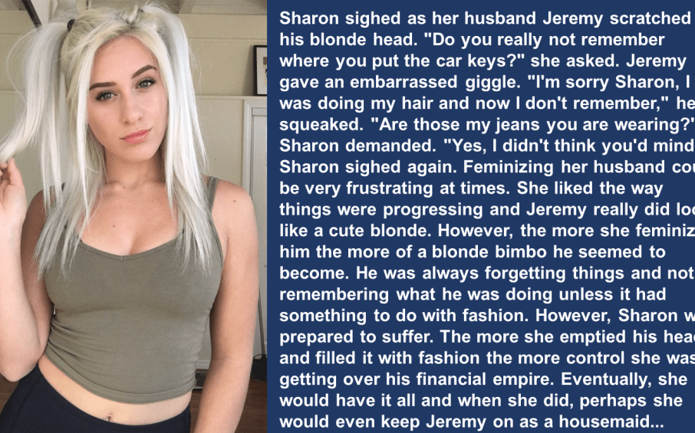

“Patrick Hudson, Attorney at Law”, he said. “I am here on behalf of Jerri-Aimee.”

“Who?” she said. She genuinely had no idea who he was talking about, probably because she never would have expected any action from that quarter.

“The young lady who used to be your husband, Jeremy”, he explained.

For a moment Sharon was a little perplexed. But then she laughed. And she threw her head back and laughed so more.

“A young lady? That sissy little shit Jeremy is a young lady? You have to be kidding me. That thing is a mindless trans-bimbo. Still my husband, but not for long.”

“As you say, still your husband,” said Patrick. He did not help himself to a seat, and did not look at all disturbed by remaining standing. “Still subject to the laws protecting matrimonial property in this state. The laws that protect her rights to the businesses established by her in what I might call, her previous life. That is not to say that you do not have a share – not more than half but much less, I suspect. But with 46% in the hands of public shareholders, and Jerri-Aimee’s share now controlled by me, you do not have control.”

“You had better take a seat,” said Sharon. This was no joke and she knew it. She reached for her phone to call her own attorney Brent. He was the one who had assisted her in taking control. He would have an answer. But she disliked him. He was smarmy and not good in bed. That was the price she had paid for his assistance, as what he had done for her was not always ethical, or even legal.

“I will sit down,” said Patrick. “But you are in my chair. You see, I have the support of four of the public shareholders, and directions from them in this folder. Their 24% of the company and Jerri-Aimee’s 27% is enough to remove you. That is what I am here to tell you. I have been appointed to replace you. You may leave, and you should do so immediately.”

“You can’t do this,” said Sharon. “How could you get the authority you need from that airhead?”

“Well, not so much of an airhead as you think,” said Patrick. “You see I am actually attracted to pretty little blondes like Jerri-Aimee. My mother runs a clothing boutique and Jerri-Aimee is so into clothes she always seems to be there. My mother suggested that I meet her and listen to her story. When she mentioned you and this business, well, that is when I …”.

“Get out of my office!” screamed Sharon. Her cellphone rang.

“As I said, it’s my office now,” said Patrick. “Call Brent. I know he is your lawyer. I suspect that is him calling you right now. I have taken the liberty of sending him the papers before I walked in here. He will confirm what I am telling you.”

Sure enough, the caller was identified as “Dickhead”. It was Brent. But instead of picking up she glowered at Patrick. “Where is Jeremy?”

“You mean Jerri-Aimee,” he said. “Thanks to you, no longer male. A pretty young lady these days. Very attentive and playful. She is living with me at the moment. As you are aware, her divorce will be coming through soon, and I hope that when it does, she might consent to be my wife. I have every intention of marrying into money. That means less for you, I’m afraid.”

The End

© Maryanne Peters 2019

Notes on this Story:
This is the classic wife-turns-husband-into-mindless-bimbo thing. But I have a sense of justice, and something about the girl in the picture called for her to come out of this a little better. Not by going back to being a man of course, but getting her own man.
I hope that it comes through that he loves Jerri-Aimee as much for her attentiveness and playfulness as for her dowry.

Decision Day
Inspired by yet another fantastic captioned image by Jenna (https://jeannasadventures.tumblr.com)
By Maryanne Peters

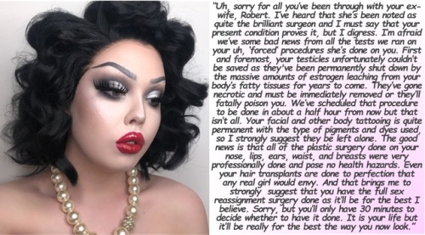

He wore only the pearls. For some reason they were still hanging around his neck as he sat naked on the doctors examination bench. His neck and shoulders were still solid, but the laser treatments and the hormones had left the skin soft, smooth and pale over them. For some reason he could not even find the strength to take the necklace off.

Thankfully there was no mirror in front of him, but he knew what was there. He had already considered how he could return his face to anything like a male face. He could not shave off the perfectly shaped eyebrows as the doctor had pointed out that the same arches were tattooed underneath. He could not change the permanently red lips with having them cut away. His brow bone, and what had been a strong chin, had been ground away, and his aquiline nose had been reduced to a sculptured button. How could any of this be rebuilt?

If he still had a male body, maybe … . But it now seemed pathetically small and fragile. All muscle had been eaten away by these hormones. He could almost feel them coursing through his veins, eroding him further, destroying him from the inside.

And now, the last proof that he ever had been male, his balls cupped tight by a retracted scrotum beneath his vestigial penis, were threatening his life.

But what kind of life could he lead? He had spent his whole life dominating women, as his father had before him. He was rich and could have any woman he wanted. Even his wife, his now ex-wife, the brilliant Constance, physician, dance, renowned beauty … he married her because she was the complete package. She added to his status. Love? What is that? There is power and there is pleasure. That is what he loved, not any one person.

No women can experience that. They can exist to be beautiful, to be vulnerable, to invite somebody to rule them … just like this creature that he now was. Pretty and weak. The lowest form of life – female.

Surely to look female without being female is the worst thing? Choose death. Testicular necrosis – septicaemia – death. Better than this? The choice was clear.

He looked up. He was about to open his mouth. He was about to use that stupid squeaky voice that had been created by the surgery on his voicebox. He was about to assert his last remnant of masculinity and request death over dishonor.

But then as his eyes rose, he saw the crotch of the doctor’s pants. And his eyes travelled up to his face. Doctor Laing was a good-looking man. And there was a look on his face that puzzled Robert. In his years in business making money, he knew how to recognize the looks in a man’s face, but this was not a look that he was familiar with. It was perhaps close to … greed. But not in a bad way. Maybe a longing? His eyes seemed larger somehow, almost as if he could dive into them.

“The bi-lateral orchidectomy is essential,” Dr. Laing said. “Once it is complete, you may wish to get another opinion on the penectomy and the vaginoplasty …”.

What was he saying? Robert was still trying to understand what he was thinking. And exactly why he was so concerned about what this man was thinking. Or was it what he was feeling? Were there feelings at work here? Feelings were not something Robert had ever been concerned about – at least not until the hormones began to dominate his body.

“I have to confess that in suggesting the full assignment surgery, I may not have the required objectivity,” Dr. Laing continued. “You see, I … er … I really do find you extremely attractive. I know who you are and everything … and I am not gay. I just cannot see you as a man. I don’t think that anybody will, from now on. I think that you could be very happy as a woman. I would like to see you be happy. I would like to help.

Robert suddenly realized that ‘This guy is guy is coming on to me’. But the look was not lust, despite the obvious kink in his pants that he had only just noticed. It was something new to Robert. Could it be …?

Whatever it was, Robert was suddenly aware that power and pleasure might still be possible.

“Sure Doc,” he said. “Lets have these balls docked and then we can schedule that other surgery.”

The look on Dr. Laing’s face was priceless. Joy and relief, and maybe to the hope of something more. Robert knew that he was in control again.

“And why don’t you call me Roberta.”

The End
© Maryanne Peters 2019

Notes on this Story
This image is the very epitome of a man so feminized that he cannot go back. The hairline, the chin and the nose all appear artificial, and the eyebrows, lipstick and makeup could easily be permanent. But the neck and shoulders could have once been male. The words follow the theme.
Once again, the doctor is the love interest, simply to not add any other characters or scenes.

Notes on the Compilation:
These six tales from captions are some of my favorites and also just happen to fall outside the collections that I have done and I have planned for posting in the future.
If anybody has any others that they think should displace any of these.

