Pretty
A Short Story
Possibly inspired by an old movie
By Maryanne Peters

The voice on the other end of the phone surprised him. It was not at all masculine. Had he not been calling a man, he would have thought that he was talking to a woman.

“Is that Eve?” he asked.

“It is I,” she said playfully. “Eve. The first of women. At your service.” He liked her already. She would be perfect.

“Would you be available for a longer-term hire?” he asked. “Maybe starting this afternoon and finishing around 1:00 in the morning?”

“Everything and anything is available,” she said. “But time is money, as I am sure you know.”

“Money is not an issue,” he said. It most certainly was not. The issue was how to make a statement. In his view, a tranny on his arm would make that statement.  “Should I come to you?” she asked.  “Please,” he said. “I am staying at the Bragato Hotel. Room 2002. How soon can you be here?”  “I could be there within the hour,” she said.  “If you are,” he said, “I will buy you lunch.”  He looked again at her image on his tablet screen.  “EVE, Busty and athletic transgirl. Sexy and urbane”  Surely, she meant “urban”, he thought, as in gritty but exciting. | 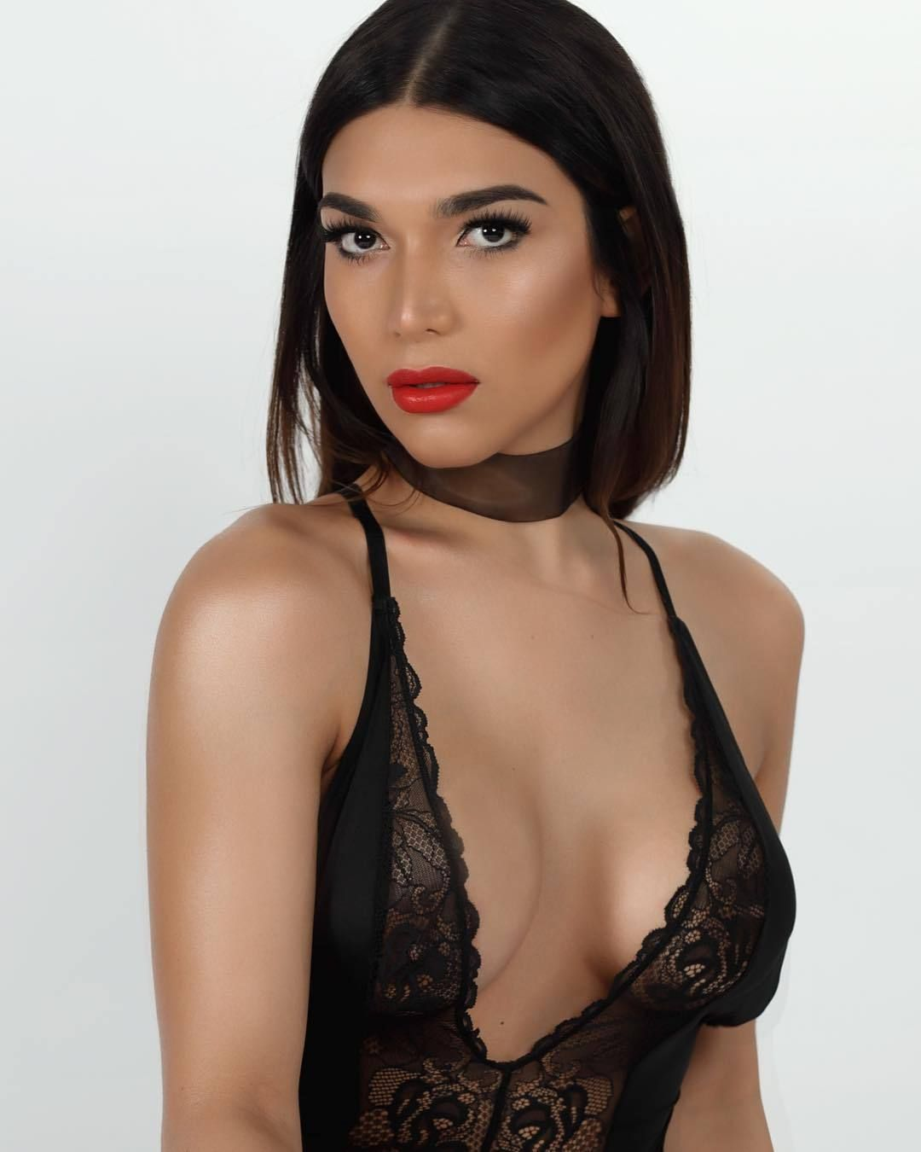
***

He opened the door and there she stood. She was big and strong, and her legs were long in that short tight dress, but that was not what he saw. He would have assumed that her eyes were brown from the image online. She had a lovely coppery complexion with skin smooth and without blemish. She could have been latino or maybe Italian. But her eyes were a dark blue. And her smile was … genuine. When she held out her hand she did not need to say “happy to meet you”, because he knew that she was.
She was wearing a skin tight glittering striped dress, which looked surprisingly appropriate for lunch, but could also have been worn that very evening. She struck a few poses to show herself off. She was gorgeous.

“I thought I ordered a trans,” he said with a smile.

“Well aren’t you sweet,” she said. “I will take any compliment.”

The voice was perfect. More masculine than her appearance, but yet feminine.

There was a hint of power in the legs and the shoulders and upper arms. “Athletic” was the word. “Busty” was another that was confirmed. Implants, but tastefully done. “Sexy” – undoubtedly.

She watched him looking at her. She asked: “Do you want to get it on now? You talked about from now until 1:00 am so that would be 13 hours at … let me see … say $5,000.”

“Sure,” he said. “I have that, and some more besides, to buy you lunch, and something to wear, so that we can be at the charity soiree by 7:00pm tonight.”

She looked around the room. There was no bed visible. It was a huge suite. There was a lounge and a dining area with a table and eight chairs. The table was strewn with papers. Across the room, through a door only slightly ajar, and at the far end of that room, she spotted an enormous bed.

“So … what now?” she asked.

“Lunch,” he said.

‘What should I call you?” she asked.

“Miles,” he said. “My name is Miles.”

***

The took the hotel limo to restaurant which the concierge had told him was near to a premier shopping street. The restaurant was traditional French. It was a food he had come to love.

“I will have the tête de veau,” she told the waiter as he looked her up and down disdainfully.

“Do you know what that is?” asked Miles.

“It means ‘head of calf’,” she said. “I have heard of it, but never tried it. I have always wanted to. My grandmother was French. A war-bride. She taught me some French.”

“How interesting,” he said. “You are interesting person, I think.”

“I like to think that,” she said. She flipped her long hair behind her shoulder. “And I think that you might be quite interesting too. You are clearly here for work. I saw an awful lots of papers on the table in your suite.”

“Well, I am here for the party tonight, but my work travels with me. It’s not that interesting, I’m afraid. I work in finance.”

“I might be able to understand,” she said. “I have a college degree in finance.”

“Really?” he said.

“Is that so hard to believe?” she asked with mock indignation.

“Well, I just thought … why are you … why are you not working in finance?”

“Welcome to trans community Miles,” she said. “This is not the work I want to do. But it allows me to live as a woman and be accepted for what I am. I do not hide it. You may look down on the sex industry, but people want me for what I am. I will not let it demean me. I like attracting men.”

She was speaking fervently but softly. She did not want to embarrass him. Miles realized that this was a very intelligent person, inside this very attractive body.

“What about your family?” he said.

“They are very conservative,” she said. “Republicans. Christians. They have turned their back on me.”

“That’s sad,” he said. Then he added: “I am a republican. Or, I was until very recently.”

She confessed: “The truth is, so am I. Or, I was until very recently.”

***

The name of the boutique was “Condotti”. It looked expensive. That was what he wanted. She should wear something expensive.

She surprised him by looking a little uncertain of herself. Over lunch he had gained the clear impression that this was somebody 100% secure in their own skin, even if that skin may have appeared odd to some, and perhaps offensive to a few. It was difficult to see which of those applied to the two haughty shop assistants.

“I want you to make a statement, tonight,” he said, loudly enough that the two ladies would hear. There was nobody else in the store.

“So, what sort of statement is that, Honey?” Eve asked.

“I think, here I am, loud and proud, and dressed expensively,” said Miles. “That is the look I want.”

“I do like this,” said Eve. It was a day dress in a floral pattern, cut low in front.

“Not for tonight,” said Miles. “But try it on. If it looks as good on you as I think it might, we’ll have that too.”

It did look good. He had them bag it for her.

“Maybe this red outfit?” Miles enquired of her. “It’s the color of heat, of blood, of sin. That makes a statement.”

“What about white?” She asked.

***

He was standing outside the limo, parked outside the salon, but he was looking across the street at a couple arguing on the corner.

A voice behind him said: “I ready.” It was his escort. Her husky voice. Before turning he momentarily wondered what he was doing.

But what greeted him staggered him. If the limo had not been behind him, he would have fallen over.

She was wearing the long white gown he had bought for her, that hugged her figure. It had faux pearls sewn into the bodice, matching the pearls on the clutch bag he had chosen.

Her hair had been put up expertly. She was wearing the drop earrings she had chosen – a little too cheap for his taste, but the right look. The makeup was perfect. The smile was perfect. She was perfect. This was a woman.

He groped to open the door for her, holding out a hand to assist her. She entered the limo with class, her ample bottom first, dressed smoothed beneath it, legs swung around to reveal the dress was split to the hip, her marvellous legs on full display.

He closed the door and entered from the other side.

“I love the dress,” he said. “But why are your shoulders covered?”

“I wear sleeve or half sleeve like this,” she said. “I have very broad shoulders. Manly shoulders really. I like dresses which show off my curves, not my shoulders.”

“I am sure that your profile picture had bare shoulders?” he said. “I thought they looked perfect.”

“A side on shot,” she said. “I played sport at high school. I was really quite good. I had the build for it. Now I don’t like them. It is part of my body that I cannot change.”

“The dress is perfect,” he said.

So, what exactly is the occasion?” Eve asked. “And why exactly are you taking me.”

“It is a charity ball,” he said. “A very high-class affair. So that is why we are going shopping. And why am I taking you? Because my wife … my soon to be ex-wife – has sent me a ticket for myself and a guest. I am not her partner anymore. She has a new person in her life. A woman as it turns out. I am not sure what that says about me.”

“I see,” said Eve, thoughtfully. “I am going with you to make some kind of point.”

“Is that wrong?” he asked.

“No, Hell, no,” she said. “You are paying. If you want me to tap dance, I can do that. With a little help I could probably even barf on the floor if you want that. What do you want? Do you want me to embarrass myself?”

He suddenly felt awkward. “I am sorry,” he said. “I cannot expect you to perform as part of some spite show. I apologize. I really have no idea about this. I just wanted somebody who would turn heads, and in that dress, you will certainly do that. But I will leave it to you how you behave. So long as you know that I do not care what any of these people think. They are more her friends than mine.”

“That’s cool,” said Eve. “You are talking to a transwoman. What we do is we follow two simple rules in public: Look good, and hold you head up, always.”

“Let’s do that together then,” he said. “Heads held high. Right. I think that you are going to be the perfect partner.”

***

As they entered the room arm in arm, the impact was immediate. Eve was clearly, the most striking woman in the room. At well over six feet tall in high heels she was even slightly taller than Miles himself, and with the hairdo she definitely was. But if Miles had originally intended his escort to be bold and brassy and clearly incongruous, Eve was not that. She did not appear to be anything other than a tall beautiful woman. That was what drew the eye of every man in the room.

She was the only woman wearing white, and that made her stand out too. And the curves. And those legs.

She took a glass of champagne and sipped it elegantly. It was as if it was something she did every day.

“Miles, good to see you, and who is this?” It was Gareth Holden, who might probably describe himself as a competitor, although Miles could have bought his business one hundred times over.

“Hello Gareth,” he said. “This is Eve.” No label supplied. She extended a hand imperiously, looking down on him from her height. He appeared to slobber over it while attempting to kiss it.

“Have you come a long way too, or are you local?” Gareth asked her.

“I’m living locally,” she said. “But I am not from here.” Her voice was deep and superior. It left Gareth momentarily puzzled. Miles felt that the look on his face was priceless. Eve was perfect. They could work the room together. Tongues would be wagging.

“I don’t care for hockey,” she said to Chester Beale, a rather oleaginous friend of Miles’ ex, and a huge NHL fan. “I am more of a football fan. I have always felt that a hockey stick is a phallic thing. Something for men who have to have it their hands a little too often, when we know where it really belongs.”

When Miles introduced her to Pierre Fardell he kissed her hand with a flourish, and said: “Enchante mademoiselle.”

“Alors. Vous parlez français. Enfin quelqu'un avec qui parler,” she said

Pierre looked puzzled. It seemed to Miles that he was not as fluent in French as he would have others believe.

When Eddie Kramer remarked upon her height, given his own limitations in that area, she said: I generally enjoy the view up here but I find myself recognizing men by their bald spots.” He walked away from them, looking as awkward as his comb-over.

She was the queen of the put down. Miles was beaming.

But in meeting women Eve adopted a far more friendly and feminine tone of voice. It was clear that she could sound like a woman when she wanted to, but that she knew that she was to leave the men in the room guessing. It was soon apparent from the discussions taking place and with looks toward Miles and Eve, that she was having the impact he had hoped for.

Miles interrupted her thoughts: “Sweetheart, this is my ex-wife Helen and her new partner, Suzanne.” It seemed to Eve that his words were coming out of gritted teeth.

“So, pleased to meet you,” said Eve. She did not extend a hand. She clung closely to her man. “Miles has told me all about you. I feel that we are sisters of kind, you and me. And, this really is a very grand affair. Such a privilege to be here.” Eve’s voice seemed a little deeper, as if deliberately betraying that she was not all woman.

Helen acknowledged her with a forced smile. Eve knew the look. It was disgust. Helen knew who or what Eve was. It was the look of a woman who might even be disgusted by her own lesbianism but had faced the reality that it must be embraced. The look on Suzanne’s face was more interesting, or rather, interested. She and Eve smiled at one another. Perhaps Suzanne was wondering what sex might be like with a girl with a penis.

“Have you known one another long?” asked Helen.

“Not long,” said Eve, pulling Miles closer to her.

“It’s a start,” said Miles. He cast her a look which Eve returned. If it was an act, it did not seem like one in that moment. The start of what? Eve wondered.

Miles wanted to scream at Helen: “She is more of a woman than you!” but it was her party He would force himself to be pleasant.

“Thank you for coming all this way, Miles,” Helen said. “I know that you are always so busy. Thank you for finding time to support my charity.”

“Haven’t I always?” he said. “I am thinking of making an endowment donation. Something permanent and final.” Something to put an end to this charade.

“We should talk about it,” said Helen. “But for now, I must mingle.”

She did not bother with giving Eve a word or even a parting look as she walked away. But Suzanne turned and winked at Eve. Miles did not see it, but Eve winked back.

“Do you think my wife is attractive?” said Miles. “What about her girlfriend? What do you think of her?”

“Why are you asking me?” Eve said hotly. “Why aren’t you asking me what I think of the men in this room?”

“I am sorry,” he said. “I suppose I just thought for a moment that I could ask, sort of man to man.”

“Look at me, Miles,” she said. “If you think that you are talking to me man to man then you wasted your money at that salon.” He looked at her as requested. She looked beautiful.

He smiled, and said: “No, I didn’t waste my money.” Then after a pause he added; “So what do you think of the guys in the room?”

“I just can’t see any,” she said. “Except the one on my arm.”

***

“Clearly you can dance,” he remarked.

“Believe it or not, I took some ballet lessons,” she said. “I was the oldest student in the class. I just felt that I needed to acquire some grace in my movement. I have to say, I loved it. And I love watching all dancing. Even the crazy interpretive stuff.”

“You are a constant surprise,” he said, pulling her a little closer.

“The surprise is that you can dance,” she said. “From what I hear about you, I would have thought that you were too busy.”

“It was Helen,” he said. “She wanted me to learn a few dances so she could impress her friends when we took to the floor. And, well, I like to do things right.”

“What kind of dance is this?” she said.

“This is just the face to face shuffle,” he said. “A timeless and popular dance …”.

He found her lips on his. He found that it was what he wanted. He had wanted it from … perhaps even the moment that he first saw her.

“I thought you said no kissing,” he said. “You told me back at the hotel that if I wanted to kiss you, I would need to shove a condom into my mouth.”

“A girl has to be careful about disease,” she said. “But after listening to you go on about your wife for most of the evening, I have come to the conclusion that you are pretty much a one-woman-guy. So, little chance of disease. And besides, I felt that in the circumstances, a kiss was just what was needed.”

“I suppose it might have drawn a few looks,” he said with a grin.

“I wouldn’t know,” she said. “You know I’m not looking at anybody else.”

“Neither am I,” he said. And for that dance, and the one after, and halfway through the one after that, they may have well been the only two people in the room.

“Do you mind if I cut in?” It was Wes Gunson. Somebody that he had described to Eve earlier as “a special breed of dickhead, more dick than head, because a head hints at the presence of a brain”.

Eve gave him an approving glance, so he released her without a word. He needed fresh drinks in any event. He made for the bar.

Wes took her hand and shuffled as best he could in time with the music. But he was not up for small talk. He said: “So the whisper is, that you are a guy. Is that right?”

“Do you want to dance with me or carry out a medical examination?” Eve asked.

“I knew it,” said Wes. “You are a tranny escort, hired for the night. Aren’t you?”

“Everybody is interested in money,” Eve remarked. “You too, I am sure. That does not make everybody a whore.”

“What is your rate?” he said, sliding he free hand up towards her breasts. “Maybe we can cut into your client’s time and you can blow me in the men’s room …”

Bang! When a lady slaps you with an open hand it is designed to cause a sharp shock. If she hits you hard it might cause pain, even a welt, but it is not designed to lift you off the floor and leave you sprawling. Wes Gunson was not sure why that was where he was.

Miles suddenly appeared from nowhere and took her hand, leading her into the crowd that was looking at the man on the floor.

“Does this mean that I am back on your dance card?” she asked him.

“Our drinks are waiting for us at the bar,” he smiled. “Looks like he is not much of a dancer anyway.”

“A little too laid back,” she said, accepted the glass of champagne.

“Are you ready to get out of here?” he asked. He could see that she was.

***

In the cab on the way back to the hotel, they laughed. Miles did impersonations of all the people that she had met that night, and she had to guess who they were. Miles realized that she had a good memory for names. More than that, she knew people.

She clung to his arm across the lobby. They were alone in the lift. He took her hand and danced a turn with her to the lift music. She laughed again, that mellow throaty laugh that seemed to warm him. Her smile was wonderful.

He opened the door for her and closed it behind them.

“I want to double the agreed sum,” he said. “I want you all night.”

“Why did you say that.” Suddenly she seemed angry with him. The night had been perfect.

“What did I say?” he pleaded.

“It’s about the money,” she said.

“We have had a good time, haven’t we?” he said. “I have never … never treated you like a prostitute.”

“You just did,” she snapped. And then again, softly, to herself, with a tear forming in one eye: “You just did.”

“What should I have said,” he asked. There was a desperation in his voice. “Eve, I am sorry. What can I say to put it right?”

“What about: ‘I want you to stay the night. I want you to stay because you want to stay too. Not because I am paying you.’ What about saying that?”

“That’s what I want,” he said. “I may be crazy but that is what I want. But I want you to have the money too. As much as you need, to buy the operation.”

“I didn’t say that I needed to buy an operation,” she said. “I said that I needed to pay for it.”

“You mean … you mean you have already had the operation? You are …?”

“A month ago. But I am in debt because of it. I am only now up to using my new thing. You were going to be my first. I hoped that it would not be a customer. I wanted something real. It was too much to ask. It was too much to believe. It was …”.

She did not have time to finish. His mouth was upon hers. His hands were around her body.

As they disengaged, he looked into her eyes. They were still moist, and they seemed to sparkle, almost as if there was magic in the air.

“I don’t think that I have ever made love to a virgin before,” he said.

“If you saw what I have been shoving up there, you would hardly be able to call me a virgin,” she said with a wry smile. But then with visible concern, she added: “But just promise me that you will be gentle. I am not sure how it is going to feel.”

He unzipped the back of her dress, and it fell to the floor. She was wearing lacy red underwear, but not for long. He needed to see her naked. He needed to behold that body. The broad shoulders were just right. Beneath those the most perfect breasts, not at all unnatural. And below that her navel tracing down to a trimmed muff of pubic hair and … something wonderful.

“I just need some lubrication,” she said.

“Let me,” he said.

He held her again and kissed her, steering her towards the bed. From somewhere she had produced a small tube of gel. He applied it lovingly to her perfect pussy. She gasped.

“Is there any pain?” he asked.

“You are the pain,” she said. “That sound I just made is anticipation. Get inside me now or I will go crazy.”

So he did.

***

When he woke she was looking at him. It was light. Very light. He always woke first. But not this morning. Things were different now.\

She looked at him with those blue eyes.

He was in love, and so was she.

The End

© Maryanne Peters 2019

