- Stabilized volume for Apartment maps (set at 25% volume for each map)
- After a bug with one day sleeping (Friday to Saturday in the previous version) I now need to test each of these three things on each day.
DAY | NAP | WORK | SLEEP
MONDAY | TESTED | TESTED | TESTED
TUESDAY | TESTED | TESTED | TESTED
WEDNESDAY | TESTED | TESTED | TESTED
THURSDAY | TESTED | TESTED | TESTED
FRIDAY | TESTED | TESTED | TESTED
SATURDAY | TESTED | TESTED | TESTED
SUNDAY | TESTED | TESTED | TESTED
- Tileset adjustment – can now sit on couch.
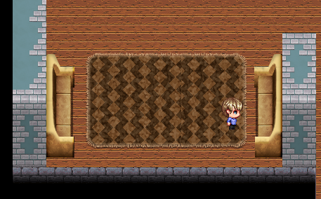
- Added common command to get rid of picture when gifting – severely reducing “clipping” on Clover, Kendra, and Margot. Placed before all gift-giving commands, removing original picture before adding new one based on item received.
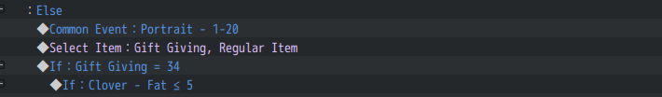
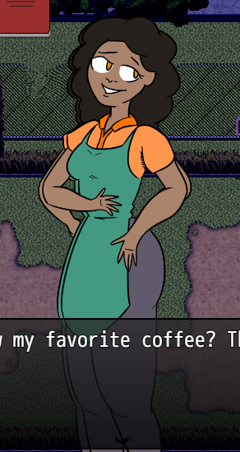 ( <- “clipping” refers to this)
- Installed guardrails around this part of town so that this should be impossible.
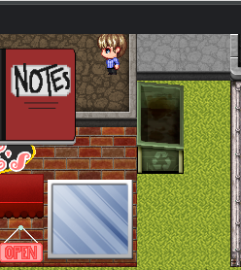
- Deleted redundant “Ask” Common Event here in Charlie’s Skinny dialogue.
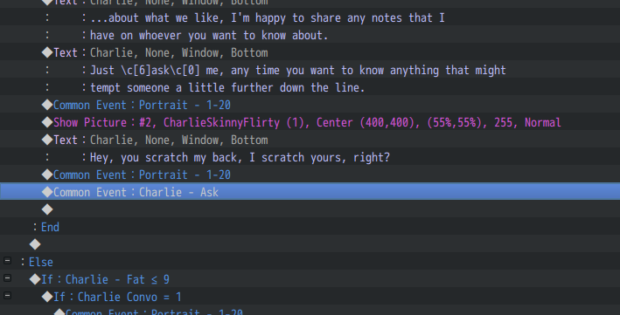
- Wrong variable for one of Clover’s “skinny” talking points (applies to 8, 9, & 10)
- Changed variable from “Clover – Friend” to “Clover – Convo” and changed switch to “Male”
- Same but for Clover at “Chubby” levels.
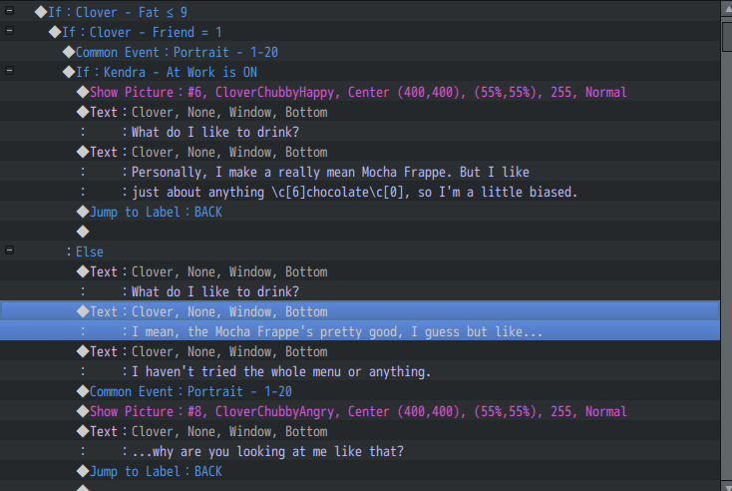
- Bobo’s Food has been given a new variable – effectiveness of fattening now varies by the day. Otherwise, it’d be too easy to make Charlie fat.
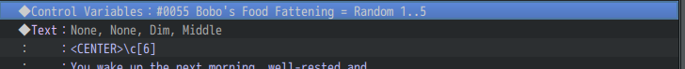
(Variable included in the “NEW DAY” Common Event.)
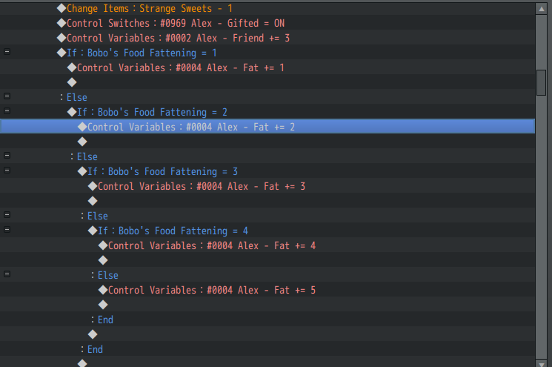
(Example of how this is scripted – this has been implemented for all five characters.)
- Gifting Charlie now adds weight. Here is proof of this. Keep in mind, Charlie only accepting gifts from the Bobo’s Cart is not a bug. She’s just a picky eater.
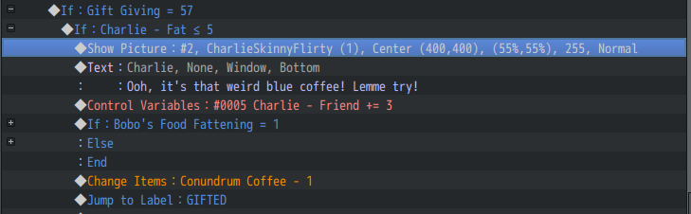
- Fixed this for Bean Machine.
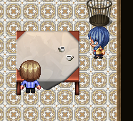
- Fixed this tileset issue for Broken Stool.
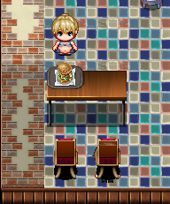
- Another tileset issue for Broken Stool.
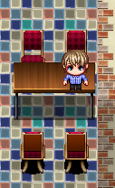
- Tileset issue for Fiction Addiction
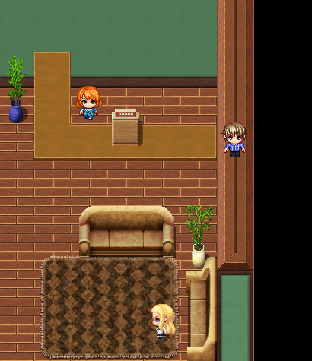
- (Deep sigh) Another one.
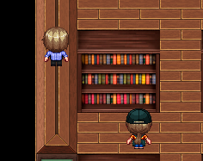
- We da best tileset issues—DJ BEAN MACHINE.
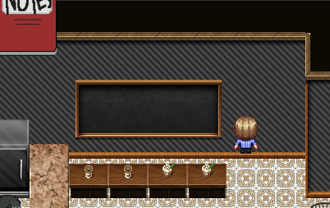
- More tileset issues.
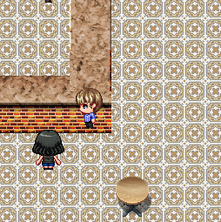
- These changes have resulted in a new look for the Bean Machine. Otherwise the chalkboard would be off-center.
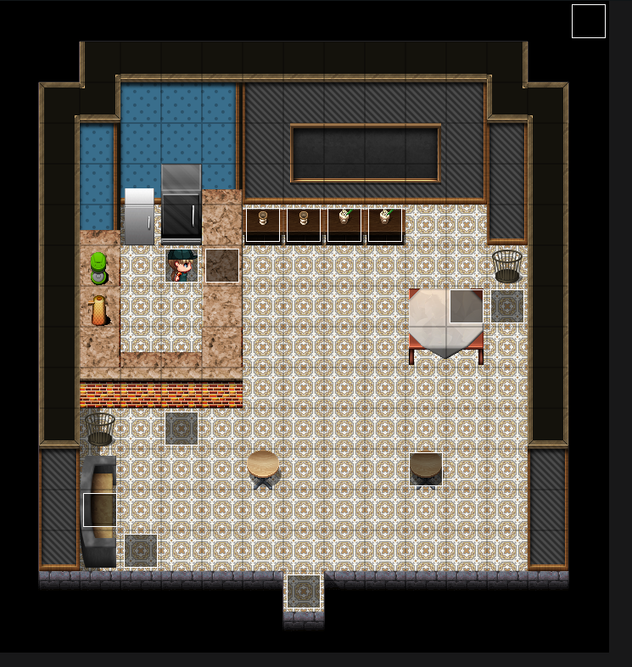
- We’re fixing this issue too. (Apartment Maps.)
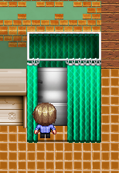
- Spider-Sam, Spider-Sam. Does whatever a voyeur can.
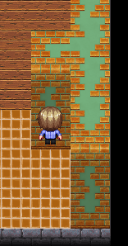
- Fixed HUD bug where characters wouldn’t automatically skip to next character in line. (Alex to Charlie, if not then Clover, then Kendra, then Margot—plus the reverse.)
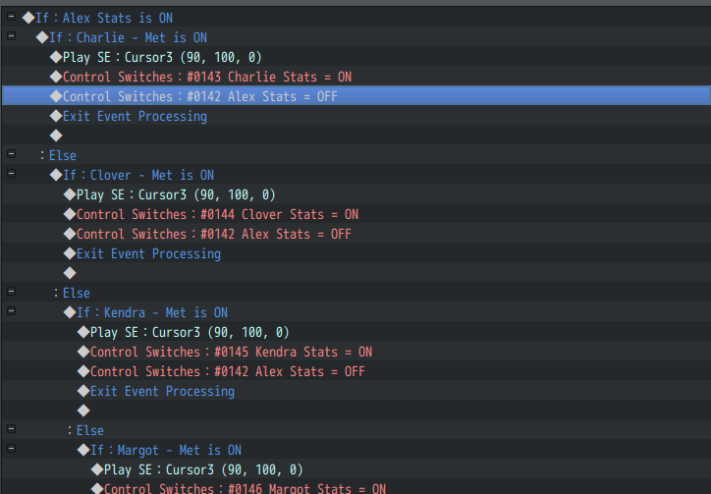
- Fixed no portrait – Charlie / Chubby
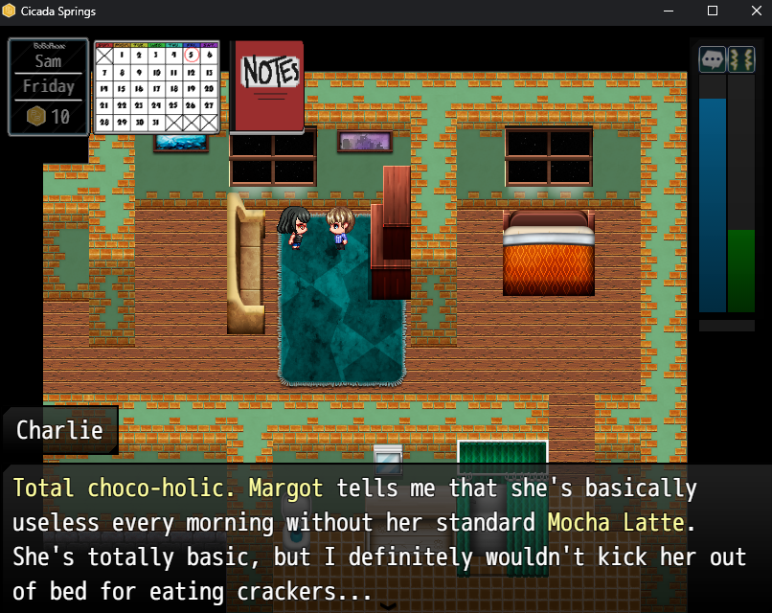
- Completely reworked Kendra/Clover’s house. Tilesets are completely walkable.
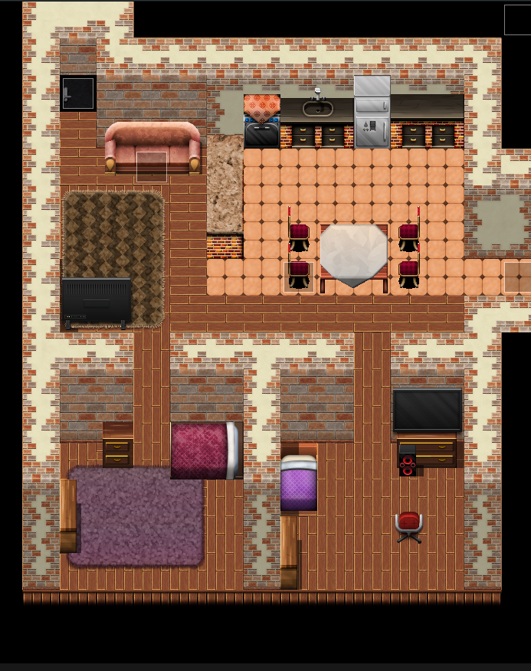
- Fixed an issue with working more than five days undoes all of your raises for being a slave to the Capitalist Hamster Wheel.
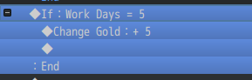
- Fixed an issue where Charlie switches weight stages mid-conversation
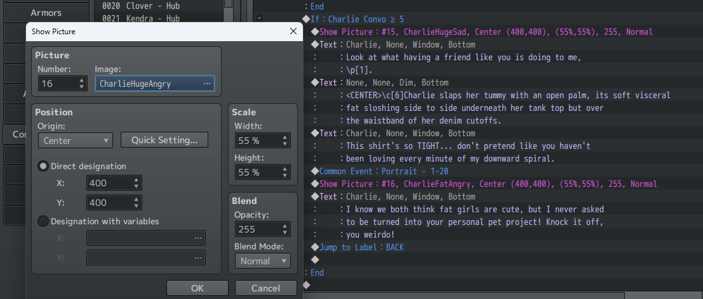
- Remap of Apartment Hallway – tested and walkable
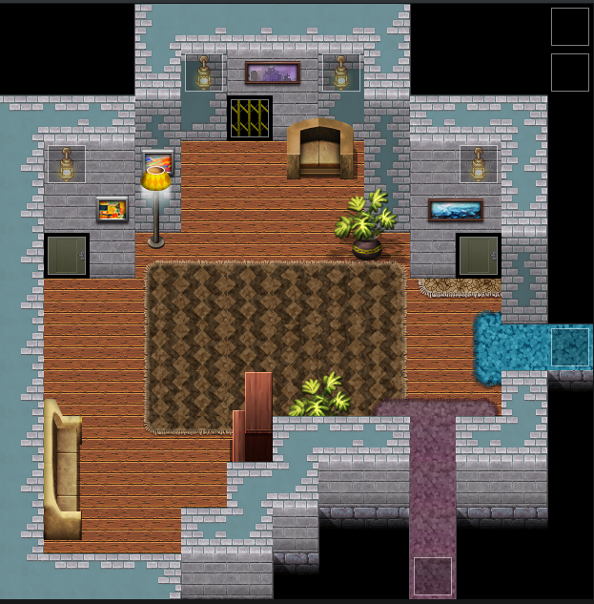
- Fixed not being able to give Charlie gifts here
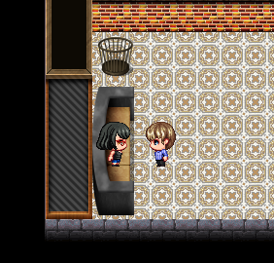
- Added a debug mode. Interested? Hit me up on the Discord.
- Fixed infinite blueberry frappe glitch with a self-switch.
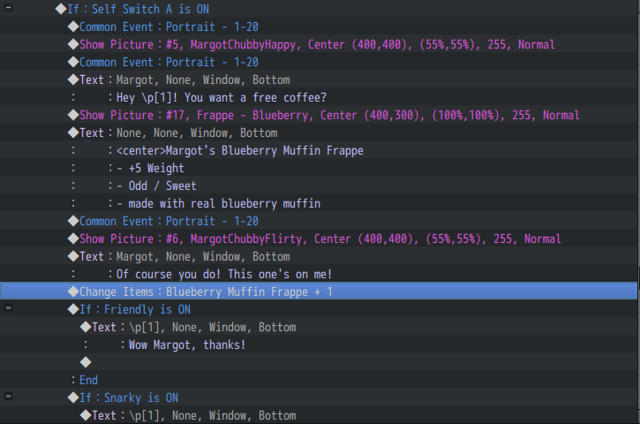
- Fixed feet coffee.
- Old fragments of code left in “work” events that were deleting important things like gender, a lack of gender, and the concept of Tuesday.
- Clover is now giftable. There was an instance in an old event running on Parallel where the switch had not been removed, thus causing the issue of her thinking that she’s at work all the time. This has been fixed.
- As a redundancy to issues 33, I have added several “schedule” events that run in parallel so that anything I didn’t catch from previous versions should be taken care of.
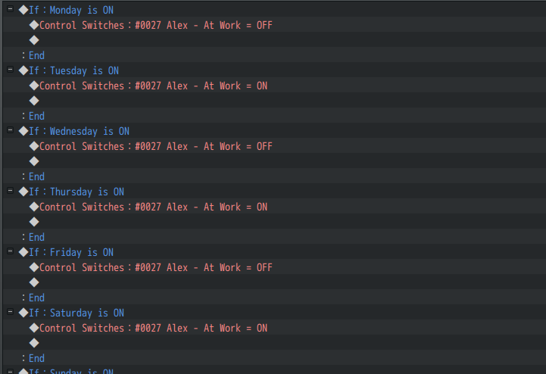
- This will no longer be possible.
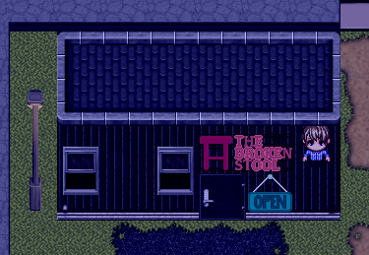
- No more entering Kendra’s house through the wall – you have to use the door like a civilized person.
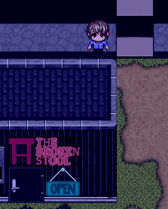
- New Title Screen – it’s not permanent, so mind the low resolution.

