Alternative to Prison
Inspired by this captioned Image by Cat
https://catscaptions.blogspot.com
By Maryanne Peters

Maybe some guys can do it, but I knew that I couldn’t. It is not claustro-thing. You know, the thing when you go crazy because you are in a little room, or whatever. It’s more like, being locked up with all those really nasty guys. I guess that is what made me make the choice.

It was three strikes for me. You know what I am talking about. This time it was jail for sure. There is this aggravation thing – makes it way worse. Like, because the car hit some other cars and stuff. Nobody was killed, but they said that was just luck. All injuries minor, but the aggravation, or whatever.

So, what you going to do? I know I am crazy to say: “Do it”, but the way I see it is that I will go crazy if I say: “Don’t”. Do or Don’t – you know?

Maybe I just thought that it might not happen. Maybe I just thought it was like a scary thing. It just seemed so weird that it was like, this can’t really happen. Like, not for real, right?

But then I wake up and it is done. Like, it’s not me in the mirror. My face has been remodelled with a tiny nose and a little pointy chin, and my eyes way bigger, or so it seems. And I have this pink hair, grown out a bit now. Like, long hair.

And then they have taken to my body with axes – that’s how it feels. Skin on my chest stretched over two basketballs, my groin turned inside out, even rib bones removed to give me a skinny waist. Nobody is going to know that this was once a guy’s body.

No hair left south of my eyes and the top of my head, and just a small tuft where my dick used to be. Everything else is right down between my legs, so you need a mirror to check it out. I can only pee sitting down. They gave me lessons. “Feminine Hygiene” they called it. Feminine Hygiene and Hair and Makeup lessons.

So, they said they would be doing some mental change too, from the girly drug capsule they stuck inside me. But not for me. No sir. If you accept the changes, they don’t need to hollow out your brain. You just say: “Hey, I kinda like being a girl. I like being pretty and dressing in a sexy way. I like boys and the way they look at me”. If you say stuff like that, you are Ok. If not, then you are going to be trouble, so they dumb you down so you can cope.

I have seen it happen. Some of the guys I went through with have different stories to tell:

This is Manuel Garcia, who was a Sicario for a major cartel. They gave him the works including giant boobs, hair transplant, duck lips and some operation to give him blue eyes.  I think they look kinda weird, but that’s what won “her” the husband every girl like us dreams about.  Her name is now Maria, wife of Esteban Gutierrez. She is standing by the pool at her house outside Sausalito. We go around there for pool parties sometimes. Everybody loves pool parties – right. We get to wear tiny bikinis and shake our stuff at the guys.  To think that Maria used to be that kind of guy – big and hairy and macho. Now she is just the perfect wife. Like classy, but really sexy – right? You can’t say she is dumb. She has everything she wants. | 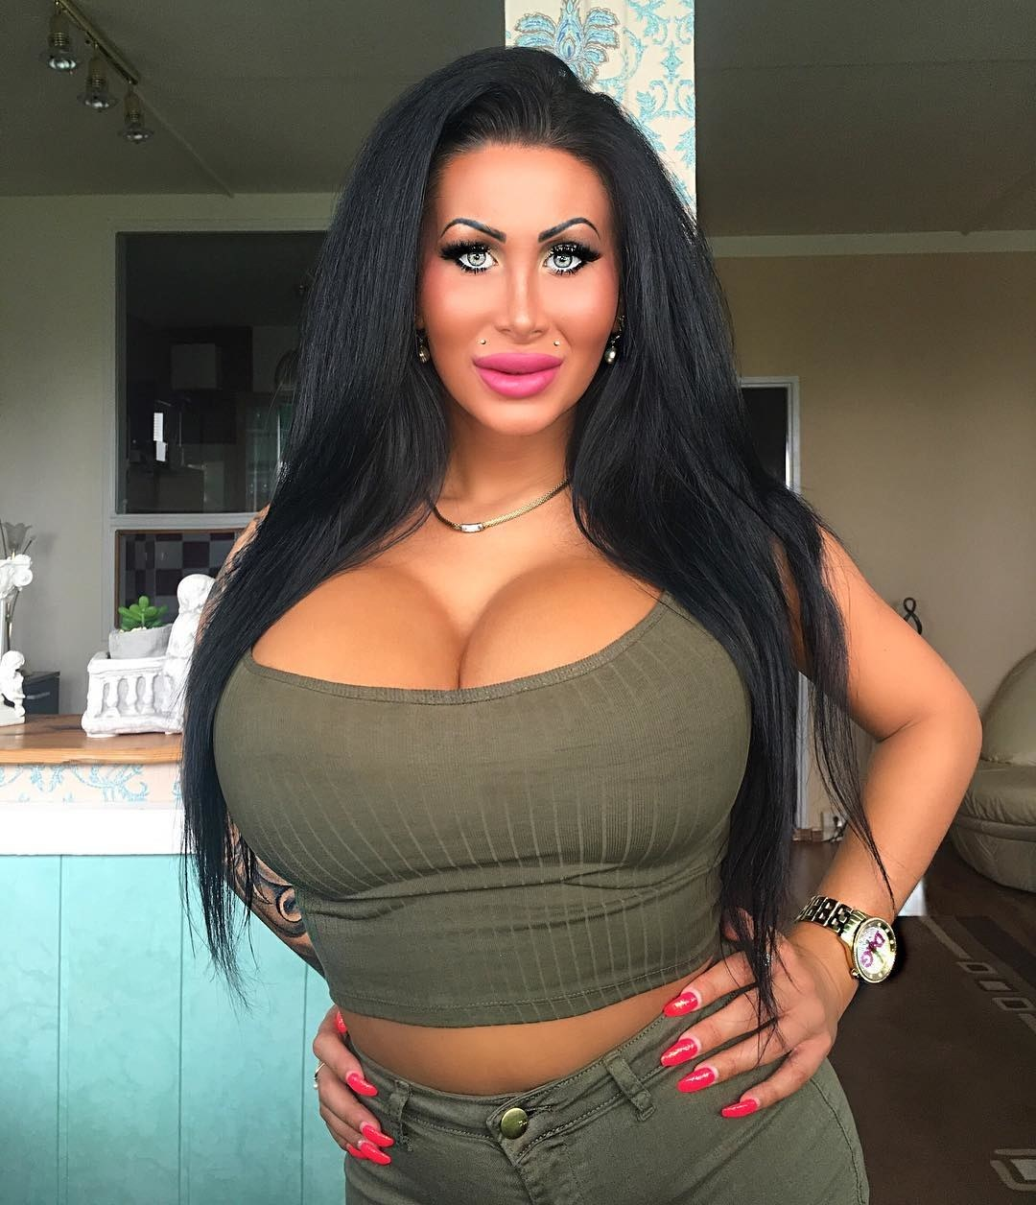

Aliyah Hatton used to be known as Tyrone. Tyrone was in the joint for rape. Not just one either.

Now she just wears white. She says it is a sign of purity, or virginity, or whatever. Anyway, when she got her pussy she said that she was going to protect it with her life. Now isn’t that … what is the word?

Aliyah said that no man was going to get a piece of her sweet pussy, but man that girl looks so good many guys were chasing her down, no matter where she comes from or what she done.

Word has it that some dude charmed her white panties off of her, and they are now married – a white wedding for sure – and out east somewhere. I am guessing she won’t truck no violence in that relationship.

These are the Costello brothers. 15 years each for armed robbery with homicide, or a life of freedom as two killer blondes. What choice, right? Bring on the scalpel, right?

And there was the fact that Mickey and Ryan were in different prisons and they just wanted to get back together. They have always done everything together that pair, but the prison system wanted to keep them apart. This way they are back together.

They go by Mimi and Roxy these days. Some say they still believe in armed robbery. But they use those tits instead of guns to slay the guys, and when their victims hand over the cash these days, they do it with a smile.

Who knows when they will settle down? For now they are living the high life, with not thought about the future. Great huh?

This is Miranda, one of the latest to make the choice. She is still getting used to those heels and needs to steady herself – so cute.

She is a big girl, but a good corset and the right dress makes her look a peach. I did her hair myself, with those adorable curls.

She was Mark, lined up for 12 years for rape. She said that she would never be able to have sex with a guy, but I said: “You had better get down and do it girl, cos otherwise they are going to mess with your head and there won’t be nothing left.

Anyway, last night she took a man inside her new fanny for the first time, and she loved it. She said that he might have been little rough but I told her she should not stand kind of thing. I guess she now understands that “no means no”.

Anyway she is walking a little unsteady today, because she got such a reaming last night. But in a good way. She said he was “dreamy”.

Bobbi is another newbie. I took this shot just after the big reveal. She had the surgery months before, but she had just had those tits plumped with the final silicone injection and the girls had just finished with the dye job and curls. Wow, right?

Anyhoo, the man she once was had been sentenced to 12 years for almost killing his wife. I guess she might know what a wife has to do to keep her husband happy. Stay looking as good as this has got to be a good start. And make sure that man has plenty of good food and even better sex, right?

I wonder what his old wife thinks or him now – I mean her.

This is Darnelle.

Damn, that girl just can’t stay off the phone. She is fighting boys off with a stick. Well, not really. That’s what got Darius in trouble in the first place. Three separate charges of serious assault on top of two priors. So what are you going to do? Lose the dick, that’s what. Get yourself a pussy, that’s what. Make love not war, right.

I hear tell that one of the guys she beat up in a prior life is now chasing her hard. Now she is teasing him a little, saying that she will only go with him if he can find it is his heart to …, whatever.

Don’t you just adore that outfit? Pink with the ribbon trim and the pompom and all? Isn’t pink just the most wonderful color? That is why I like my hair pink. I think it says: “Look at me, I am the girliest girl in the whole world”. But Darnelle is close

Joey Thadwell had other motives for taking the deal. He had enemies that were trying to track him down. He was a bit of a ladies man, so what better to throw them off the track that do the one thing thing they would never expect him to do – have over his cock and balls.

One thing Joanne knows is how guys like their girls; Blonde, big busted and scantily dressed, and just the way Joey liked them, low enough self-respect to be ready for sex without too much resistance.

I think that part came as a surprise to him more than the rest of us, but the fact is that the surgery done was high class. We all have sensitivity down there. We all go off big time when a guy pumps us properly. Just ask any of the girls

This is Noelene at the salon about to send a message to her boyfriend Zane showing his the new blonde hair color we did for her. She can never do enough to please Zane.  You see, Noel killed Zane’s wife and mother in law in a road accident while escaping from police. When she elected to avoid prison by entering the program, Zane could have used a … is the word veto? Anyhoo, I guess he was curious as to how it would turn out, and well, he sure found out. He just has a thing for blondes.  Noelene thinks that if he could marry Zane and be a mother to his two children now without a mother, that would be like, the happiest ending ever. Like, of course it would be, right?  She looks pretty pleased with the hair. For her I am hoping that Zane likes it too, spread out across the pillow while he is fucking her brains out that is.  I hope she gets her husband and her ready-made family just the way she wants. It was an accident afterall. | 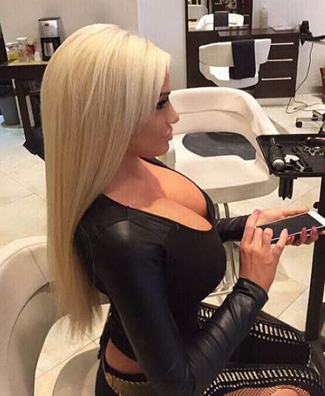

All we want to be is free, and to be out in society contributing our bodies to the cause, and adding a little beauty into the world, in payment for our crimes. I think the programme is working. Nobody has any complains that I have heard of. All the guys we know seem happy.

Perhaps more criminals should be offered an alternative to prison?

The End

Rescuing Roberta
A Very Short Story Inspired by a Captioned Iage
By Maryanne Peters

I will admit it, Robert Kradel Junior was a prick, back when he had a prick. But he did not deserve what he got.

Jose Berganza had reason to dislike his boss, but what he did was way beyond that. It became clear to me that there was real hatred on display. Venal, viscious hatred to warrant this level of degradation.

Marrying Robert would provide a path back to citizenship, but Jose could have done that in any one of a number of states as a gay couple. To marry Robert as his transvestite bride was all about demeaning the man who had once been his boss. Demeaning him and making sure that if he ever were to be forced back to his country of birth he would be marked for open abuse given Putin’s policies towards gender variants.

I suppose that Jose could not resist the irony, that he, constantly teased by Robert as “an Illegal”, could use his status as a true American, to allow Roberto to stay.

So I was invited to the wedding, along with all manner of people who had known Robert. And it seemed to me that all who turned up, turned up to laugh at him. Who could guess that a man would have so many enemies?

I should have been one of them. God knows that man made my life a misery. I paid for a space on the dance card. I wanted to get up close to this man – close enough to spit in his face.

But that is not the way things turned out.

It was slow dance. I pulled him close. I had my hand on his ass, burried in the ruffles of that ridiculous wedding dress. People who looked on could see, and they laughed.

“Doc, I’m desperate,” he whispered. “There is nothing left of me, and still Jose wanted every last drop of my blood.”

It was hard to disagree, so I listened.

“I am married to him now, but I need a way out. I have done not just bad things in my life. You know that. Please help me.”
A few good things, maybe. So I told him: “Well, you cannot go back to being you, that is for sure.”

“How could I,” he said. “Look at me.”

I have to say, that in that moment I looked at him and I did not see Robert at all, but only the new Roberta. It was a wig on his head, with the flowers and ribbons in it, and the makeup was caked on thickly, but there was a real femininity in his eyes. Those eyes spoke of vulnerability. There was nothing of Robert Kradel Junior left.

“I can get you some tablets,” I told him. Tablets that will ultimately make you unattractive to Jose. He is gay after all. He likes his men femmy, but not fishy. If he abandons you then your immigration status will hold up. If he does, come to me.”

I did not stay until the end of the reception. I had seen the humanity in Roberta and could not stay on to watch her further humiliation.

I dispatched the pills, and several repeats, and like everybody else, it seems, I saw nothing of either Robert or Roberta for over a year. Then I checked my online diary and found that I had an afternnon appointment with Mrs. Roberta Berganza.

When she walked in, I immediately thought how stupid it was to think that this could be the pathetic creature I had danced with a year before. The woman was tall and attractive, with honey blonde hair that was clearly her own, and a stunning body clothed in the skimpiest little black dress.

She waltzed in and put an emmpty jar on the table.

“You were right,” she said, her voice high and clear, but with the barest trace of the voice I knew. “He hates my breasts.”

“Of course he does,” I said. “He is gay. But what do you think of them?”

“I love them,” she said. “They make me feel … right, somehow. But what do you think of them?”

“Well, I am a doctor,” I explained. I thought they were wonderful, but I gave a professinal opinion: “I think that they are surprisingly advanced if they are only from hormones.”

“They are,” she said. “But I understand that a girl like me can expect breasts a size one or two sizes smaller than my mother’s, and she had very big breasts.”
“Well, congratulations,” I said. “But are you here seeking my professional assitance.”

“Yes,” she said. “The next thing I want is to have bottom surgery. To get rid of these awful dangly bits and get myself a neat and tidy front for summer.”

“If Jose is no longer interested in you, then why would you bother?” I asked.

“Well, now that he has moved on, back to his drag queens, I have been considering my future, and I have decided that it should be as Roberta. And I have decided that Roberta should share her life with somebody that she respects and admires.

“Do you have anybody specific in mind?”, I asked.

“Yes,” she said, smiling sweetly at me. “Yes I do.”

The End

© Maryanne Peters 2019
Breast Cream
Inspired by a captioned Image by CyrilleTG
By Maryanne Peters

I really did not know that she would have such a bad reaction to fake face cream I whipped up for her, but she had been getting on my nerves going on about the problems on my chest. It was gynecomastia caused by late onset puberty. It is a real problem for a boy. Ok, so I over-reacted by trying to go out all macho, but I needed to reassert the fact that I was male.

Then her face blew up and she was furious. I can’t say I blame her for being angry.

Mom said: “This is your fault, so you need to make good. Whatever this costs your sister you are going to have to find a way to fix it for her. She will tell you how.”

There was only one thing that worried her – what was Brad going to do. She could not let him see her like that, but she could not let him go on the prowl. She was so insecure that she thought Brad would find another girl and that would be that.

So how was I supposed to fix that problem?

“You will be a stand in for me,” she said. “You can be my cousin Caroline, escorting him around until the swelling goes down.”

Of course I protested. But Mom said that I had to pay the cost and she had the right to tell me how.

“We are going to put those breasts of yours to some use,” she said.

Breasts? Of course that is what they were. Gynecomastia is an awful thing for a teenage guy to have to endure. But I kept them hidden. She said that for the time I was to be Caroline, they would need to go on display. She had some special hormone cream that she had been using for months to make her tits bigger, without much success. Somehow on my chest, this stuff seemed to have immediate effect.

With the right undergarments she was right - suddenly I had a girl’s body. Even my crotch was modified by a special panty-thing. No that there was much to conceal given the fact that I was still pre-pubescent at 14.

“We can also put that long hair to good use too,” she said. “No wig necessary. I will just give you some soft curls. And a good makeup job to show off those bright blue eyes. We will go pink. Matching lipstick and fingernails.”

She took a photo of me as she turned me towards the mirror. It makes me smile to look at it now, but at the time I was mortified.

“Hi Brad, it’s me,” I heard her on her phone. “I can’t go with you tonight because of some family stuff, but I don’t want you to go alone, so would you please take my cousin Caroline with you? She is in town for a few days. You can show her around. Yeah, whatever you like. She’ll be good company, I promise. I am so upset by not being able to be with you, hun. Just look after Caroline, OK? She is a country girl so excuse her being a little awkward. But I have given her one of my special makeovers and she looks gorgeous! Ok. Missing you. Bye.”

“Why me?” I said. “Any girl would do.”

“Any girl would steal Brad. You can’t, because you are not a girl. Even then you wouldn’t, right? You’re my brother after all.” She was smiling. It was annoying.

“He will notice. I will be fucked,” I said.

“So you need to make sure that you behave as girly as possible,” she said. “We have time for you to practice. I will give you some pointers. The best way to stay safe is to stay feminine. Then Brad will protect you. He is that kind of guy – a gentlemen. He appreciates girly girls.”

Suddenly I could barely stop myself from laughing. With her face all swollen up she hardly looked human.

But that would just make things worse. She was in a state. I could help her out. It seemed like a reasonable plan. I was just to keep his attention for a few days until she got back to normal, then Caroline would go back to the country and she would have her boyfriend back.

The objective was to ensure that he only had eyes for me. I was to keep him for her. The black dress with my little tits pushed up so that they looked gigantic, would certainly help. The right shoes too, which meant learning how not to fall off a pair of heels. And all before Brad picked me up at six.

My mother opened the door. She was in on it. She called out: “Caroline. Brad is here.”

I could see his mouth fall open as I came down the stairs. That is when I got the tingly feeling that she was talking about for the first time. It was not to be the last.

I decided that I was going to keep my promise to my sister. I was going to make sure that Brad did not go astray. But it turned out that was easy. He only had eyes for me. I mean, his eyes were always on me, that night and for all the dates that followed. A beautiful girl would walk by, or maybe even one he knew would come up and maybe flirt with him a little. I would rub a leg against his and give him a little smile and he would politely turn them away.

Or if we were in the street, I would take his arm or his hand as if to say: ‘back off Girl, he’s mine’. They weren’t to know, but he was my sister’s boyfriend and I was keeping him safe for her – safe from temptation. I never thought about him becoming attracted to me, let alone me being … well, having those tingly tits, all the time he was close.

You can’t go out on a second date without giving him a kiss – can you? It was give in or have him drop me and look for a real girl, then my sister could lose him. Just a kiss, but make sure that it is the kind of kiss that carries the promise of more … much more.

Of course, I had nothing more to give. He could put his nose in my cleavage, run his hands up my shaved legs, but if he got anywhere close to you-know-where I would have to grab his hand or smack it aside.

“I’m not that kind of girl, Brad. I would steal my cousin’s boyfriend.”

But then he would take me in his arms and kiss. It was so close the sex the way we kissed. It was just … I don’t know – something special.

My sister’s face was almost back to normal. But Brad was saying that I was driving him crazy. I was his girlfriend now, or if not me then not back to her. I felt I needed to do something to keep him on track. I was not going to blow him, but I agreed to give him a hand-job.

He asked me just to kiss the tip. I thought: ‘Well, I have another guy’s cock in my hand, so what the hell?’. But Brad the moment my lips touched him there, he erupted jizz all over me. I knew what it was, even though I had never produced any myself. He apologized but I could see that he was the happiest man alive. I was less happy. It was all through my curls.

“What is that in your hair?” How could I reply?

“Sis, it is your turn to take over. Tidy yourself up because that is that last time I go out with Brad. And never ask me to do anything like that again.”

I took off my makeup and washed my hair. I stood looking at myself in the bathroom mirror as I ran a comb through the wet locks. I should have been looking at me, but I only saw Caroline. Even with stringy hair and no makeup, but with my little tits looking so perfectly right on my chest, I looked like a girl, not a boy.

Brad called looking for me. He told my sister that he had done something unforgivable and was asking her to have me call him back, but she said it was over with Caroline and she was coming around to his place.

It was over. But instead of relief I found myself sitting on my bed and crying. I was thinking that I would never see Brad again, at least not as Caroline. I would never kiss him again. I would never stop his hand mid-thigh again. Somehow it seemed as if my life had turned into a tragedy.

It seems crazy but somehow, I felt that stealing one of my sister’s nighties and wearing that to bed would help. Maybe it did, because despite the tears I fell asleep.

My sister woke me about an hour later. Apparently, Brad went on so much about me that my sister told him everything. Yes, I was her brother, who was pretending to be her cousin – just holding the fort until she returned. Yes, I had breasts, but I also had a tiny under-developed cock, so I was definitely not a girl.

I could imagine him looking at my sister in disbelief, maybe even feeling the way I did: Love lost, like star-crossed lovers. Would he be in bed crying?

So it was all over for me and Brad, and it seemed that he was not interested in my sister anymore either. But it was not my fault.

“But I could never trust him anyway,” she said. “They call men like him ‘a hard dog to keep on the porch’ and I am not sure if I need the aggravation.”

I could not let her see me upset, so I agreed. She left my room. I cupped my tits and wondered what it would have been like to have Brad hold them like that.

So I suppose it should have ended there. But it didn’t.

Brad called the following afternoon. He said: “Caroline, is that you?”

Was it? What a good question. I said: “Yes. Hello Brad.”

“What are you doing tonight?”

“Brad, I am a boy, remember?”

“For the moment maybe …”.

I found myself saying: “My boobs are not really as big as they look”.

“We can watch them grow together,” he said.

It is lucky that my sister has plenty of that special cream.

The End
Losing or Winning?
A Short Story Inspired by a Captioned Image by MrSalty236
By Maryanne Peters

Could I really help it? When you look at my face – eyes a little too big, chin a little too small, lips a little too full. I was not really a good-looking young man. As for my body – a little too short and chunky, my arms a little too flabby, and my tummy too. But as they put it, perfect for corseting, to give me a narrow waist and enough soft skin on my chest to be pushed up into a cleavage with the right gel inserts.

My legs are not muscled either. Not fat, but certainly soft. Olivia calls them shapely. I suppose they are. When she had finished ripping the hair from them, and soothing the inflammation with moisturizing creams, the looked nothing like boy’s legs. And when you wear heels, those goddam heels, well … they look wonderful.

My hair could have been shorter, but I grew it long to drape it over my face and look invisible. But with the glossy dark extensions, down almost to my waist if they are not curled, I wear it off my face, parted to one side and styled to be as full and lustrous as possible, while showing off my feminine features.

The very things that made me unattractive as a man, make me pretty as a girl. I really could not help it.

Olivia chose the outfit: A pink dress with detailed black lace tulle over it set off by black lace gloves and black shoes and bag. The look says femininity and sophistication. You have to take yourself seriously in an outfit like that. You cannot ham it up. You have to say to yourself: “Nobody will recognize you. Tell them your name is Rosa - and do it in a high voice. You can get through this. Keep your head down and get through this evening”.

But look at me. What chance did I have of being invisible now?

After those first tentative steps down the hall, I got used to the heels, but when you walk in heels like that, and with the padding on my chest and my butt, and the black curls, all bouncing about, I was a tottering package of allure.

“An inevitability,” she called it. Men would want to talk to me, dance with me, get close to me.

Was it really flirting? I just gave back as good as I got. They were the flirters.

I think that maybe I just did not understand what it was like to be desired. I was a shy young man and I always had been. How was I to know that in a dress I would suddenly become this extroverted seductress?

Surely Olivia could not have known? Or was it my older twin sisters who are her best friends? All three of them were behind this. They say that is going to be hard to go back to the old me after tonight.

They might be right. But somehow that does not seem to be upsetting me. Did I really lose that bet, or did I win?

The End

So Wrong  Inspired by a Captioned Image  By Maryanne Peters  “But you are wrong, Sweetie” I said to her. “You could not be more wrong. Why do think I am wearing this underwear and slip? Why do you think that my hair is styled like this? Why do you think I invited you around here, months after we broke up? Why do you think that the house is full of flowers?”  “Oh, it’s all very pretty,” she said. “It is perfect for you. Everything just screams sissy around here now.”  “Not sissy. Feminine. It’s the way I like it, because today is a special day for me,” I explained. “Of course, you are bitter, and so you cannot share the day in the same way as others of our mutual friends, but I felt I owed it to you to tell you face to face. Perhaps even to thank you.”  “What are you talking about?” she said. | 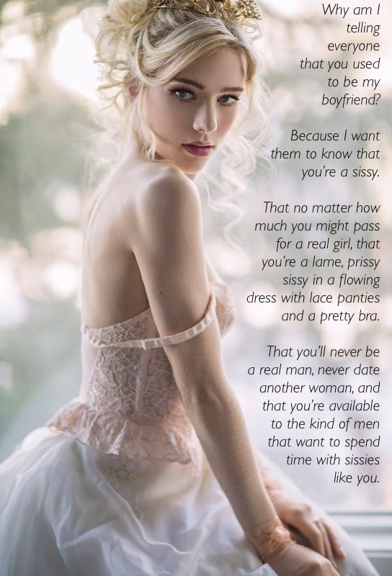

“Well, thanks in no small part to you, today is my wedding day.”

My words had just the effect on her that I hoped for. Her mouth opened and closed like a fish drowning in air. She was silent now. She was not telling anybody who I had been before, now.

“Who? Who would marry you?”

“Bradley Parkes, of course. You know how he loves slim pale blondes. Just like me. When you got chubby and ruddy he lost interest in you, didn’t he? Why couldn’t you just hold it together until he put a ring on it?”

“But, but, he would never marry a sissy,” she said, her voice cracking. “He is no fag. I will tell him.”

“But you’ve told everybody already, remember? He knows. Everybody knows. I have no secrets from my friends, even from my enemies, but certainly not my fiancé.”

She repeated it: “He would never marry a sissy,”

“He’s not marrying a sissy,” I explained. “He is marrying a woman. I had the surgery three weeks ago. The surgeon promised that I would be ready for him tonight, and I know that I will be. I have prepared myself to perfection. He will have his virgin bride tonight, but one well equipped to show a man all the pleasures that he expects.”

She staggered back, and found a chair to support her large butt.

“Oh of course we have fucked like rabbits when I was in my sissy phase and could only offer the back door,” I said. “But even then, I was a woman to him. More of a woman than any one he ever met, he told me. So as for your contribution to helping me be that, I want to thank you.”

“You bitch,” she said.

“Thank you for using that word,” I said. “So totally appropriate to my new gender.”

“You are still a sissy. Everybody knows what you are.”

“And everybody accepts me for what I am. Everybody except you perhaps. I want everyone to see how far I have gone to be the woman I am now. I am proud of it. I am proud of myself. If you think that you can belittle me by referring to my past, you are so wrong. Now I need to put my dress on. Wish me luck.”

The End

© Maryanne Peters 2019

