The Rag Trade  Inspired by a Captioned Image  By Maryanne Peters  My wife walked out. We had not been married for long. She had insisted on keeping herself pure before marriage, I went along with it. Then sex was a disaster. I had to face the fact that I was not attracted to her naked. It seemed that when she was dressed, I was drawn to her in a way that felt thrilling. She dressed so beautifully, and with that hair and the makeup!  But naked – she was so very attractive, but just not attracting me. I could not explain it to myself so how could I speak to anybody else about it.  I brought in Tim to help me pay the rent. He particularly liked the garage and the fact that I did not have a car. As it turned out, he needed it for his business.. | 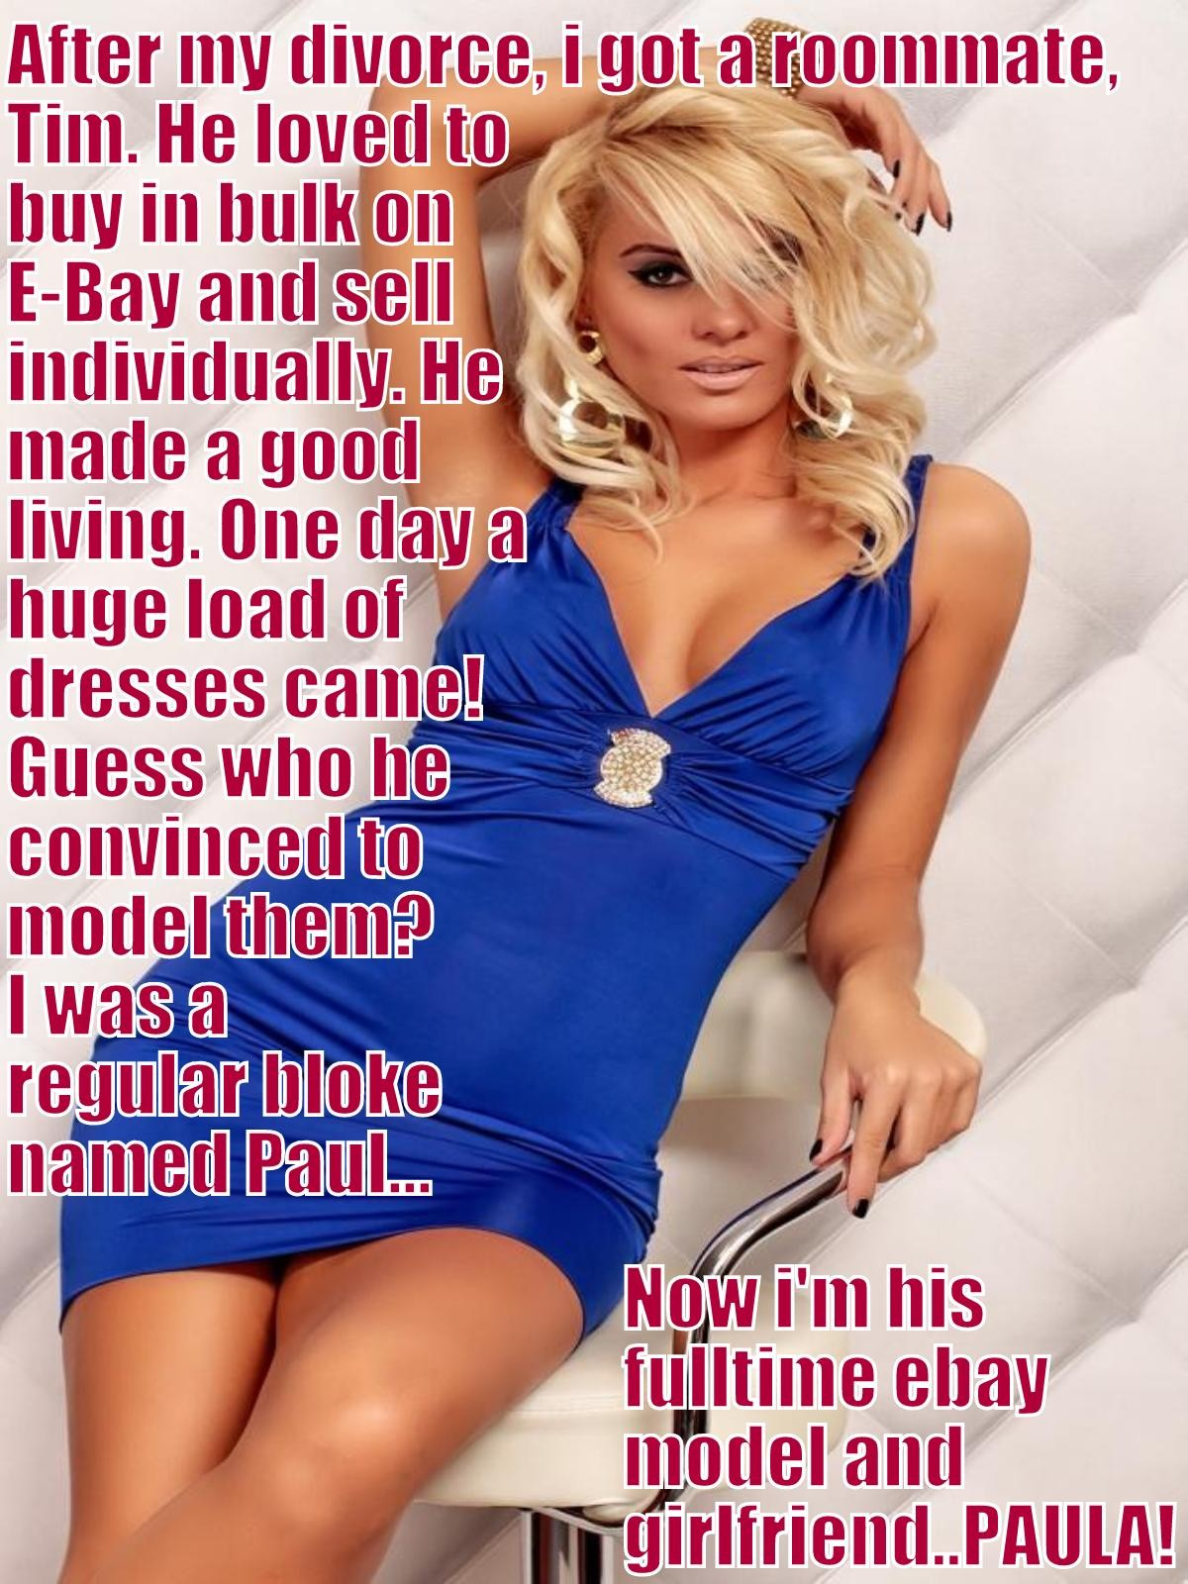

He called it “the Rag Trade” – he dealt in high end garments – one-offs, end of lines, prototypes – all sorts. He liked to buy in volume and sell online.

He said that he needed images with the clothes on, and suggested that I could help. It seemed like a crazy idea, but he insisted.

“Hey, I am just talking about garments that need to hang right,” he said. “I will crop your head of course. The fact is that you are slim and you have long legs. Yours is the body of one of those androgynous models that designers love to work with. It is the square shoulders, the narrow hips and the small butt that makes clothes look really good.”

When it was just standing on the screen fabric in the garage wearing a dress, it seemed like nothing, but then he kept asking for more.

“We need to show the hemline a little. I need to show some leg. You wouldn’t mind shaving your legs for a few shots, would you? You really have great legs.”

“You will need to wear a padded bra for this one. We really have to show the front with a bit of shape. Actually, we need a cleavage. I can get some breast forms and use makeup to cover the edges.”

Hey, for this evening gown I need to show the back, and it would look really good if you put your long hair up. Do you know how to do that? Like just a French twist or something. We need to see the detail across the top and the nape of the neck. Could you do that? What the hell, let’s have a shot of the front too. I’ll take you down to the beauty shop to get your hair and makeup done. This garment is a winner. I tell you what – if you do this, I will split what I make out of this one.”

It was not the money. I would have done it anyway, at least after I wore that first dress and had him take those photos. The fact is that every time I put on a dress after that, I began to feel happier somehow. It was as if I had found myself.

So when he started to talk about acquiring a new shape better suited to more figure-hugging outfits, hormones seemed preferable to padding. Now I can pull off an outfit like this blue one … and I will, for him.

The End

Custom made Bridesmaid  Inspired by a Captioned Image by Tiffany  By Maryanne Peters  Just before her friend’s wedding we had a huge row over my cross-dressing. When we married, I told her that I was going to stop it, but it had been less than a year and the urges were too strong for me to ignore. I went through the whole “I am weak” thing. Sharon said that it was pathetic, and she was right. She was still boiling when we stepped onto the plane.  All of her friends were getting married in those couple of years, including the tall and glamorous Fiona. But she was not even engaged to her man Toby. It was the wedding of another friend and my wife and Fiona were in the bridal party. It was not until we turned up that we learned that Fiona was in traction, and Toby was there alone.  “Sharon, you can fill in as bridesmaid, but we need another attendant – one who is 5 foot 10 and with feet to match.” | 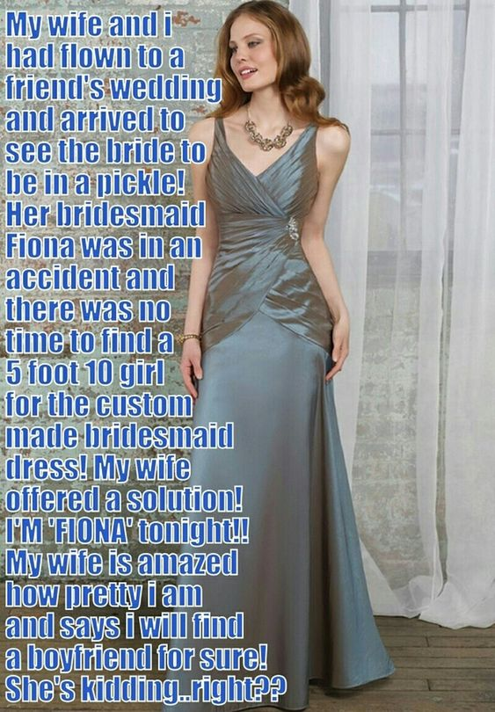

She looked at me with a sneer. She just blurted it out – “We have somebody right here who will wear that dress and be overjoyed to do it.”

“Would you do it?” The bride was looking at me. It seemed unbelievable, but she was sizing me up and wondering how I would look after a few hours in the salon.

A stronger man would have no straight away, hopefully with a huge laugh. But I didn’t. I am weak, and the silver gray dress was hanging up right there, and it looked gorgeous. The truth is that I could not wait to try it on, preferably with a silk slip underneath. I had to restrain myself from blurting out my agreement to such an outrageous idea.

“Well, of course I want the wedding to be a success, so I will do anything I can to help, but …”

I waited for somebody to say something like “a man in a dress would be an awful idea!” But nobody said a word.

Nobody until the bride said – “Well that is settled then. You two turn up together at the salon tomorrow and we will all get ready together.

I needed some corsetry to get into that dress, but otherwise it was a perfect fit, and so were the shoes. As for the beautification, an all over wax was added to my routine, and I needed hair extensions, but otherwise the four of us received similar makeovers. Sharon looked really good, but the most dramatic transformation had to be me. I looked truly fabulous.

I was just grateful that in addition to the corsetry I was wearing pants that held my crotch area lightly enough to conceal the erection that my appearance caused. Other crossdressers will know the feeling – you see the woman you always dreamed that you could be, and it is thrilling, but you cannot grow where you must. Somehow the restraint doubles the thrill, and you find yourself dribbling down there. I had cleaning up to do, and I had to borrow panty liners to cover future accidental emissions.

Another quick bridal team rehearsal gave me more time to perfect my feminine mannerisms, and the suggestion that I sing a part in the scheduled “bride’s chorale” gave me the chance to develop a higher speaking voice.

Before I knew it I was with the other attendants in the second limousine, and then we bundled out, checking one another’s hair and hems and giggling like schoolgirls, me included. It is hard not to get caught up in the whole thing, me included. A wedding is as much a celebration of womanhood as anything else, and I felt that I had joined that treasured sex.

The ceremony was wonderful, and I think a shed a little tear as much as everybody else. I needed to freshen up like the others and they ushered me into the ladies’ powder room as one of them.

Of course I was paired with Toby who was a groomsman. He came over to dance with me. He was very tall so that even in my heels he was taller than me, as he must have been for Fiona.

“I don’t think that we have met,” he said. “I’m Toby.”

“We have met,” I said. “I know Fiona … and Sharon.” I could hardly admit that I was married to her. “But the salon has done a remarkable job. You would not recognize me tomorrow.”

“I am sure I would,” he said. He was trying to charm me and strangely, it was working.

“I am sorry to hear about Fiona,” I said.

“Of course, I am sad that she broke her back,” he said. “But she did it by taking my Ferrari without my consent and wrapping it around a tree. It’s a write off for the car, and probably for us too. But for now, all my attentions are on you.”

“A Ferrari you say. That must hurt more than a kick in the balls.” I don’t know where that come from.

“That’s a pain that you will never know,” he said. “The balls I mean.”

“Well, actually …”.

It should have ended there. That seemed to be my intention. He leaned back a little to look at me, and raised an eyebrow, but then pulled me back in and we continued dancing.

When the bridal party stepped out of the salon that afternoon Sharon had said to me – “You are just so pretty as a girl you will find yourself a boyfriend tonight, for sure”.

She was right about that, just as she was right to volunteer me to take Fiona’s place. As it happened I took her place in more ways than one. But I will always be grateful to my ex-wife for setting me on the path to happiness, and Toby is grateful for that too.

The End

I Know What I Am  Inspired by a Captioned Image by Tiffany  By Maryanne Peters  I know that it has gone way to far, but we just have so much fun together! It was my idea to dress up, it was just that when it came to taking the dress off, I had a problem.  I denied that I was a crossdresser because I had never done it before. I used to think of myself as an admirer of women. I liked dresses and hairstyles, but that did not mean that I would ever wear them.  The ”cross-dressed prom” was not the real thing – it was just a fun party and a rehearsal for the real thing a month later. Not all the guys dressed up as girls, and not all the girls dressed up as guys. It was just that I felt that I needed to strike out and be somebody. I was otherwise invisible. | 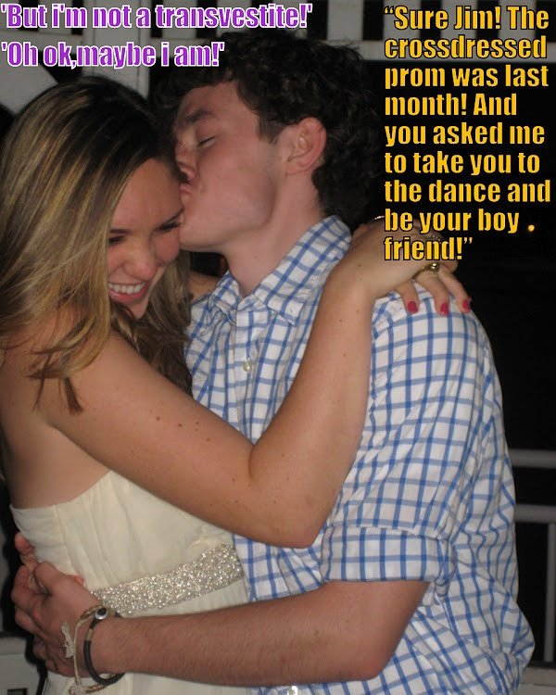

It was my mother who said – “Don’t do this by halves. That would be demeaning to women. If you are going to be a girl for the night then do it properly.” She is in the hair and beauty business, so she knew what to do – hair extensions, brow shaping, leg waxing. It is all stuff that would last at least a month.

Of course it was me who asked him to be my boyfriend and take me to the real prom, but it was because I could see him staring at me all the way through the cross-dressed prom. I could see that he was besotted. There is something about being looked at that way which breaks down all your ideas about sexuality, and replaces it with sheer lust.

But the cross-dressed prom was last month. Since then we have made love at least a dozen times. Sex as a woman is just the best thing. It is now all I want to do.

I am not really a transvestite. What I am is a transsexual. I know that now.

The End

My New Life
Inspired by a Captioned Image by Tiffany
By Maryanne Peters

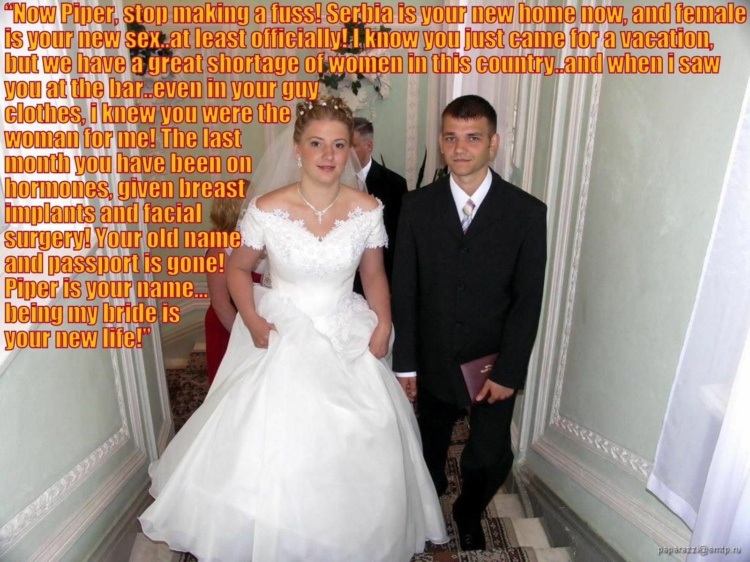

I decided that I wanted to travel around Europe and I had the crazy notion that I would not need much money – I could find work as I went. I turns out that you need work permits for each country that you are in, and many countries will not pay cash under the table for a stint waiting tables.

I found out that Serbia is a country that will still take you on for cash, and so I ended up staying there. Any being a scrawny long-haired kid from Michigan mean that waiting tables was about all that I could do. It does not pay that we if you are an illegal. You have to find a place where you can collect tips and keep them – somewhere like “Crossbar”.

I suppose that you would call it a drag show, but not quite. Sure, there was a show with men dressed as women, and the waiters were required to dress as waitresses, but it was not bright and loud like the drag back home – the performers looked like real women, and the waitresses were expected to look like that too.

What I did not know was that Serbia had a problem with gender imbalance, in particular among young people. There were so many more men than women that it was said that “Crossbar” was filling a need.

I guess that I Iooked pretty good in that waitress gingham dress and apron with my long blond hair piled up. It was not like I laid it on too thick, but the policy was that if you looked like a girl you should act like a girl, and the better you did that, the more tips you would make.

At that stage I was ready to give up on Europe and head home, but I needed the money for the return ticket. Now since 2022 you need the return ticket to even get into Europe, but then I was stuck there.

I would dally with the customers, collect my tip then push them off, but Milos was different. He was insistent. He is that kind of guy. If you look at him perhaps you can see it, with those piercing blue eyes. He told me that he always got his way – he always got what he wanted in the end, and he wanted me.

“Hey Pal, this is just a costume. Under this I am a guy just like you. Thanks for the generous tip, but if you want a girl you are in the wrong place.” That is what I told him. I may have suggested that he come back the following night, which is just what he did.

But that night he had come prepared. That night he was ready to abduct me after I had finished work and bundle me into a van. That night he had a place for me to be held prisoner, and the morning after he had a surgeon lined up, and my life as a man was over.

He said that he had seen me dressed as a man arriving at the bar the day before, and that was what had convinced him that I did not belong in men’s clothes, or even in a man’s body. He had money and could afford to dress me well and even remodel the flesh beneath those clothes.

It was forced on me. I cannot describe the shock of waking up with your manhood taken away from you, let alone the physical pain that goes with that. Put pain subsides, and so does shock. First there is anguish and then resignation, and he kept away from me through that, leaving me in the hands of older female relatives to help me through it all.

I did not speak more than a half dozen words of Serbo-Croat before the surgery, but afterwards I learned a new language and a new life.

And then he reappeared and reminded m of what he had said – that he always got what he wanted in the end. Then he dropped onto one knee and asked me to marry him!

You must be saying that I would automatically refuse him. Afterall, he was the man who mutilated me! There was a moment of real confusion, but I suppose that I had time before that moment to consider my options, and one of them was to accept what had happened to me and recognize that I could not go back to America and expect to ever be the man I was, or any man for that matter. And there was something about the look in those eyes I have mentioned – that steely determination that say that he will never give up until you say yes.

So I did.

That is us on our wedding day. Don’t I make a beautiful bride? He certainly thinks so.

The End

The Pledge
Inspired by a Captioned Image by Tiffany
By Maryanne Peters

I confess the whole fraternity/sorority thing was not something I was interested in. I just happened to get a sponsor to the college and it came with a residential bonus. It was not a scholarship or anything like that. The truth is that I am not that smart. It was just an old guy in our town had a fraternity spot that made available to local high schools on a pure lottery. I won.

I don’t even understand the pledge thing. I just understtod that threre was no getting out of it. If I wanted to keep my spot, I had to it. They say that joining a fraternity or sorority is not just for a few years – it is for life – so you have to commit yourself.

In our case the pledge involved pairing with the sorority next door. Is was also about reinforcing the relationship between the two institutions. It is like tradition or some such. Each new brother pairs off with a new sister and they set the challenges for each other.

In my case everybody said that I lucked out to be paired with the beautiful Gwendoline. I suppose that the officers must have reckoned that we were a match, being the least smart of any at college. I set Gwendoline the goal of placekicking a ball between the posts, something that I can do. As for her, she had no idea what I should do.

“I am like you, I guess, except I am here because of a family connection,” she said. “But I am a beauty queen, and that is … like … all I know. Hey, come to think it, I could really do something with that long dark hair of yours.”

So that is how my challenge was set. The houses were both advised in advance and we had to discharge our pledges. Sure enough I was able to coach Gwen into kicking that ball, and she was able to get the ball and between the posts on her first go. And then it was up to her to turn me into a beauty queen for the freshman dance on the Saturday.

I don’t know what any of the guys thought about me succeeding. I don’t even know what I thought. I just heard that I had to do as well as Gwendoline had – “For the honor of the fraternity”.

I listened to everything that she told me, I sat through whatever work needed to be done, and I followed all of her directions in how to talk and how to walk, and how to behave so that I would appear to be a beauty queen, or at the very least, not a man.

I suppose that the most startling thing for both Gwendoline and me was how easy it was.

“I know girls who could not pick this up as well as you have, Dave,” she said. “Are you sure you haven’t done this before? Or perhaps you are one of those sad guys who should have been born a girl but you weren’t? Seriously though, you are a natural woman.”

The crazy thing is that, that is how I felt. I just fell into the role, as if it were not a role at all – as if it was the real me.

It certainly helped that I looked gorgeous. And the purple dress was great too, although it did require latex breast forms and concealer to pull off the plunging neckline.

At the dance every guy in my fraternity wanted to dance with the wonderful Diane, and I did my best to show off the beauty queen I had become and to assure them that I was up to the pledge.

But at the end of the evening the fraternity committee met with me and told me that they had agreed that I was far too beautiful to return to being a member of that house, and that my place for the term was now in the sorority house next door, rooming with Gwendoline.

I laughed and told them that it was just what I wanted – to share a place with the best looking girl on campus. But the truth is that my relationship with Gwedoline is not like that – I am more like her sister. And she is no longer the best-looking girl on campus – I am.

The End

© Maryanne Peters 2022

