A Sissy Christmas
A Vignette
By Maryanne Peters

I suppose a lot of families have a weird uncle who is not really an uncle but who turns up for Christmas – right? I mean he might have been married to my aunt’s cousin at one time – so family but only slightly. It was just that Uncle Bart lived alone and has nobody, but he is rich and he gives good presents so he was always invited. Nobody really understood much about him or even tried to, but he has always seemed to join in, and then he just disappears for a year.

But he is not the reason I ended up spending last Christmas dressed as a girl. That is down to me, I guess. It was because the whole family suddenly took on this “dress up for Christmas” thing. It was down to my sister inviting her friend Alice to stay over as her parents were spending the holidays in Europe and she was basically home alone. Alice said that all the women in her family dressed in something fancy for Christmas and all the guys wore silly sweaters. Mom thought it would be something different and we should do it.

Dad pulled out an old sweater and Uncle Bart had been told and arrived with a truly awful one. I was offered a sweater that Alice had worn to a Christmas party, but I lost my rag, I guess. I was not going to wear any girl’s sweater. I guess I went a little over the top and laid down some abuse about women that got me into serious trouble.
So Alice said that if it was not going to be that sweater then she had a bunch of suitable outfits, but they were all for girls. I was howling.  Mom said to Alice – “You choose one and he will wear it. I will make sure of it. He won’t be receiving that new gaming unit unless he goes along with the family plan for Christmas. Besides, it will do him good to join the ladies this Christmas. Maybe it will teach him a little respect and humility. That is the very essence of Christmas.”  It was much worse than I thought. Alice picked the most feminine outfit imaginable and it was going to be a total look with hair and makeup. Mom and Dad said that I had to go along with it. It was ridiculous – a Lolita dress – like in the book, designed to attract an older man. The effect was to make me look like a total sissy. Alice and my sister even had me shave my legs under the white stockings. They even colored my long hair and cut girlish bangs in the front, and parted and braided it. I hated it … at least to begin with, I did. | 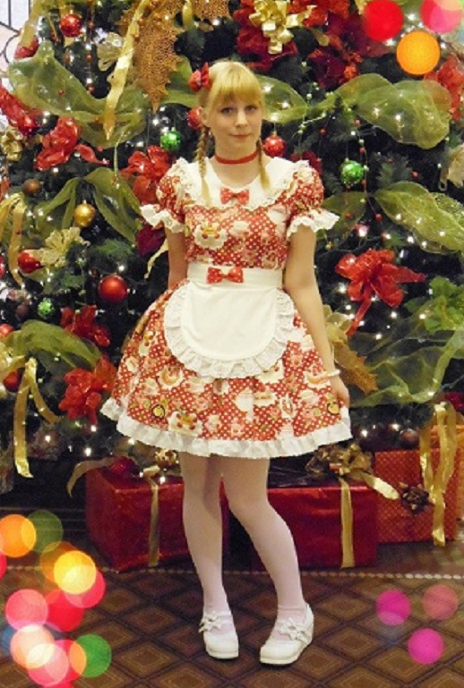
Okay, when I posed for that photo in front of the tree, I may have had a little smile on my face. I was allowed some of Uncle Bart’s eggnog which was quite alcoholic, and I may have overdone it. But it was Christmas after all, and once the presents were all opened up we were all a little happier.

It seemed that Uncle Bart was teasing me as his presents were all suitable for girls, or rather young women – an expensive scarf and some makeup and nice hair ornaments, and a smart designed bag to put them all in. I could not put it down to the eggnog, or the shared enthusiasm of my sister and her friend Alice, all this girly stuff was simply gorgeous.

Uncle Bart suggested that if I really liked it, I should give him a kiss, so I did. I whispered in his ear in a girly voice – “Thank you for the presents, Uncle Bart”. I swear that he shuddered like he was having an orgasm.

It turns out that Uncle Bart has never got married again because his taste in women is a little different from normal. He likes his women to be like me with boy bits. In fact, he likes me in particular, a whole lot.

It was hard to get Mom and Dad to accept things at first, but Uncle Bart is just like family, and I am family. And this Christmas I have offered to host the festivities at our house, or Bart’s house really, but ours now. It is huge and has room for everybody to stay. And of course I have progressed beyond the sissy stage by now – I am more or less a wife. I would like to pull out that Lolita dress to wear again this year, but the truth is, there is no room in it for my breasts.

The End

© Maryanne Peters 2023

